**Temporary 1st Floor Arrangement**

**Overview- During the 2nd Floor redesign reduced library services and resources will be available on the 1st floor in the meeting room areas. Certain resources will be relocated to other areas of the library.**

**-Thurston Room: Fiction, Non-Fiction, Large Print books returned after 1/31/2014, and select current Magazines.**

**-Bret Kelly A: DVD Collection (excluding Dewey numbered), Audio Books (excluding Dewey numbered), current newspapers, Device Checkout, and info desk.**

**-Bret Kelly B: Public Computer Lab with printer.**

**-Lobby Area: Additional Hold shelves, Tax Forms, Copy machine, and Change Machine**

**-3rd Floor: Additional Tables and chairs, Colorado Revised Statutes.**

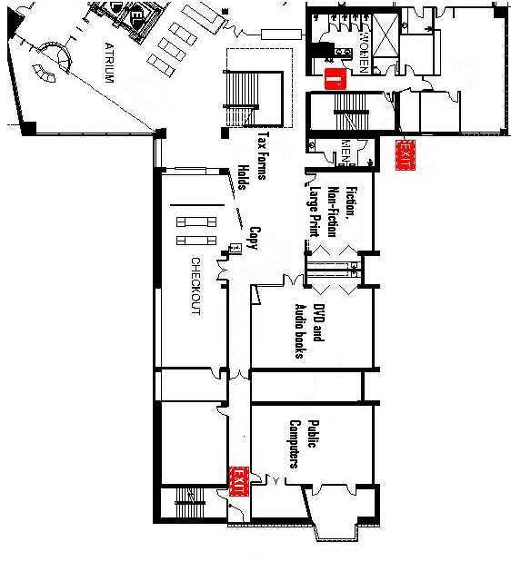

**Thurston Room- Limited selection of Fiction, Non-Fiction, Large Print books, Popular Magazines**

**Staff Notes:**

**New Fiction, New Non-Fiction, New Large Print located at the beginning of the shelves.**

**Magazines located on window sill (limited to 20 popular current issues)**

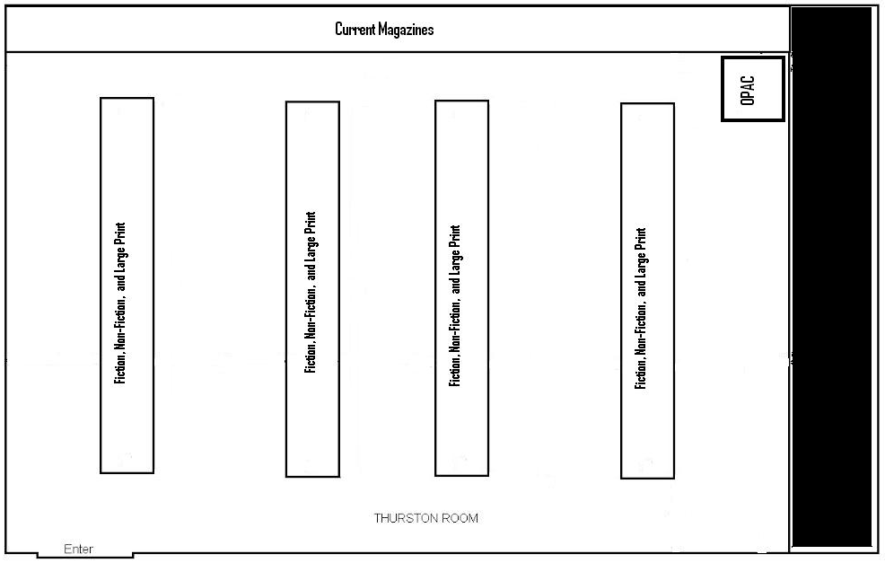

**Bret Kelly A- DVD collection, Fiction Audio Books, Device checkout, and an OPAC**

**Staff Notes:**

**Entire DVD collection (only 4 copies of any title)**

**Audio Books-Fiction only**

**Play Away (located on white mobile shelf)**

**Staff computer with Sirsi Workflows, SAM, internet, receipt printer**

**-Device checkout and resetting**

**-Phone**

**-City Directories (Pueblo/Colorado Springs) located on cart.**

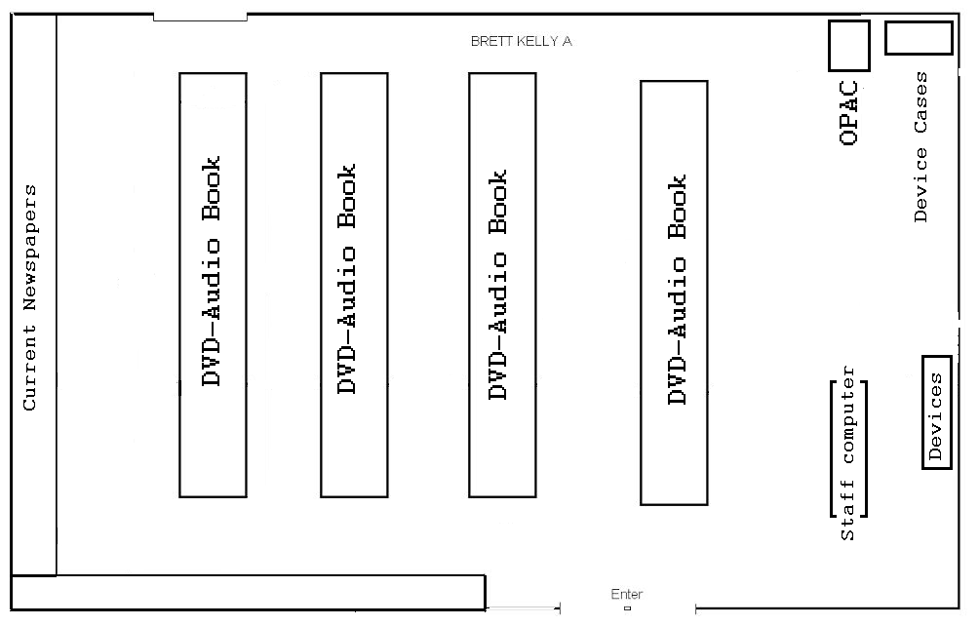

**Bret Kelly B- 30 Public Internet Computers (no staff workstation/Staff equipped with iPad).**

**Staff Notes:**

**No access to SAM in room.**

**Pass should be printed in Bret Kelly A**

**Cannot extend time in the room**

**IPad mini available**

**Help patrons place holds.**

