**Youth and Teen**

**Summer Reading Report – 2017**

**Five-Year General Overview:**

|  |  |  |  |  |  |  |  |
| --- | --- | --- | --- | --- | --- | --- | --- |
| Year | Programs | Attendance | Youth Registration | Tween Registration (Subcategory of Youth) | Teen Registration | Total Registration | Total Finishers |
| 2017 | 975 | 17,970 | 6,215 | 2,842 | 885 | 7,100 | 967 |
| 2016 | 709 | 12,869 | 4,824 | NA | 649 | 5,473 | 967 |
| 2015 | 686 | 16,553 | 6,281 | NA | 940 | 7,221 | 2,070 |
| 2014 | 431 | 16,951 | 5,867 | NA | 1,207 | 7,074 | 1,888 |
| 2013 | 409 | 13,185 | 4,542 | NA | 1,039 | 5,581 | 1,586 |

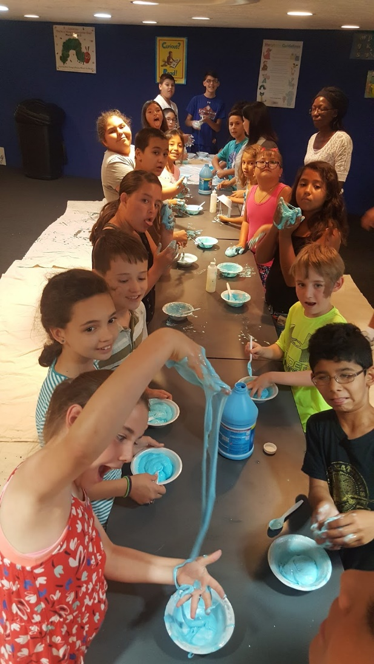

Why is there a new “Tween” subcategory?

We’ve been working as a District to recognize and serve tweens as a unique group with unique needs. Beginning to track tween summer reading figures separately from those of younger children will help us better understand and serve this group. Tween registration numbers were not recorded separately from the general youth numbers in past years, which is why previous entries in this category are marked “NA”.

Why is the “Total Finishers” number this year so low?

In order to promote reading **all** summer we divided the board by month. To finish, patrons would have to return for the final prize during August. We realized that a lower number of finishers would probably result from this decision, but we wanted to encourage a consistent habit of reading – and not have young patrons race to finish the board as soon as possible.

Our finisher rate does not reflect our rate of participation, which was great!

**2,193 participants got at least one prize – 31% of registrants. 1,715 participants got at least two prizes – 24% of registrants.**

In total, participants aged 0-18 read **24,402 books!**

Why is the “Programs” number this year so high?

Several departments and branches offered new and additional programs this summer, including:

* The Lunch at the Library program at Rawlings and Lamb.
* Regular Rawlings teen and tween programs continued over the summer, rather than going on hiatus.
* Discover Tech activities and additional movies in the InfoZone.
* Regular drop-in activities at Giodone, Greenhorn and Rawlings.

**Registration by Library and Age Group:**

|  |  |  |  |  |
| --- | --- | --- | --- | --- |
| **Library** | **Pre-Readers (0-3)** | **Readers**  **(4-12)** | **Tween (Subcategory of Reader – 8-12)** | **Teens**  **(13-18)** |
| *Rawlings* | 331 | 1513 | 829 | 219 |
| *Barkman* | 124 | 580 | 317 | 81 |
| *Lamb* | 72 | 486 | 285 | 99 |
| *Pueblo West* | 132 | 1146 | 559 | 138 |
| *Lucero* | 57 | 393 | 256 | 102 |
| *Giodone & Avondale* | 63 | 787 | 365 | 60 |
| *Greenhorn Valley & Beulah* | 24 | 264 | 133 | 166 |
| *Library at the Y* | 37 | 87 | 45 | 7 |
| *Books in the Park* | 22 | 96 | 53 | 13 |
| **Total** | **862 (-15%)** | **5,352 (+41%)** | **2,842** | **885 (+36%)** |

As in the overview table, tweens are broken out of total youth numbers. Overall, **tweens accounted for about 40% of total registration.**

Why is registration higher this year?

Boosts to registration in the youth and teen category are due to a variety of factors:

* Increased focus on promotional outreach – At the end of last summer, we noticed the connection between promotional outreach and Summer Reading participation, and made a commitment to increase promotional outreach this year. As can be seen below, **outreach numbers overall increased by 41%**, despite a decrease in teen-focused promotional outreach.
* Automatic registration – District 70 and PCCLD worked together to upload **932 registrations**. Each student was then given a copy of the Summer Reading gameboard by their teachers.

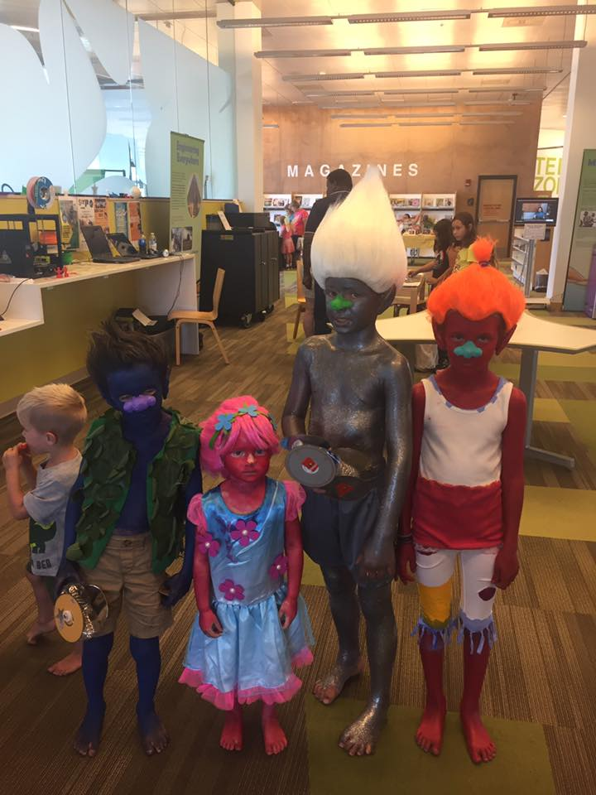

A family of trolls at IDEA Con.

**Program Attendance:**

|  |  |  |
| --- | --- | --- |
|  | **2016** | **2017** |
| **Youth and Tween Promotion** | 15,134 | 23,233 |
| **Youth and Tween Attendance** | 11,875 | 17,091 |
| **Tween Attendance (Subcategory of Youth and Tween)** | NA | 1,767 |
| **Teen Promotion** | 1,821 | 622 |
| **Teen Attendance** | 994 | 879 |

Why is the “Teen Promotion” number lower this year?

Some schools in District 70 did not see a need for us to visit when they were already automatically registering their students. This is something I will talk with D70 administration about next year. Face-to-face contact is very important, and the results of a lack of personal “marketing” can be seen in the slight reduction in teen attendance. (Although teen attendance is still higher than it was in 2015.)

What caused this year’s gains in program attendance?

Overall – **non-promotional program attendance increased by 40% this summer**. This is the result of many factors, including.

* Changes to the summer family program structure. This summer, we offered three program “tracks” to provide different experiences at different locations. **Summer family program attendance increased by 18%**.
* The new Lunch at the Library partnership which took place at Lamb and Rawlings. In partnership with District 60, PCCLD served **4,004** lunches to patrons aged 18 and under at these two locations. Many young patrons reported that they wouldn’t have been able to eat lunch at all without this program.

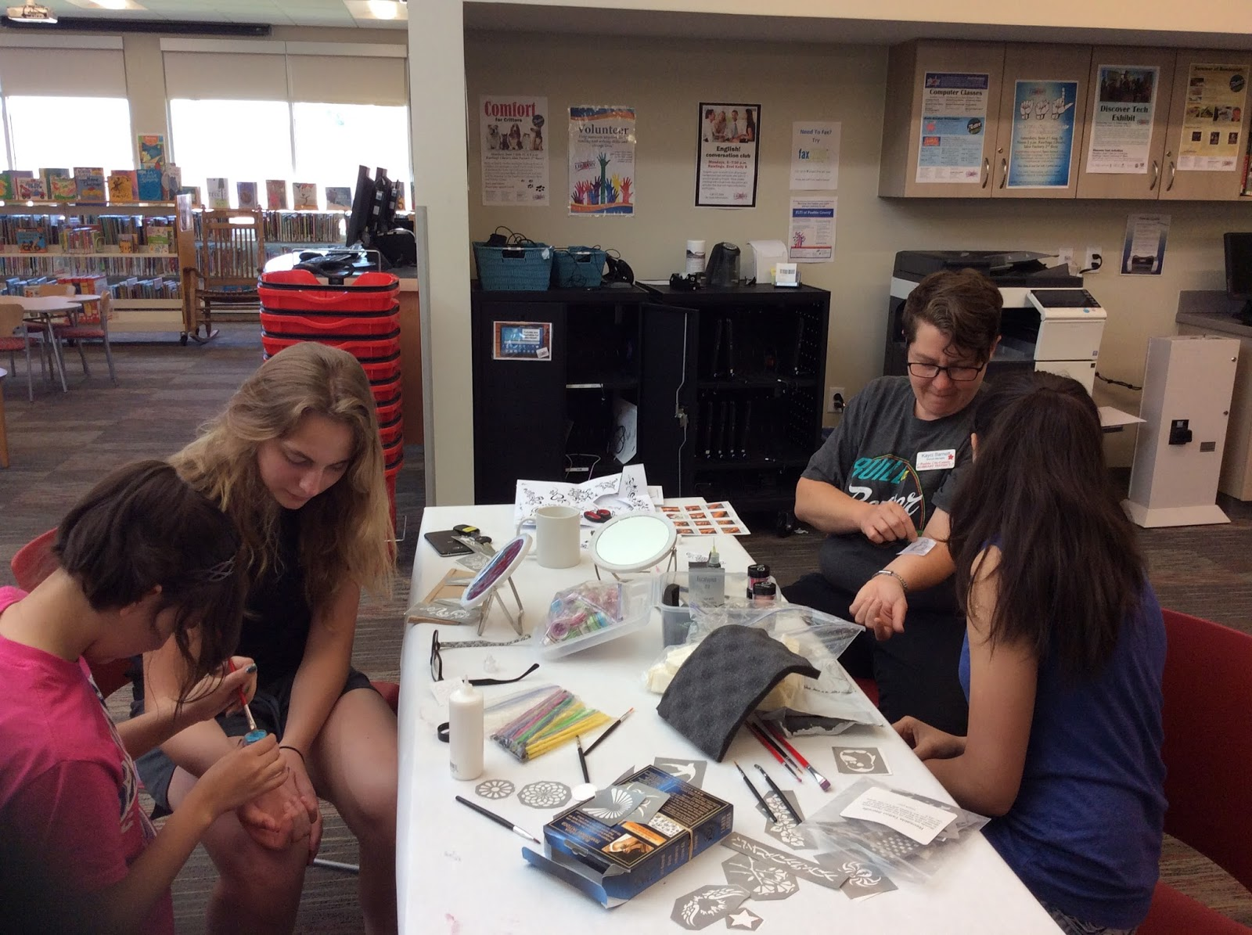

Teens make temporary tattoos at Giodone.

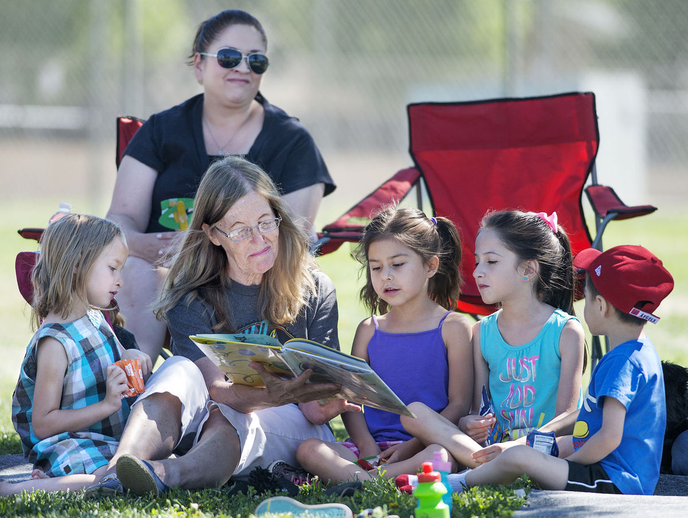

Books in the Park staffer Jean Tucker reads to children at Fairmount Park.

(Photo courtesy of the Pueblo Chieftain)

**Books in the Park:**

Books in the Park had a fantastic year, continuing its trend of growth from 2016.

Total Circulation – 7,450 **(15% increase!)**

Total Visits/Program Attendance – 2,170 **(28% increase!)**

Note that increases in attendance resulted despite reducing Books in the Park to its original schedule of eight weeks, removing four extra days at Bessemer Park.

Why are “Visits” and “Program Attendance” counted as one number?

Last year, we observed that visitors tend to partake in one or more “programs” at Books in Park – storytimes, crafts, etc. – in a freeform way, wandering from one to another. This makes it very difficult to count program attendance separately from visits. Really, all visitors to Books in the Park are participating in a library program, thus these numbers can be easily and safely condensed to one statistic.

Fairmount Park continues to grow, with:

* 914 visits – a 66% increase, and an average of 57 per day.
* 2,942 circulations – a 47% increase, and an average 184 of per day.

Particularly telling was the huge increase in lunches and snacks given out at both locations:

* Snacks – 870 **(363% increase!)**
* Lunches – 1,519 **(113% increase!)**

Like the high participation in the Lunch at the Library program at Lamb and Rawlings, this shows that we are filling a huge need in the community by providing food to children at our programs.

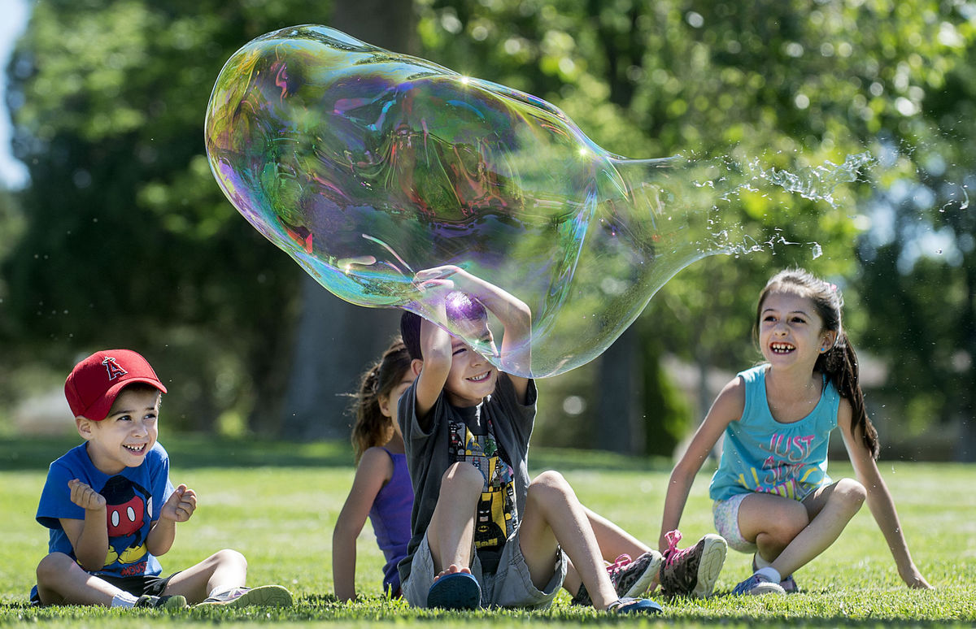

Big bubbles at Books in the Park’s Fairmount kickoff.

(Photo courtesy of the Pueblo Chieftain)

**Grand Prizes**

This year, we gave out 18 teen grand prizes and 6 youth grand prizes. Teen prizes were themed backpacks full of great stuff including books, comic books, journals, art supplies, and candy. Teens loved these prizes, and expressed surprise that they were getting so much.

Youth grand prizes were gift certificates to some of our top coupon donors in the community – a thank you for all that they contributed this year and in the past.

**Takeaways – What worked this year?**

* **Prioritizing outreach visits** – The connection between outreach, registration and program attendance was made even more clear than it was last year.
* **Leveraging partnerships for registration** – District 70’s automatic registration was a huge success. Expanding it to District 60 is top of the list for Summer 2018.
* **Changing the centralized family program structure** – Family program attendance increased, responding well to changes. In Summer 2018, we will consider how to change centralized teen and tween programs to be more customized as well.
* **Increasing the visibility of Summer Reading internally and externally** – We dramatically increased communication about Summer Reading, incorporating staff incentives, staff trivia, public and staff countdowns, and regular public and staff updates.

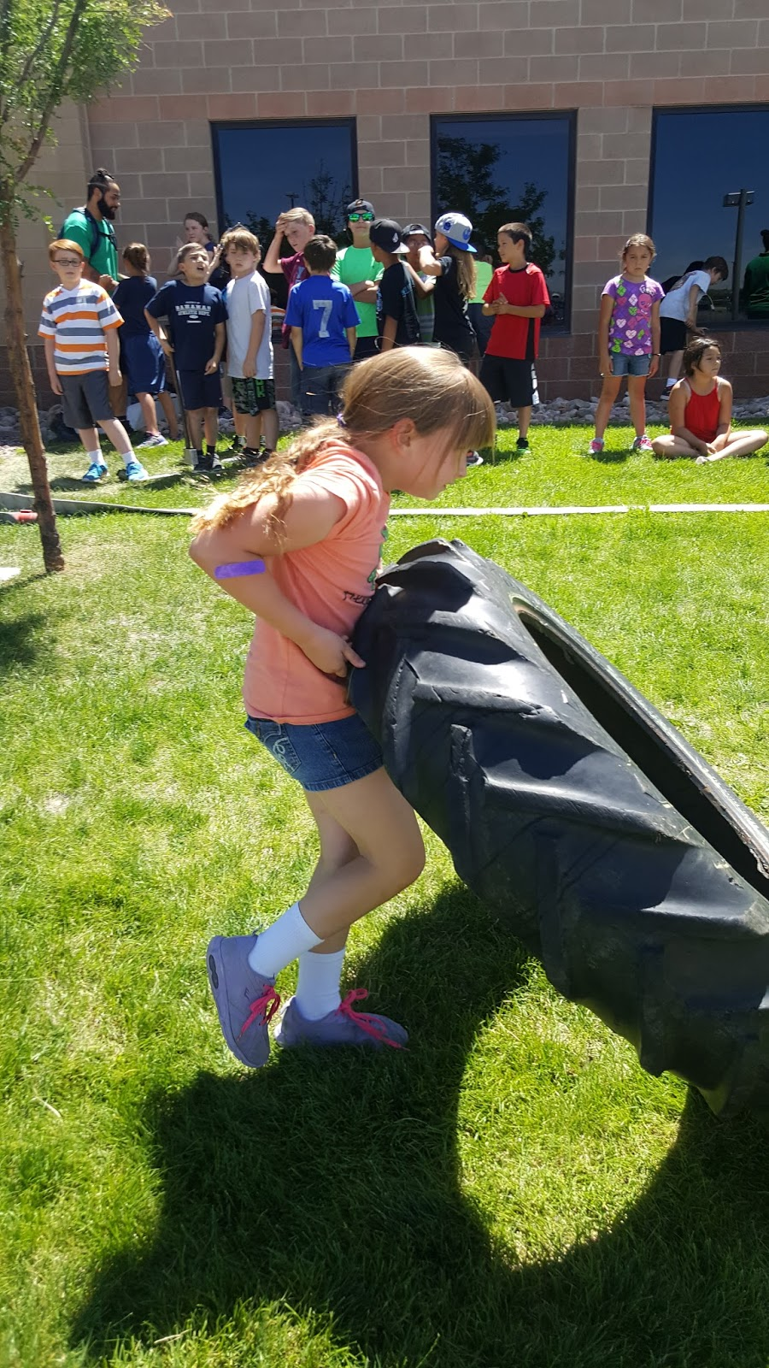

**Summer Game Plan 2018**

* Continue to focus on summer outreach to schools and community events.
  + Staff incentive for outreach.
  + Strongly promote outreach to teens. Seek opportunities within and outside schools to promote to this age group.
* Expand registration partnership to District 60.
* Re-evaluate centralized teen and tween program structure.
  + Consider more customized program structures for these age groups, similar to changes in family program.
* Continue to strongly promote Summer Reading to staff and patrons.
  + Countdowns for public and staff.
  + Summer trivia for staff.
  + Weekly updates.
  + Staff incentives and branch incentives.
  + Explore more ways to connect with patrons – social media, partnerships, physical advertising, etc.

**A Big Thank You To:**

* The Kinder Morgan Foundation for providing a $2,500 grant to fund Summer Reading!
* EPIC and the Friends of the Library, who donated most of the books that we gave away at Books in the Park.
* Janina Goodwin for coordinating the Lunch at the Library program.
* Districts 60 and 70.
* The Pueblo YMCA.
* Pueblo Parks and Recreation.
* All our community coupon donors.
* Everyone who worked to make Summer Reading a success!