Responding to an Unresponsive Person

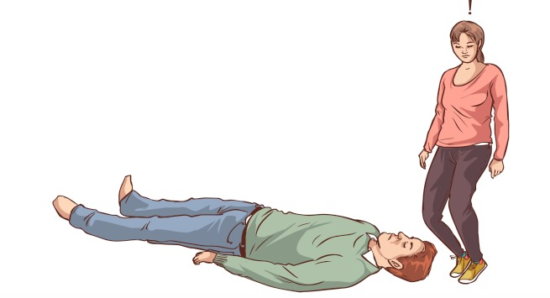

**If you encounter a person that appears to be unconscious follow these steps:**

1. Quickly approach the person as you try signal for another staff member to join you (if possible).
2. Speaking loudly in close proximity to the patron ask if they are OK: *“Sir! Are you alright?”*
3. If no response, repeat, “Sir, wake up! Are you alright?”
4. If no response, call 911 immediately. One staff member should stay with the patron while the other calls 911. You can also yell out to a co-worker to call 911 if you are alone.
5. The caller should focus their attention on the conversation with the 911 operator. Begin by concisely stating your name, location and the nature of the emergency: “My name is Sally Jones, I am a library employee. We have an unresponsive person at the Rawlings Library, 100 E. Abriendo in Pueblo. They are on the 2nd floor.” Let them know if the person is not breathing or other critical factors if possible. Listen, take direction and answer the 911 operator’s questions. Do not engage in conversations with others while talking to 911.
6. The employee with the unconscious person should stay calm and instruct others to move away from the area to allow space for the first responders to arrive.

Note:

If the person vomits or there is a bio-hazard involved, rope off the area and contact Facilities to safely clean the area.

If there is a medically trained person on the scene such as a nurse or doctor and the patron appears to be in eminent danger, it is OK to allow them to perform CPR or other first aid that is critically needed.