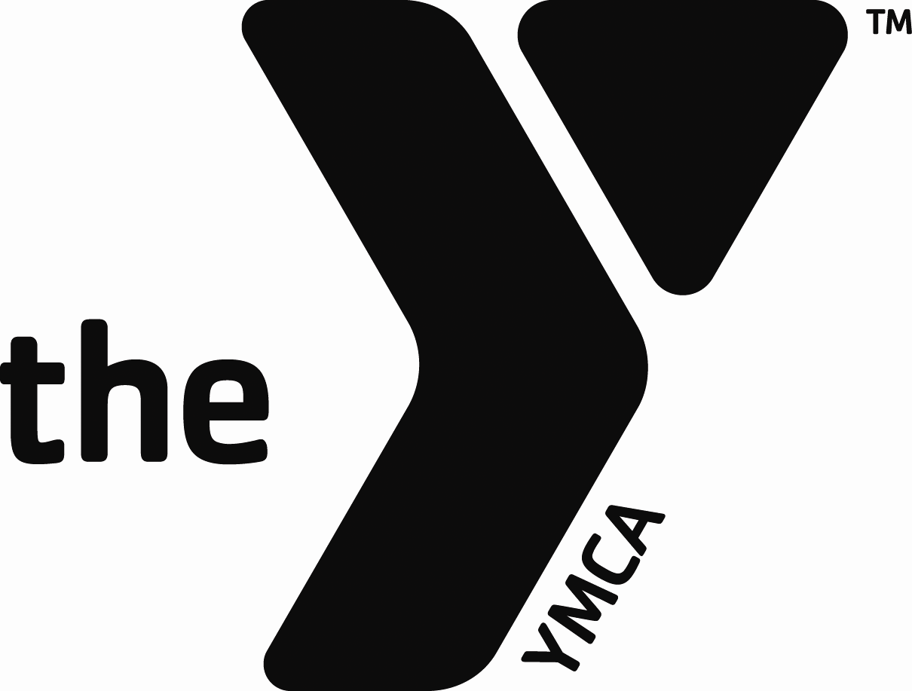
2018 YMCA Corporate Cup - Individual Registration & Waiver Form

First Name ___________________________ Last Name _______________________________________
Home Address _____________________________________________________________________________
City _____________________________________ State __________________ Zip _______________
Phone (Day) __________________________ Evening _________________________________________
Email ____________________________________________________________ Sex (circle) M / F
Date of Birth ___________ Age (on 9/10/18) _______ Shirt Size (circle) S M L XL XXL 3XL 4XL
Company Name ______________________________ Dept __________________ Shift _______________

Select Events
Event Limits: Division 1 – 7 events Division 2 – 6 events Division 3 – 5 events
Note: Not all events count toward your event limit. See lists below.
See the website www.puebloymca.org for event details and all rules

Events COUNTING toward Event Limit Events NOT COUNTING toward Event Limit
_____ Kickball _____ Event Worker
_____ Bowling _____ 5K Predict Run/Walk – Predicted Time:__________
_____ Golf (time limit is 2 hours) hh:mm:ss
_____ Softball _____ Basketball Shoot – Score Predict _______________
_____ Team Challenges _____ Bike Predict – Predicted Time: ____________
_____ Tug of War (time limit is 2 hours) hh:mm:ss
_____ Volleyball _____ Duathlon (automatic entry if in both 5K & bike)
_____ Executive Challenge _____ Soccer Kick
_____Dodgeball _____ Togetherhood (Service Project Event)
_____ Disc Golf _____ Mile _____Run or _____Walk
_____ Corn Hole _____Climbing

Waiver of Rights Agreement: In consideration of this entry being accepted, I, for myself, my heirs, executors, administrators, assigns, and personal representatives forever waive and release all rights and claims for damages I may have against YMCA of Pueblo and all other sponsors, their agents, representatives, servants, employees, successors, and assigns arising out of my participation in the Corporate Cup event. I further agree, now and forever, to hold the above parties harmless and indemnify them for all claims, damages, judgments, costs, and reasonable attorney’s fees should they be held liable for any damages, personal injury, or death I may sustain or claims rising out of this event, including those which may be attributable to weather conditions, a course that may have pot holes, sand or gravel present, and the possibility of drowning in the pool or slipping on a wet pool deck. I acknowledge that I am in good health and I am capable of participating in the Corporate Cup Event and that any and all of my questions have been satisfactorily answered. Further, I hereby grant full permission to any and all of the foregoing to use my name, photographs, video tapes, motion pictures, recordings, and any other record of me participating in this event for any publicity. I have read the entry information provided and certify my compliance with my signature below.
Participant Signature ________________________________________________ Date ___________________
OFFICE USE ONLY: Input by _____________________________________________ Date _____________

