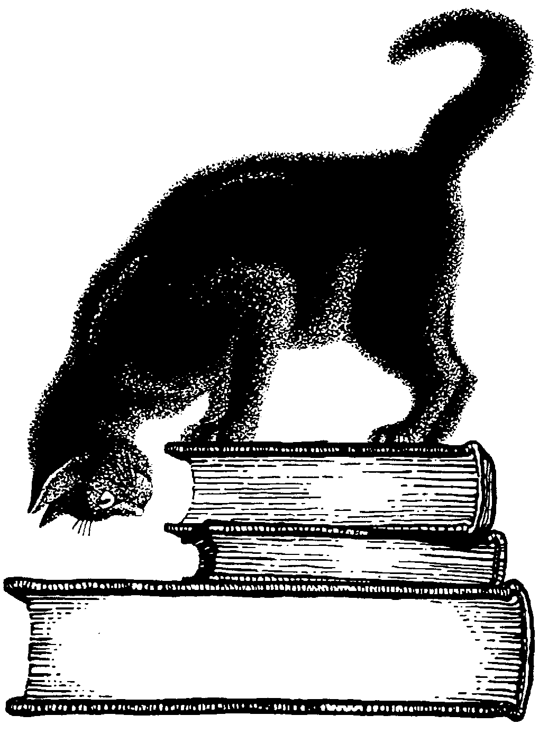
FRIENDS OF THE PUEBLO CITY-COUNTY LIBRARY
2015 FRIENDS SCHOLARSHIP PROGRAM APPLICATION

Name: ____________________________________ Date: _____________
Department: _____________________ Title: ________________________
Procedure:
- Complete Friends Scholarship Program Application.
- Write a short essay expressing interest in a library career.
- Forward both to Human Resources by January 15, 2015.
Eligibility Requirements:
- Must be employed by Pueblo City-County Library District
- Must be enrolled in an ALA-accredited Library Science Master’s program or submit a letter of acceptance prior to funding.
Educational Institution: _____________________________________________
Start Date: ___________________________________ Tuition Cost: ________
Description: _______________________________________________________
(Attach course syllabus, class schedule or class description.)
Estimated Number of Credit Hours to complete in 2015: _________________
Employee Signature: ________________________________ Date: _________

(For office use only)
□ Scholarship Awarded □ Scholarship Declined
Reason for Decline: ___________________________________________________________

Friends Board Member: ________________________________________________________

Director Human Resources: _____________________________________________________

Executive Director: ____________________________________________________________

