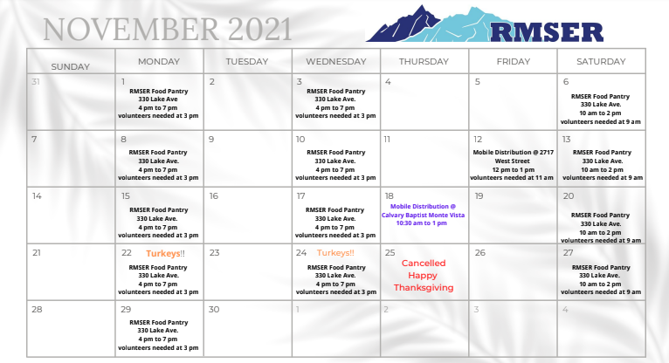

Please share the **RMSER**food access calendar with your contacts and networks.

•  all are welcome to attend •  No ID needed •  No income verification •  you can pick up for family members/coworkers/clients/neighbors •  ***handing out turkeys on November 22nd and November 24th!!!***