**DO YOU KNOW QUACK !!!**

**SEE WHAT’S NEW WITH THE DUCK THIS YEAR!!!**

****************************************************************************************************

Open Enrollment Meetings:

Rawlings, Thurston Room - Wednesday – November 5th from 11:00-12:00

Pueblo West Branch - Tuesday- November 18th from 11:00-12:00

****Please feel free to contact our AFLAC Rep Becky Sneddon @ (719) 671-5259

to schedule an individual appointment if you cannot make the meetings!

AFLAC is NOT health insurance…..we pay cash over and above any other coverage you may have…..AFLAC will NEVER raise your rates and cannot cancel you because of too many claims….MOST importantly….AFLAC pays claims within 7-10 days!

**\*\*\*Guaranteed Issue SHORT TERM DISABILITY (covers pre-ex after 1 year);  Protect your INCOME in the event of accident or sickness; covers maternity leave as well!**

**\*\*\*\* Cancer Plan – Everyone between the ages of 18-75 get the SAME RATE. Kids are FREE to age 26! Policy Pays lump sum benefit upon initial diagnosis of Cancer; wellness benefits payable for cancer screenings; pays for treatments; hospitalization, transportation, etc.**

**\*\*\* NEW Hospital Advantage Plans**! Many of us are experiencing HIGHER out-of-pocket expenses with our health plan…Let AFLAC **HELP** pay your “out-of-pocket” expenses in the event of **hospitalization**, office and diagnostic test co-pays, s**urgeries** plus more. **Covers accident or sickness!**

**24 hour Accident Plan (which the Duck himself is using….as we speak!) Pays on and off-the-job; 1st visit benefit of $120, follow-up exams; surgical benefit, ambulance, physical therapy; transportation; accidental death and much more!**

**Dental and Vision also available!**

[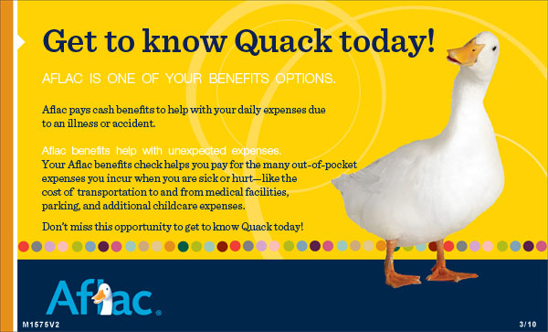](https://asc3.aflac.com/AssociateServices/eNewsLetter/accountemails/Get_To_Know_Quack_Today.jpg)