**Facilities Work Orders (Ryals & IZ)**

**Facilities Requests Template**

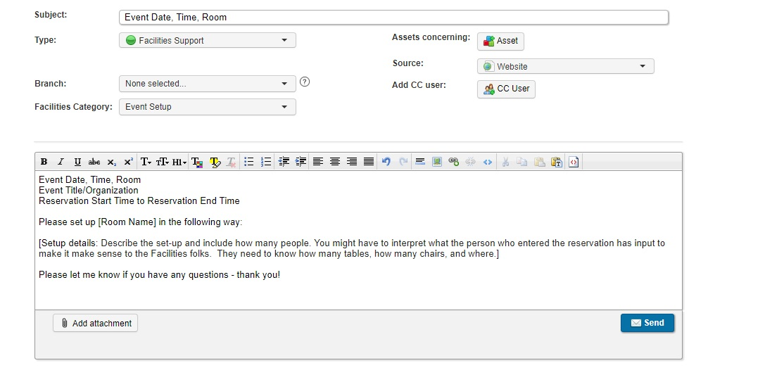

**Set-Up Styles & Furniture**

|  |  |
| --- | --- |
| **Style/Event Type** | **Set up** |
| Banquet (30) | 5 Tables 6 Chairs |
| Banquet (50) | 8 tables 50 chairs |
| Classroom | Rows of rectangular tables with chairs; More tables, less chairs |
| Dinner (Banquet) | More chairs, less tables |
| Summer Reading | Open space for floor seating plus 25-50 chairs (2-3 rows) along the back wall. |
| IZ Default | 50 chairs theater style |

Format Example: Please set up 65 chairs theater style and 4 rectangle tables along the back wall.

|  |  |
| --- | --- |
| **Furniture (4th Floor)** | |
| Round Tables | 20 |
| Rectangle Tables | 24 |
| Chairs | 200 |