  

**PCCLD Customer Service Counts Program**

**Congratulations to the drawn Customer Service Counts winners for the month of April!**

**Carol Perea of Reference and Readers Advisory,** will receive the ***Gardening Basket.***

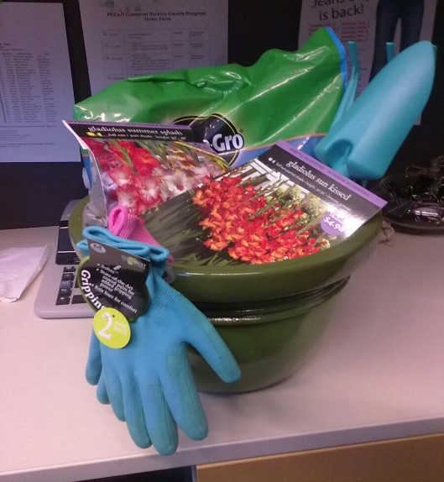

**Gardening Basket**: This includes a Flower pot, Potting soil, Gladiolus bulbs, Gardening gloves and Gardening tools.

Hats off to the **Barkman Branch and Lamb Branch**! All team members were awarded at least one star in the month of **April**….Wonderful job!

***About the Customer Service Counts Program:*** *T*he recognition cards we received were completed by both PCCLD employees and the general public. Everyone that received recognition will receive a “star” for their lanyard and HR will record 1 pt per star. Employees may trade in their points for gifts twice a year. Recognition points will also be tracked by Department, with awards presented twice each year. Recognition comment cards have been posted on the O drive under Human Resources / Customer Service Counts for all to view. For more information visit the “O” Drive /Human Resources/ Customer Service Counts.