From [www.pueblolibrary.org](http://www.pueblolibrary.org)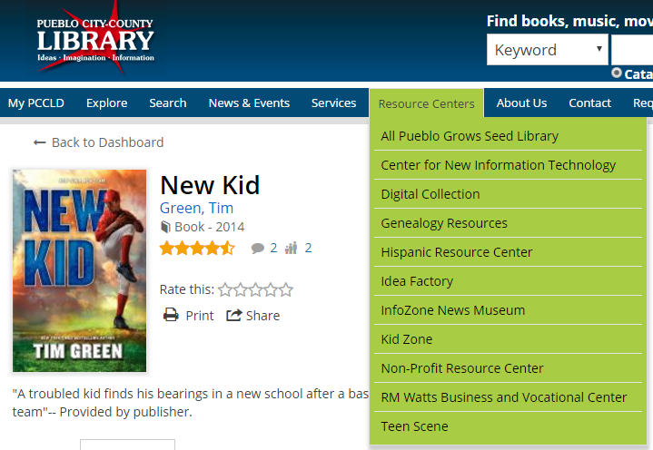

Highlight Resource Centers Tab

-Choose Kid Zone

**Choose AR Books**

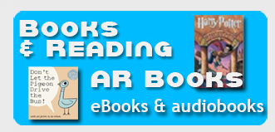

Choose Librarian Button and Submit

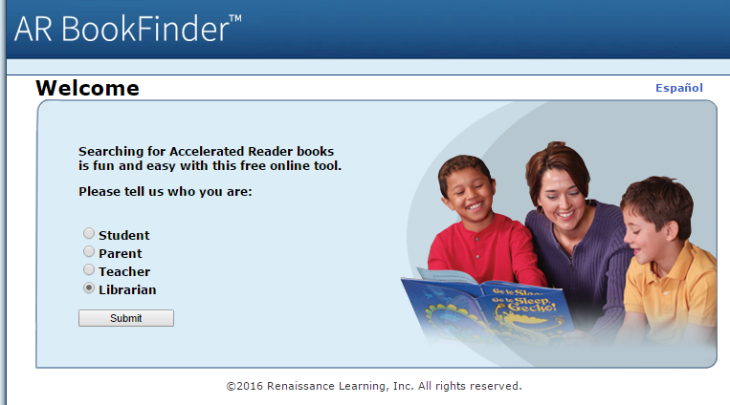

**Scan the book’s manufacturer’s Barcode** (not PCCLD’s)

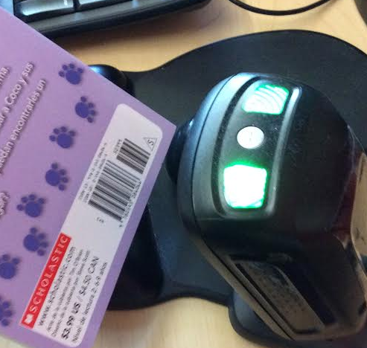

If it’s an AR book the BL(book level),

and how many Pts (points) the test is worth will display.

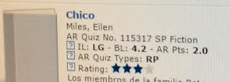

Place the AR spine label on the book without covering other spine labels.

This book would get the sticker 4.0-4.9.

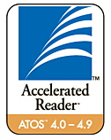

Then create a tag in Bibliocommons

Log into Bibliocommons

Search for item

Click on the Title of the item

Scroll down and look on the right side of screen until you see Tags and click Add

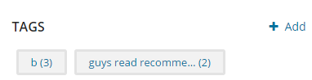

Use the format “ar4.0-4.9” (or whatever level the sticker says) and SAVE

