Request Toolbar

Where does the request come from? A library customer can log into PCCLD website go click on my account and access the following screen. 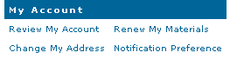

- Click Requests on the Workflow toolbar. Figure One – Step One
- Click on Display Request wizard. Figure One – Step Two
- Choose the User Request”All” option. Figure One – Step Three
- Click on Search
- The screen that appears contains the following: Figure One – Step Four
  - Those with CHANGEADDR are address changes.
  - Those with NOTIFY PREF are informing you of their preference to receive notices.
  - Any others are to be forwarded to the proper department.
- Double Click on the request ID you are working on. Figure Two
- Highlight the Users ID.
- Edit –Copy.
- Click Circulation on the Workflow toolbar. Figure Three – Step One
- Click on Modify User Wizard. Figure Two – Step Two
- Edit –Paste into User ID. Figure Two – Step Three
- The Window menu allows you to arrange windows in a way that makes it easy to display all open windows. You can cascade the windows so you can cross reference. Be sure that only those windows you want to arrange are open. Close or minimize those windows you do not want to display.
- Modify the request and if possible reply.
- Click on Remove Request wizard and delete the message. Figure One – Step 6

Figure 1.
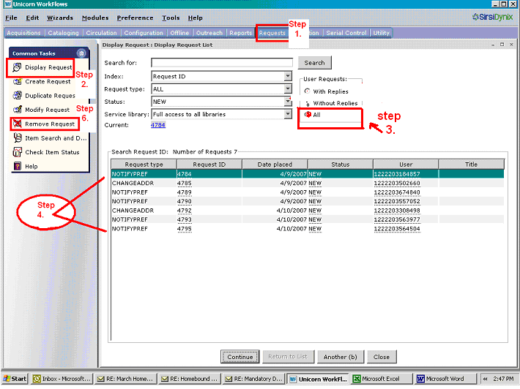

Figure 2.
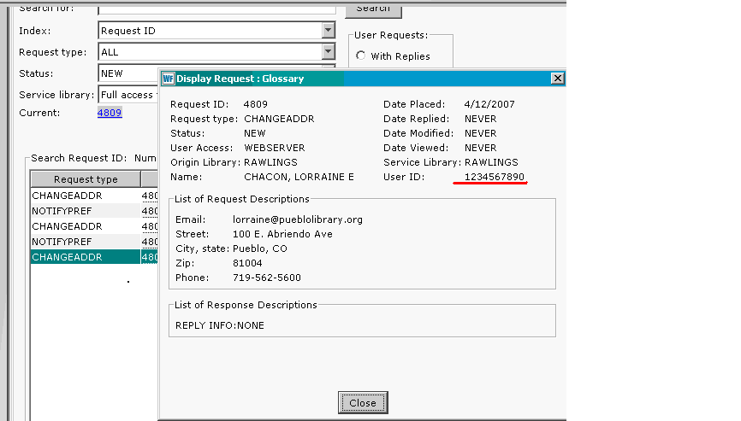

Figure 3.

