Process for accepting a replacement item

If a patron has a lost or damaged item they can replace the item in lieu of paying for the item. Books must be in good, new or like new, condition with no markings from other libraries or personal markings, and be the same type. Hard back books must be replaced with hard back books, paper back with paper back. You can look up the ISBN in the item record to give to the patron so they get the correct type of book if needed. DVD’s and music CD’s must be new and unopened to be accepted as replacements.

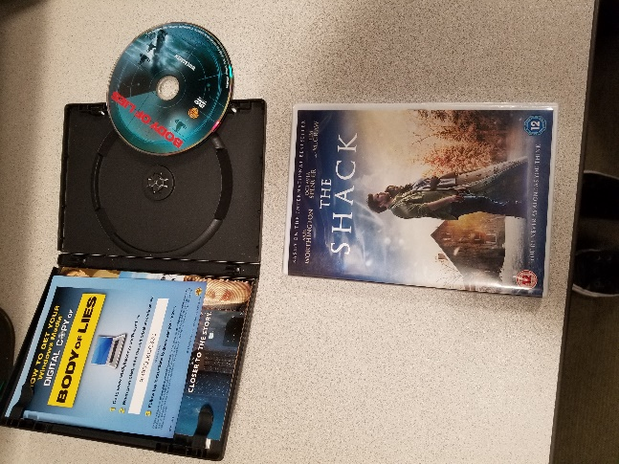 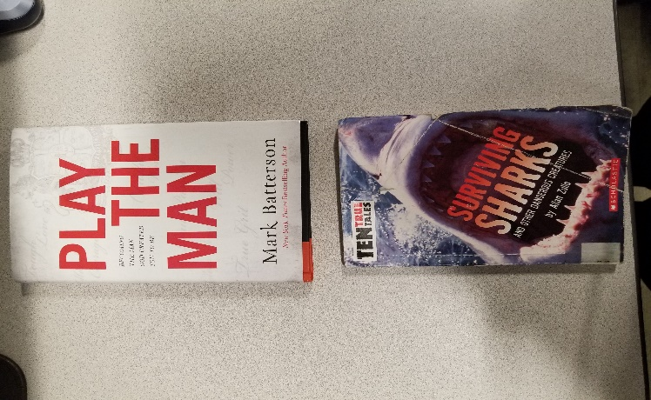 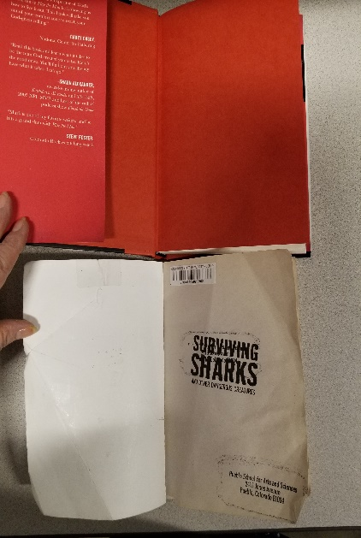

1. When a patron brings in a replacement item, and it meets the specifications for a replacement, you will print out a summary of the patron’s account so that you have the item number so that you can fill out the Replacement Item form.

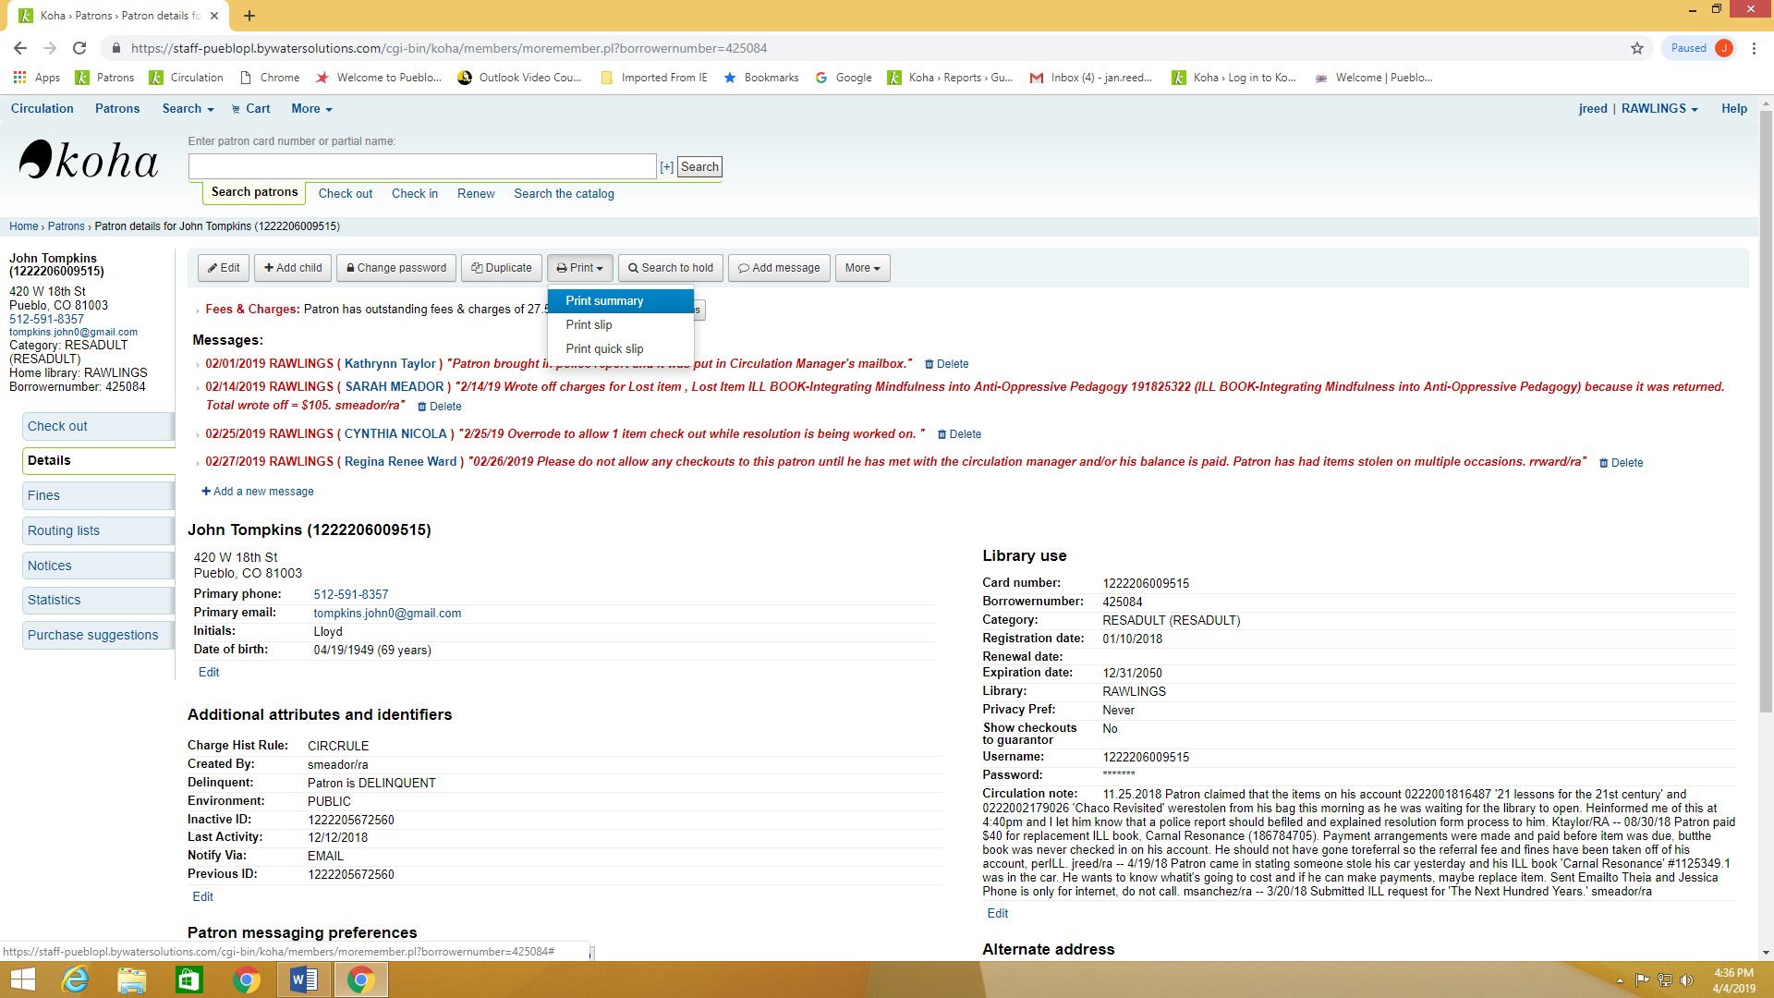 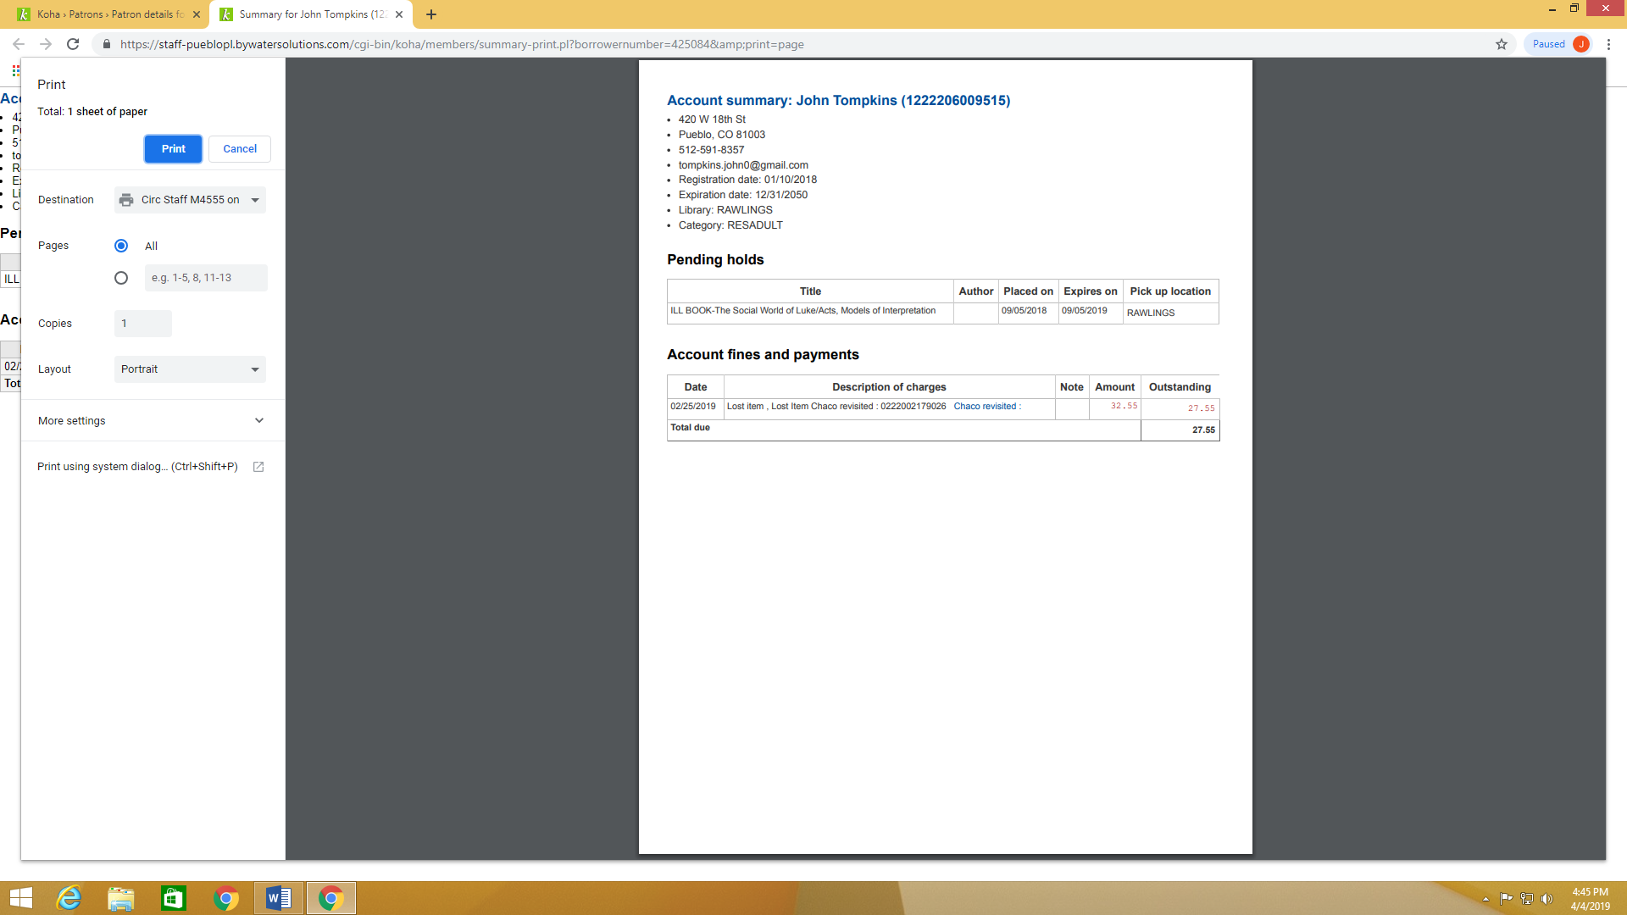

1. Next, you will check in the item from the patron’s account (Note: Be sure to follow step 1 and get the item number before checking the item in). If the patron has overdue fines let them know, and make sure the item in checked in from the account. If you are able complete the replacement item process right away. If not put your summary printout with the item number aside to complete when off desk.
2. To process the replacement item go to the portal and look in Documents. Type Replacement Items in the Search box.

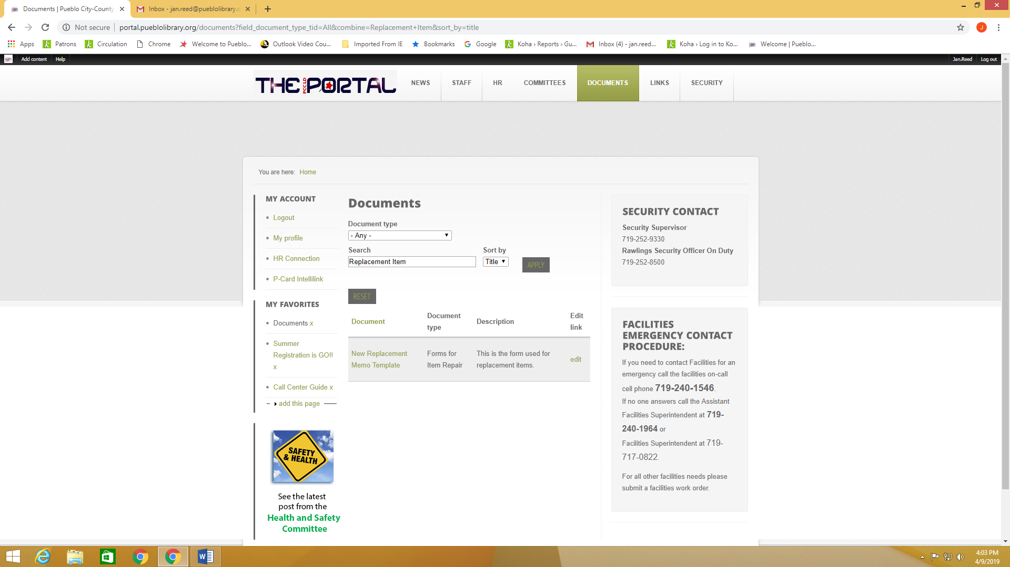

1. Click on the link and open the New Replacement Memo Template.

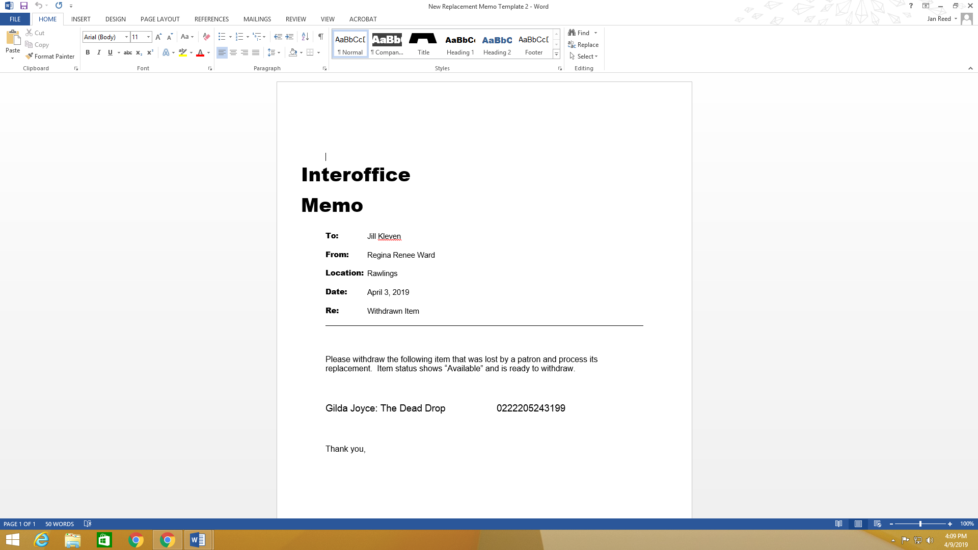

1. Once the memo is open then at the top of the page you will change the Location so that it reflects the location you are sending the item from. Change the date to the current date.



1. Next, you will replace the title that is on the memo with the title of the item you are sending. You will then put in the number of the item that is being replaced. This is the number that is on the record summary you printed out before checking the item in from the patron’s account.



1. Next you will print out the memo with the correct information and wrap it around the item and secure with a rubber band. When you close the memo document save the current info and it can be changed next time a replacement item is done.

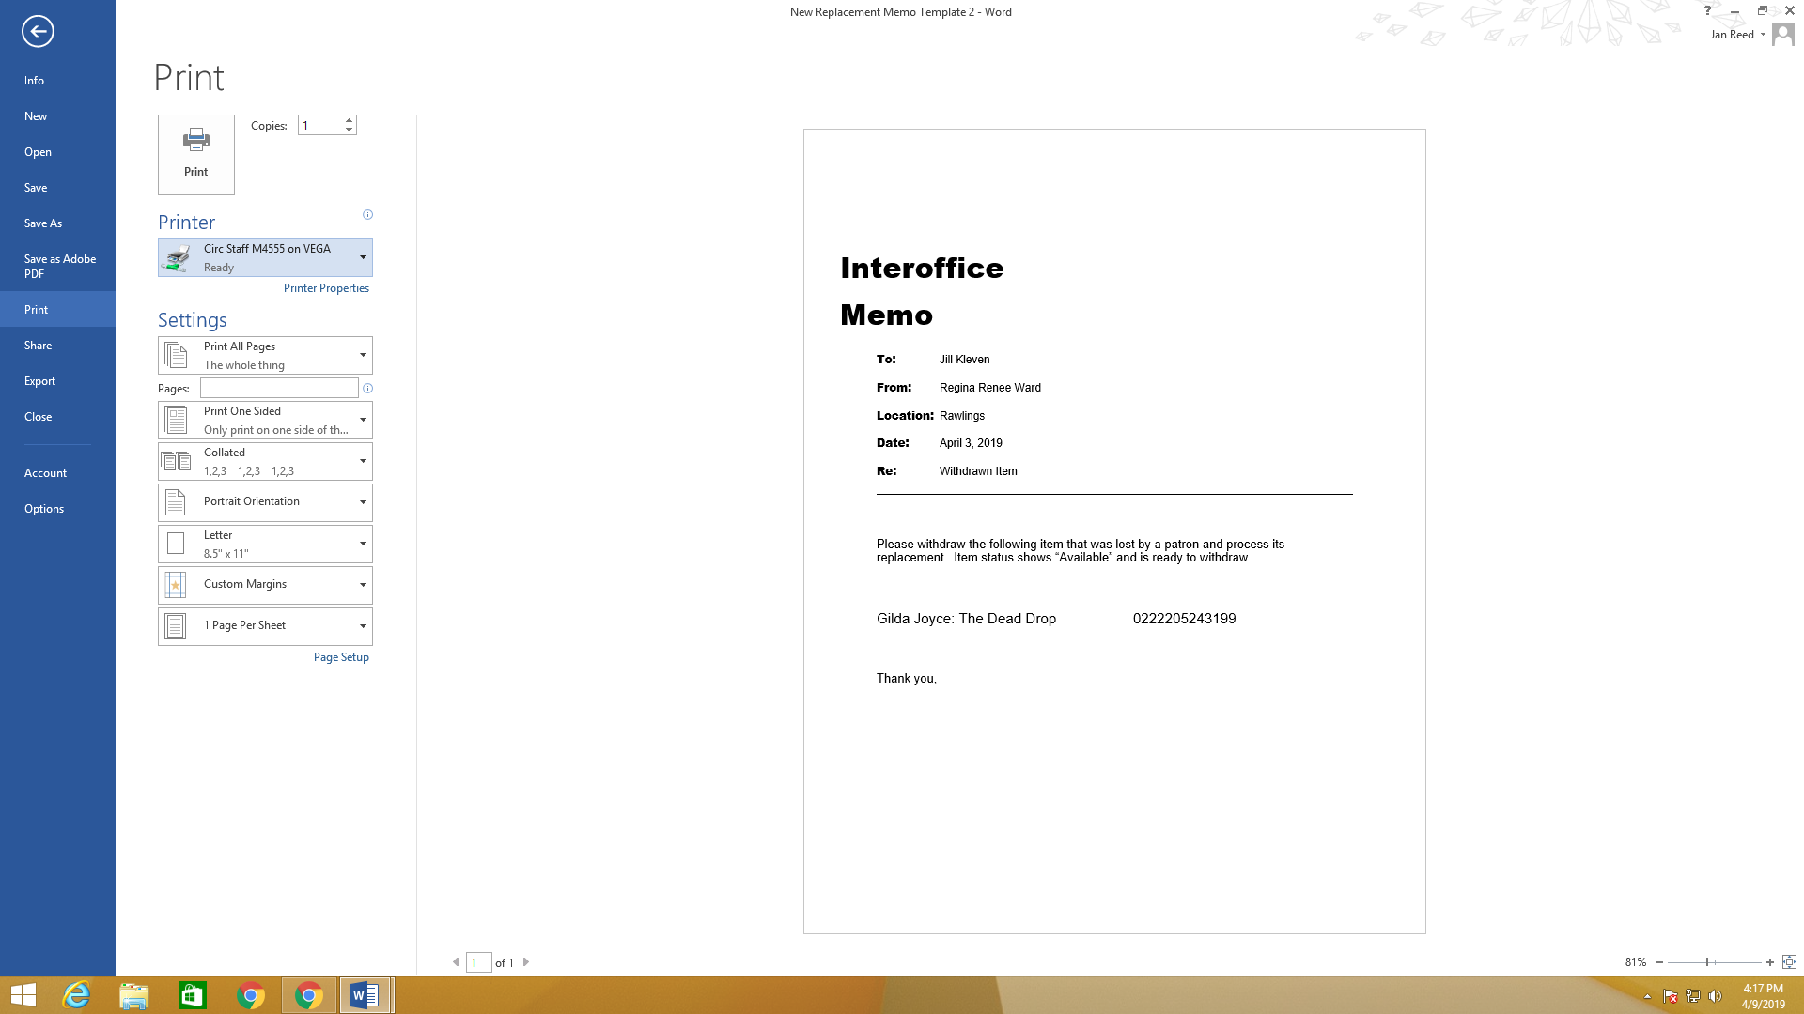

1. Last of all send the item to Technical Services. If from a branch put it in a Rawling tote for routing. If you are at Rawling then put the item on the Technical Services shelf in Circulation.