**CIRCULATION TASKS INSTRUCTIONS**

**Circulation Supplies:** *Marlene*

The supplies list is updated by categories. Items that are placed for ordering are items that we are currently using. This list will be used to keep inventory and to order supplies. Most items ordered are from Gobins. Although some items are not available through Gobins, those items are listed underneath the Gobins Supply List.

The Inventory List will include items that are not on the Supply List. We have some items that are extra from previous orders.

If there is anything someone needs to order that is *not* on the Supply List, this can easily be added. Please let Marlene know if we are running low on any items and she will place an order. After filling out the order form, please make a copy, place the copy in the *Order Supply Black Note Book* and send the original to Kayci. Kayci will then place the order. When the shipment of items comes in, be sure to mark off the items on the packing slip, just to make sure all the items have been delivered and give the packing slip to Kayci.

**Lost & Found:**  *Marlene & Monica*

When items are put in Lost & Found, put that days date on each item. All items that have been in the Lost & found for 1 month will be pulled and either thrown away or donated. *There are 2 Lost & Found totes*. The *1st tote* has been marked for small items. There is a smaller box in that tote where keys and other small items are placed so that they don’t get lost in the tote. The books and videos are placed with the titles upward so that when we are looking for titles, they are easier to find. Items that have patron names please attempt to contact the patron whom it belongs to. Also, place a message on the note field of the patron’s account. When or if items are claimed by patron or discarded, erase note in note field on their account. *Erasing the note on the note field is very important when there is a claimed item or when discarding items.*

The *2nd tote* is for bigger items such as back packs and clothing. Again, everything gets dated and discarded after 1 month. Items that have patron’s, names place a note in the note field on the patrons account, and be sure to erase note in note field when patron comes to claim item or if item is discarded.

When perishable items are received, do not keep them any longer than 1 week, and then please throw away.

Any items that are of great value, for instance, wallets with money or credit cards; or, rings, watches, are placed in the safe.

When people come to claim their items of great value, such as phones, wallets, etc, **it is important to ask for ID to make sure it belongs to that individual.**

**Address Verification** *Jan*

When doing address verifications gather all of the returned mail and take them out of the envelopes. Take the letters out of the envelopes and check to see if the yellow return labels have an address that can be changed on the customer’s account.

The next step is to look up the accounts by account number or by name if the account number is not on the letter. After opening the account verify that it is the account that is needed by matching up name and address, then proceed to the extended info tab and click in the note field. If the note field is full then open a new note field by clicking on the insert field icon located in the center of the three icons above the left corner of the extended info fields. Once a new field is inserted open up the window on the left and pick on note from the choices offered.

Once this is done, click in the note field and put the date and notate with “Verify address due to returned notices”. If noted on the letter notates to verify phone number as well, followed by my first initial and last name, slash and “ra” for Rawlings library.

Last of all save the information to the account and proceed through each letter until finished. Try to do this at least three times a week or once every shift if possible.

**New User Registration Guidelines** *Angelica*

1. Query the person’s last name and first initial(s), to determine if they already have an account. Do NOT type the whole first name as this limits the number of results and could cause you to enter a duplicate account. You may need to investigate several accounts, looking at DOB to determine if an individual is already in our system.
2. If the customer does not have an account, give the customer the appropriate application, and ask them to fill it out.
3. Click the User Registration Wizard, and scan the barcode of the new card.
4. On the Basic Info Tab, enter:

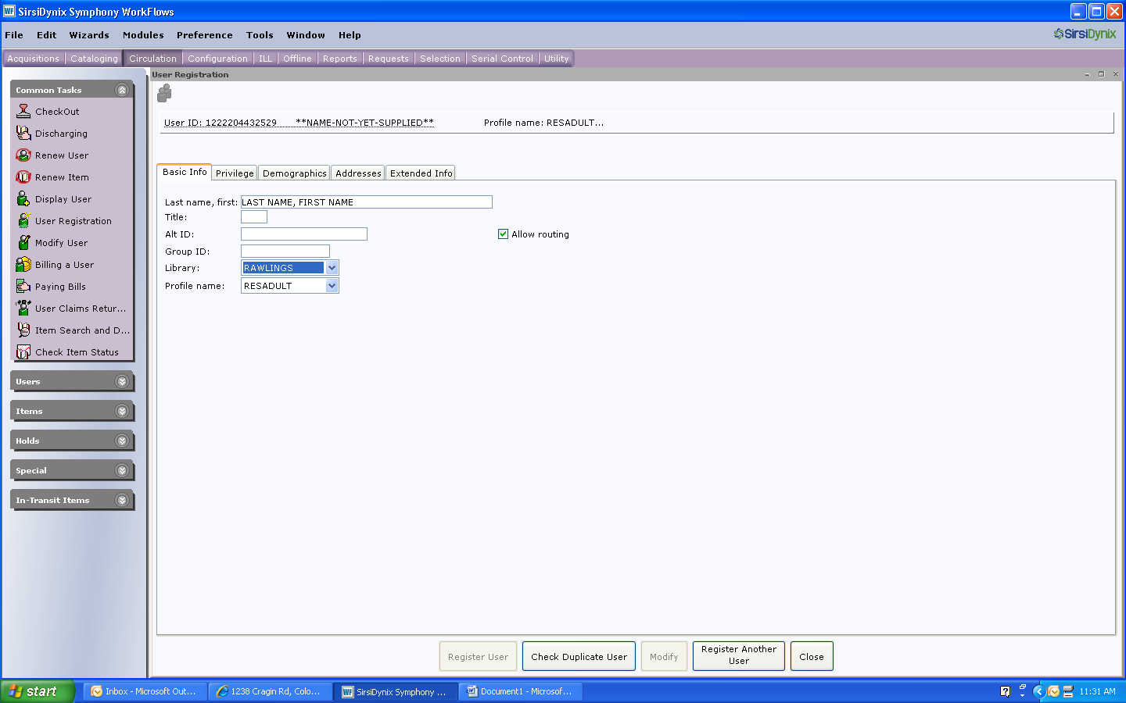

* Enter the customer’s last name, a comma, the customer’s first name, a space and the customer’s FULL MIDDLE NAME. Enter a suffix, AFTER the middle name. No additional punctuation. (Ex: SMITH, JOHN JR or DOE, JOHN III)
* Always use all capital letters (except for the email address)
* Do not use any other punctuation besides the comma between first and last name
* Choose the Library (should default to Rawlings)
* Select the appropriate profile
  + Resident Adult – person over 18 with proof of address
  + Resident Minor – person under 18 with proof of address (from parent/guardian)
  + Unverified Adult – person over 18 without proof of address
  + Unverified Minor – person under 18 without proof of address
  + Special

1. On the Privilege Tab enter:

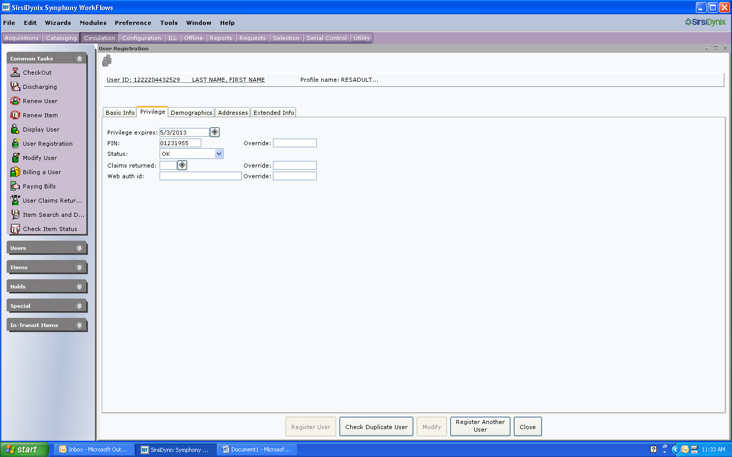

* Enter the privilege that corresponds to the customer’s profile (30 days for unverified and 3 years for verified). Be sure to check that the privilege is correct, as selecting unverified does not always change the expiration date to 30 days.
* Enter the full eight digit birth date, with no spaces or dashes, for the PIN
* Enter the override to change the PIN

1. On the Demographics Tab, enter: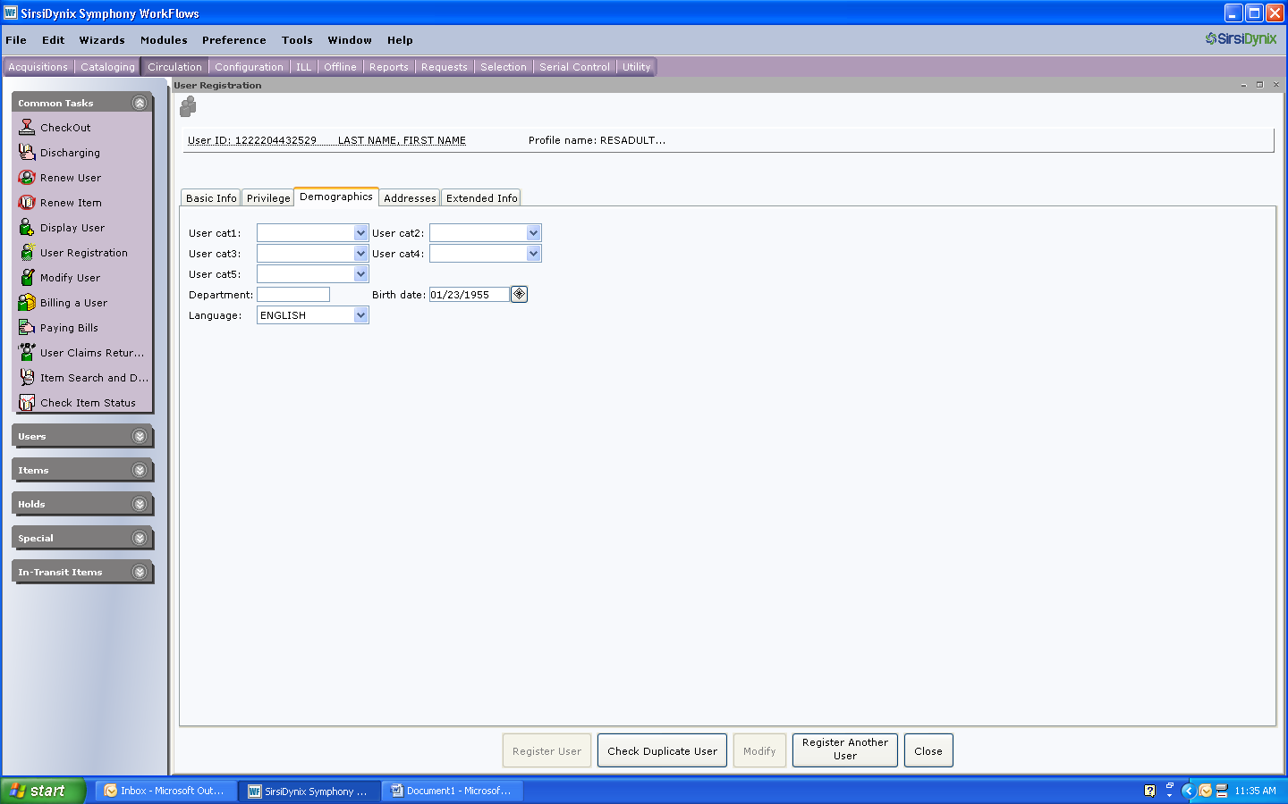

* The customer’s date of birth

1. On the addresses tab, enter

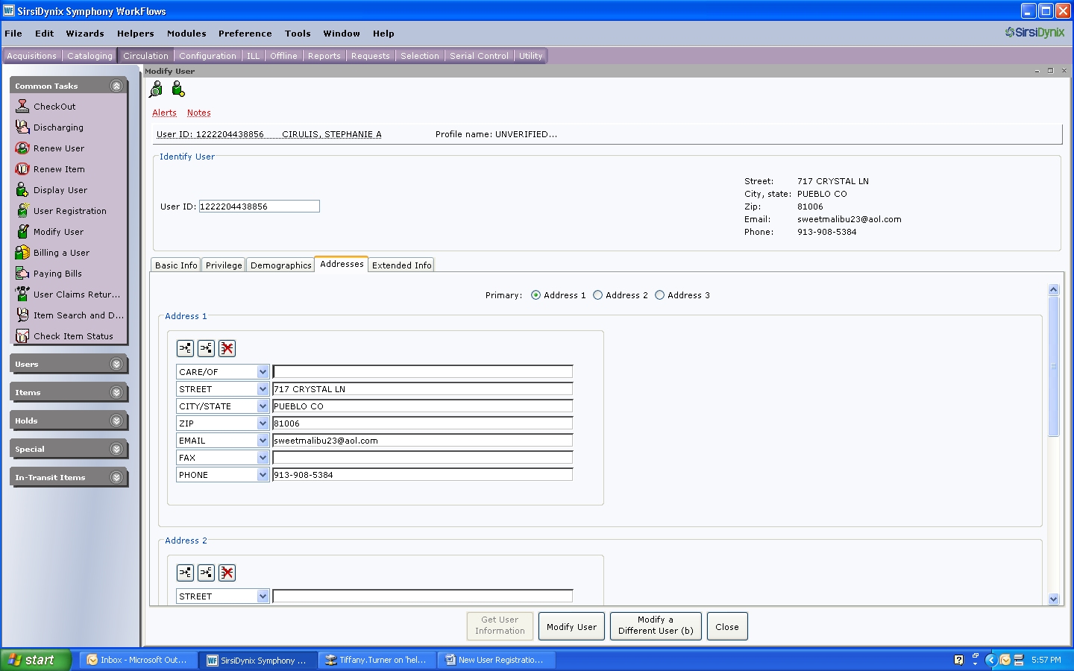

* The customer’s street address
* Do not use symbols (ex: #) or punctuation (ex: APT. or P.O.)
* No punctuation
* Use CO (the postal service abbreviation) for Colorado
* Enter the email address in lower case letters
* Enter the phone number, including the area code

1. On the Extended Info tab, enter:
2. 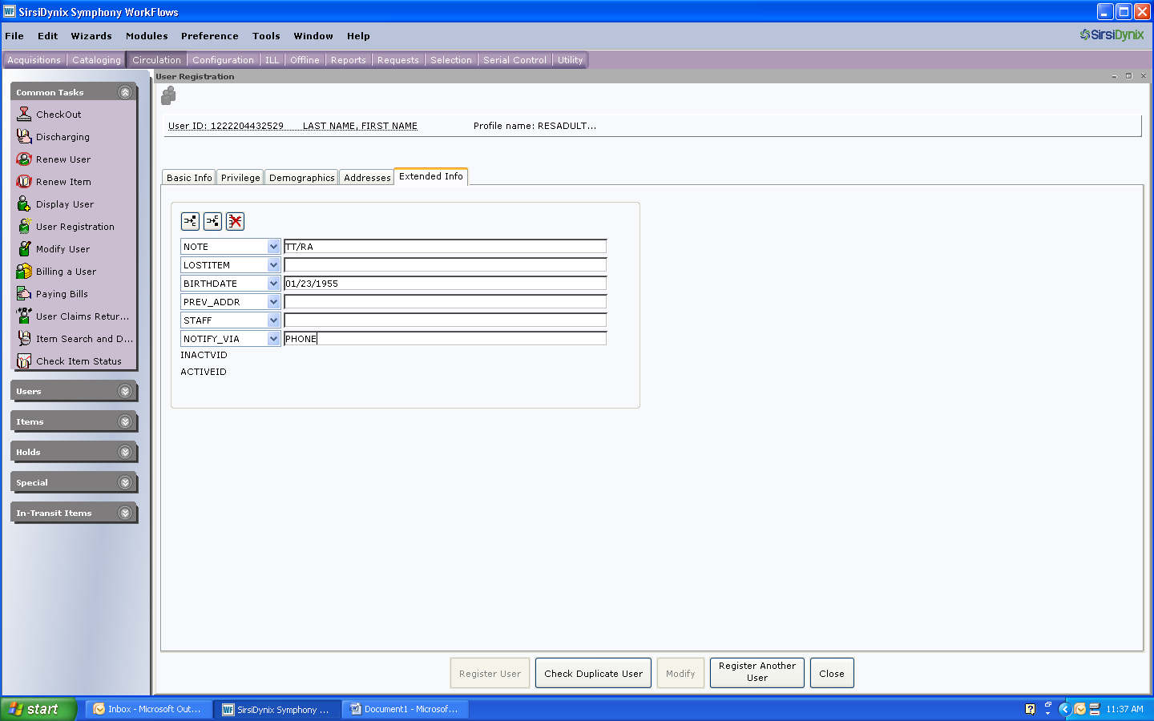

* Your initials and location in the first note line
* The customer’s date of birth
* The customer’s notification preference (PHONE, PAPER or EMAIL)

1. Check duplicate User
2. Register User

**Bankruptcies** *Jan*

*(This is a project that is still evolving so things may need to change as we get more accounts that are in bankruptcy.)*

There is a notebook for Bankruptcies. It is divided into 4 separate sections. These sections being:

Section 1

Discharged- Accounts that have gone through bankruptcy and have had their Debts Discharged. We are court ordered to forgive the charges on these accounts. We receive a letter from the United States Bankruptcy Court or we can receive a monthly report from Unique Management with accounts that have had their debt discharged.

Section 2

Notices- Accounts that we have received a letter from the United States Bankruptcy Court stating that a debtor has filed for bankruptcy. This is NOT a Discharge of Debt notice. We also receive a monthly report from Unique Management that shows us a list of our patron’s that have filed for bankruptcy. We may or may not have received a letter from the court for these patrons.

Section 3

Dismissed- Accounts that the bankruptcy court has dismissed and their debt is NOT forgiven. We may or may not receive a letter from the bankruptcy court to state that debt was not forgiven. We do receive a monthly report from Unique Management that gives us a list of our patrons that have had their bankruptcy dismissed. We do not forgive any fines on these accounts.

Section 4

Fines forgiven or cancelled but not court ordered- Accounts in this section have had their debt forgiven or cancelled but it we never received any confirmation that their debt was discharged by the court. These were done before I took over and started to organize these different letters and reports into some order. I keep them so as to check back to see if they have ever been discharged or dismissed.

**Procedures for handling bankruptcy letters**

We receive two different kinds of letters when doing bankruptcies. One is a notification letter to let us know that someone has filed for bankruptcy. The other type of letter we receive is a Discharge of Debt notice.

The notification letter has the names, including aliases, and addresses of the individuals who are filing for bankruptcy. There is oftentimes more than one name on the letter. Minor children of these individuals are not listed on this letter, but DO need to have fines associated with their accounts take off when we receive the Discharge of Debt letter in addition to the parents listed.

When we receive the letter go into each listed person’s account and notate the amount of fines associated on the letter. Investigate to see if there are any minor children of the individuals on the letter. Sometimes this takes investigation as no minor names are on the letter we receive. You may have to go into the Unique Management website and look up each person to verify the amount of fines. Juveniles are listed on Unique Management’s website so you can find the minor that is associated with the adult listed on the Bankruptcy filing notice. Notate any minor accounts by name and library card number along with fines on the letter as well. File the letter under Notices in the Bankruptcy notebook.

The other letter that we receive is the Discharge of Debt letter. When received locate the notification letter in the Notices section of the notebook so that you can attach them together and proceed to the accounts that are notated on the Notification letter.

Open the Unique Management website so that you can verify that the amounts recorded earlier coincide with the amount on the Notification letter. Once verified then Forgive all fines and fees on each individual account. After removing the fines the account is then notated with 2 different notes. The first note states that Fines of (whatever the amount is) were forgiven due to court order.

An example of this would be: 09/25/13 Fines of $120.50 were forgiven due to court order.

The second note states that the patron’s account is to be marked Special until one year from the date that is on the bottom of the Discharge of Debt letter. We do this as a probationary period with limited (5) checkouts for one year after the discharge date so that it does not encourage patrons to run up fines for non returned items again. I then change the Profile name on the account to Special.

An example of this would be: 09/25/13 Patron account will be marked Special until 09/06/14 due to bankruptcy.

**Procedures for handling Unique Management Reports**

At the beginning of each month we receive reports from Unique Management with information about patrons that have filed for bankruptcy, accounts that have had their debt discharged (debt forgiven) and accounts that have had their accounts dismissed (debt not forgiven).

When the link in the email from Unique Management is received click on that link to access the reports. Go to Resources and click on Client Login and then type in the user name and password. This will open up the page that you can print the reports from. Then click on View Report in the Bankruptcy row. This will generate the three reports that are printed out with information about bankruptcies files, discharged and dismissed.

Start with the bankruptcies filed report by going into each account listed and verify that the information is correct, such as amount of fines or if the person has already had their bankruptcy discharged. Usually the information matches up with our records so just put a check mark by the account. If the information is different notate it in the bottom portion of the report. If someone on the list has already had their bankruptcy discharged report this to Unique so that they can update their records. There are times when we receive the letter but Unique does not.

Next, move to the discharged bankruptcies report. Get the name of the person whose bankruptcy was discharged from the report and then go to the bankruptcies notebook under Notices and find that person’s paperwork. Attach the Discharge of Debt notice to the paperwork and proceed with the process or forgiving fines and notating the account with the two messages listed earlier in this document, and notating any other accounts that are listed earlier on the Notice paperwork, this including minor children. File the packet of paperwork in the Discharged section of the notebook.

Last of all, check the Dismissed report to see if there are any accounts that have not had their debt discharged. If there are any listings on the report pull that paperwork from the Notices section or the notebook and destroy it as that person is no longer in bankruptcy and responsible for all fines on their account. Just for reference, it is rare to receive a dismissed letter or any accounts on the dismissed report.

**Further Information**

Often times when trying to determine whose account you are working with when receiving letters, access Unique Management’s Account Access feature. This is very useful because there are many duplicate names in our database. With this feature you can type in a name, account number or other options to bring up anyone with that information. This way you can get more detailed information about the person to determine if it is the same person that is in collections, or if it is a minor child.

In addition to the bankruptcy procedures that are detailed in this document, also do a Change of Address report that gives you a list of updated address and phone numbers for many of the accounts that are in bankruptcy. This way we can keep our records updated with current information for these accounts.

The steps detailed in this document cover what is done to properly handle bankruptcies. New procedures or content that comes to light at a later date will be added as needed. Unique Management has many other various reports that may be utilized by us in the future.

**Request Toolbar** *Jacob*

Where does the request come from? A library customer can log into PCCLD website go click on my account and access the following screen. 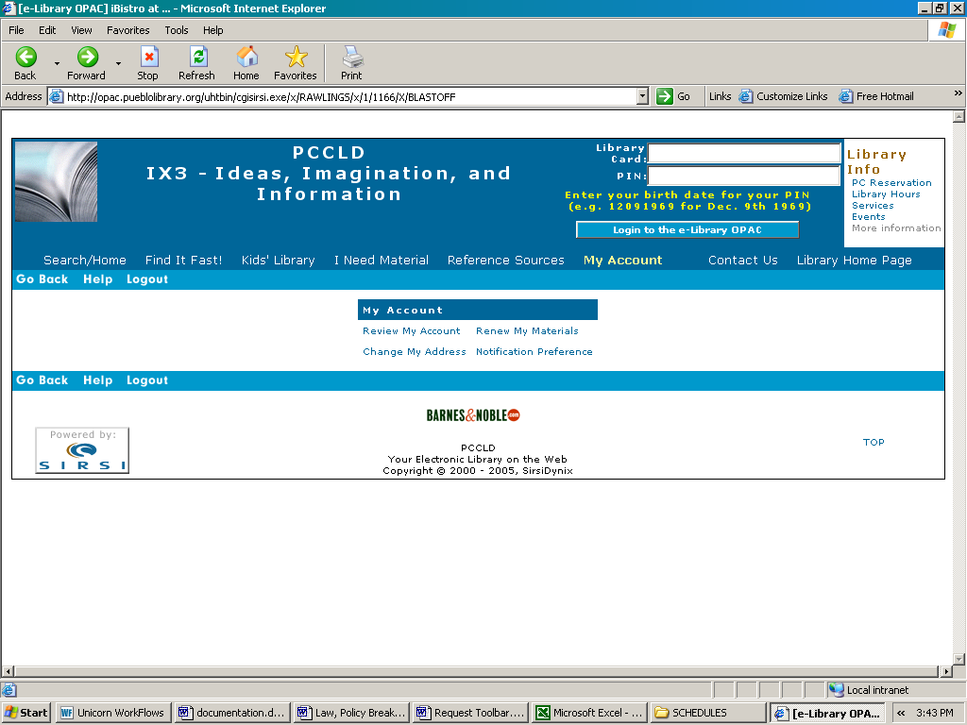

1. Click Requests on the Workflow toolbar. Figure One – Step One
2. Click on Display Request wizard. Figure One – Step Two
3. Choose the User Request”All” option. Figure One – Step Three

* Click on Search

1. The screen that appears contains the following: Figure One – Step Four
   1. Those with CHANGEADDR are address changes.
   2. Those with NOTIFY PREF are informing you of their preference to receive notices.
   3. Any others are to be forwarded to the proper department.
2. Double Click on the request ID you are working on. Figure Two

* Highlight the Users ID.

1. Edit –Copy.
2. Click Circulation on the Workflow toolbar. Figure Three – Step One
3. Click on Modify User Wizard. Figure Two – Step Two
4. Edit –Paste into User ID. Figure Two – Step Three
5. The Window menu allows you to arrange windows in a way that makes it easy to display all open windows. You can cascade the windows so you can cross reference. Be sure that only those windows you want to arrange are open. Close or minimize those windows you do not want to display.
6. Modify the request and if possible reply.
7. Click on Remove Request wizard and delete the message. Figure One – Step 6

**Problem Items** *Jon*

**Damaged Shelf**

* Arranged alphabetically by patron last name
* Missing and Damaged are filed SEPARATELY
* Shelves should be checked weekly, clearing material that has been on the shelf for 6 months
* After 6 months, remove item from damaged shelf.
* Black out barcodes and PCCLD stamp.
* Put in trash or send to Friends.

**Missing Shelf**

* Arranged alphabetically by patron last name
* Missing and Damaged are filed SEPARATELY
* Check the shelf daily, sending items to Technical Services that have been on the shelf for more than 7 days

**Damaged material that is attached to a patron (Damaged beyond repair)**

* Example: Dog-chewed books, water damage, etc.
* Check the item’s circ notes to determine if this is new damage
* Mark the item lost using the Mark Item Lost Wizard, billing the patron
* Fill out the Problem Item slip
* Contact the patron to notify them of the bill
* File the item alphabetically on the Damaged shelf

**Damaged material that is NOT attached to a patron**

* Example: Excessively worn, needs new cover, broken binding (items that should not be returned to circulation)
* Check the item out to 1REVIEW
* Place it on the Review shelf
* Supervisor will determine if the item can be mended. Items that can be mended will be routed back to the department. Items that cannot be mended will be discarded by the Supervisor.

**Items returned missing pieces/parts**

* Fill out the Problem Item slip
* Contact the patron and NOTE patron account
* Check the item out to 1TECHSVCS
* Place the item on the MISSING shelf for 7 days
* When a patron returns the missing piece or case, match it with the corresponding part from the MISSING shelf (If the case has already been sent to technical services, send the corresponding part there as well)
* Discharge the item and put it back in circulation
* **Any item that has parts returned prior to 2/15 should be sent directly to Abby

**Items returned with mismatched pieces**

* Mismatched items that cannot be traced to a patron should be checked out to 1TECHSVCS and sent to Abby

**Music CDs, Audio Books, or DVDs that have playing problems**

* Check items out to 1REPAIR
* Fill out Audio Form
* Place on Robert’s shelf

**Items that need system work (Brief title, Call # change, Location change, Item not in SIRSI, etc.)**

* Fill out the yellow Technical Services slip
* Check item out to 1TECHSVCS
* Place on Technical Services shelf

**In-Transit items** *Deanna*

Print list from icon in sirsi that says “in-transit items” – click on “pending transits” type the item # in “Check item status” if longer that a week coming from a branch or tech services, go to the “items” icon and mark item missing. Most items will have a hold or will say item is in-transit. You will need to override to complete procedure. If an item is coming from a satellite and is longer than a month, mark the item missing as well and follow the same procedure as above.

*Note*: If less than a week from tech services or branches and less than a month from satellites – skip and go back to it at a later time (just in case it shows up) most of the time it does.

*Do not do anything with items that say GEN-geneology, LIT-literature or ILL-interlibrary loan.*

**Lost Library Cards** *Deanna*

This can be done once a month. Generally lost library cards should not stay in our blue lost card file longer than a month. All cards should have a sticky note with the patrons name and the date it was found. If there is no name or date please add one to the card and most importantly notate the account, initial/ra and date.

When discarding library cards that have been there longer than a month, please remove the notation from the card holder’s account and cut the card and throw away.

Also keep in mind, that if a patron comes to claim their card, ask for I.D. and remove notation from account.

**AMH:**

AMH - Automatic Materials Handling

Instructions on emptying the AMH bins for CC1’s

The AMH sorts items into the bins depending on the type of items, such as videos, non-fiction, fiction, genre, large print, new books, audio books, and youth items.  Directly across from the bins are 8 carts that these returned items are placed on.

1. **Empty the bins from your area onto the appropriate cart.**

Each cart has a removable blue card that explains what items are placed on that certain cart, and how to sort them. For example, the Dewey bin states that 0-300’s on the top shelf, 400-600’s on the middle shelf, etc.  The bottom rows of all the carts, except DVD and Youth, should remain empty (unless the card specifies otherwise).

1. ***Push* the blue button to the right of the bin you emptied.**

The computer “counts” each item that goes into the bin, and causes the blue button to light up when the pre-determined limit is reached. Pushing the blue button resets the counter for the bin, and reduces unnecessary alerts.

1. **If time allows:**
   1. **Empty the bins which have illumined blue buttons, even if it is not your area following procedures above.**
   2. **Empty the Exceptions Bin.** At the very end of the conveyor belt is the exception bin. These are items with holds, missing pieces, or in transit.
      1. Take ONE item out of the exception bin.
      2. Place it on the white stand under the AMH computer, a beep will sound if it was able to read the tag.
      3. **If it is a hold**, a receipt will automatically print. Double check that the receipt item id matches the barcode, and place the slip in the middle of a book, or under the plastic of an AV item.  Place in a stack on hold shelf.
      4. **If slip prints a branch name**, place in the appropriate transit bin.
      5. **If it doesn’t print a receipt**, place the item back onto the conveyor belt to give AMH another chance to sort correctly.