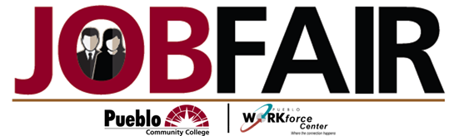

November 2, 2017

Student Center Pueblo Community College

11am to 3pm.