**New User Registration Guidelines**

1. Query the person’s last name and first initial(s), to determine if they already have an account. Do NOT type the whole first name as this limits the number of results and could cause you to enter a duplicate account. You may need to investigate several accounts, looking at DOB to determine if an individual is already in our system.
2. If the customer does not have an account, give the customer the appropriate application, and ask them to fill it out.
3. Click the User Registration Wizard, and scan the barcode of the new card.
4. On the Basic Info Tab, enter:

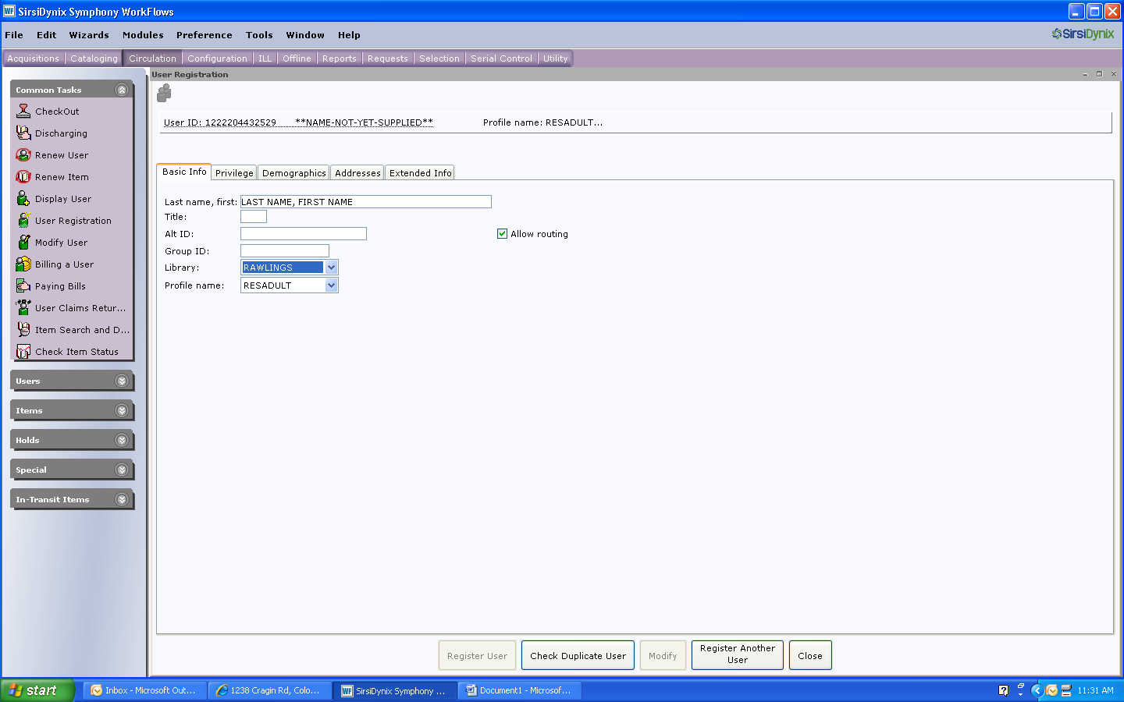

* Enter the customer’s last name, a comma, the customer’s first name, a space and the customer’s FULL MIDDLE NAME. Enter a suffix, AFTER the middle name. No additional punctuation. (Ex: SMITH, JOHN JR or DOE, JOHN III)
* Always use all capital letters (except for the email address)
* Do not use any other punctuation besides the comma between first and last name
* Choose the Library (should default to Rawlings)
* Select the appropriate profile
  + Resident Adult – person over 18 with proof of address
  + Resident Minor – person under 18 with proof of address (from parent/guardian)
  + Unverified Adult – person over 18 without proof of address
  + Unverified Minor – person under 18 without proof of address
  + Special

1. On the Privilege Tab enter:

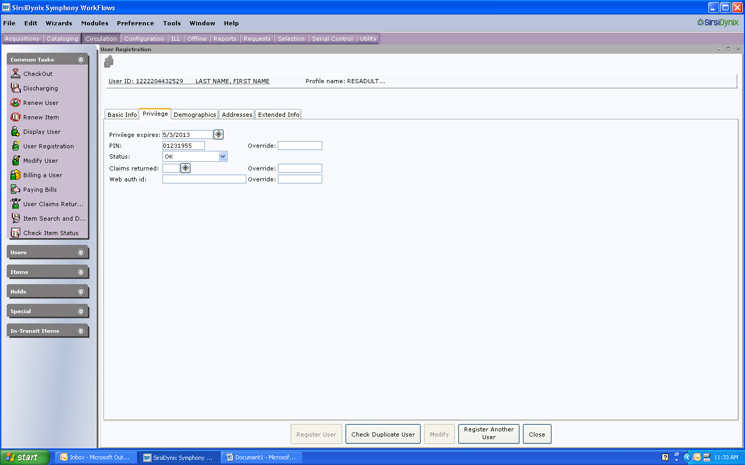

* Enter the privilege that corresponds to the customer’s profile (30 days for unverified and 3 years for verified). Be sure to check that the privilege is correct, as selecting unverified does not always change the expiration date to 30 days.
* Enter the full eight digit birth date, with no spaces or dashes, for the PIN
* Enter the override to change the PIN

1. On the Demographics Tab, enter:

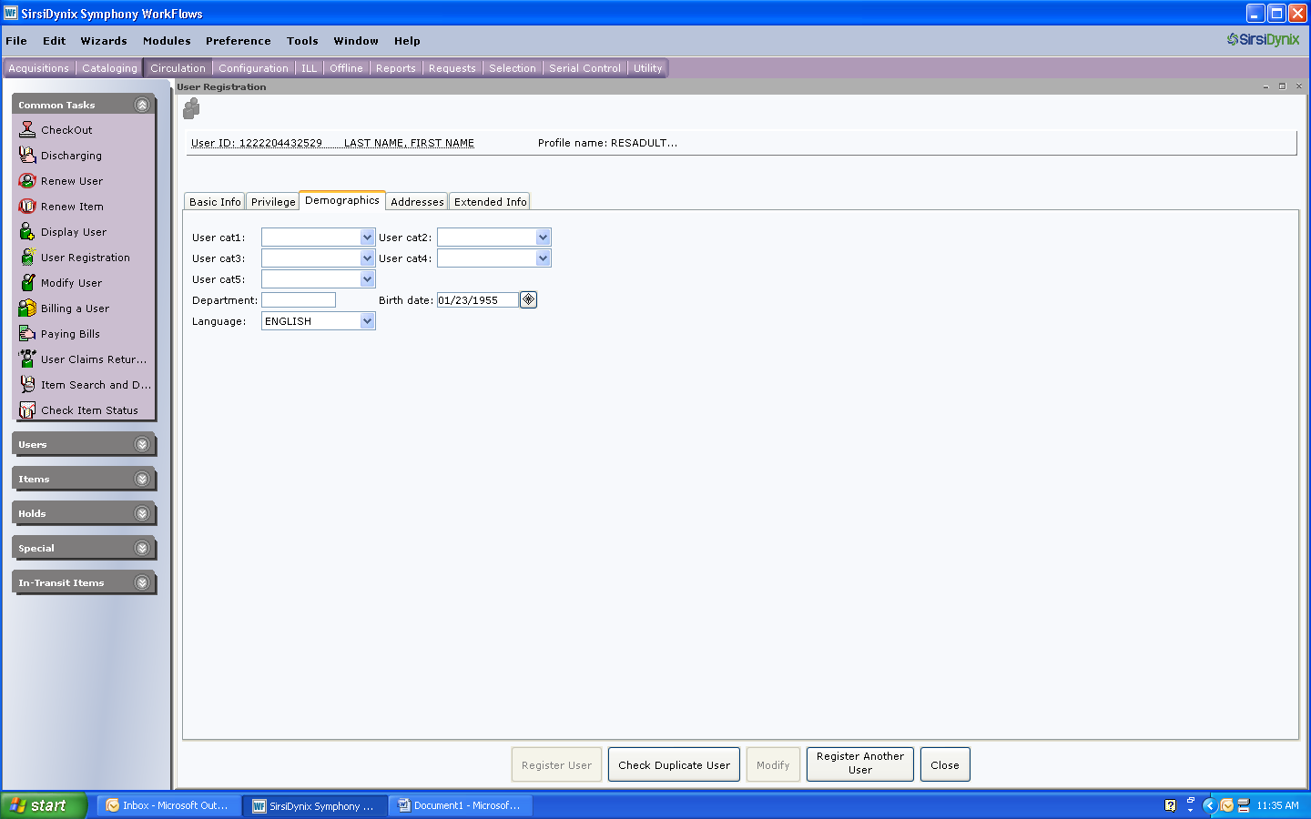

* The customer’s date of birth

1. On the addresses tab, enter

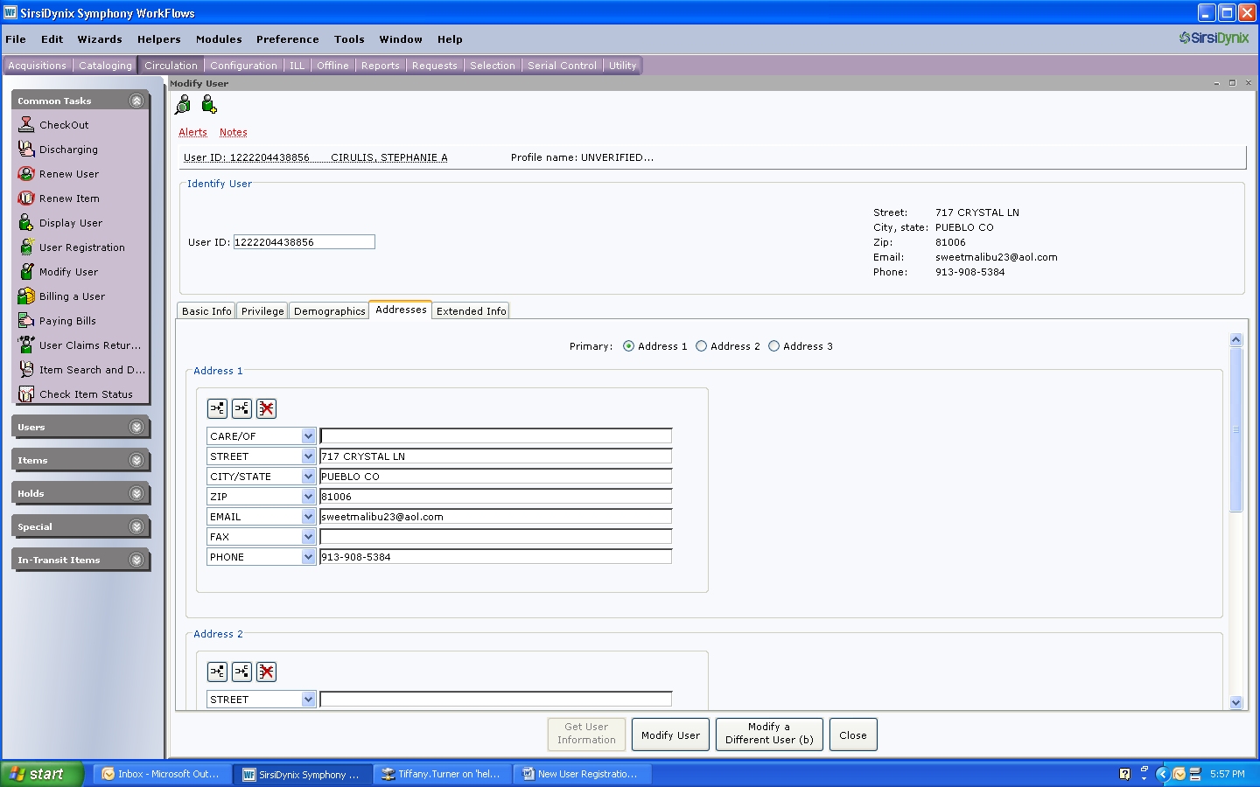

* The customer’s street address
* Do not use symbols (ex: #) or punctuation (ex: APT. or P.O.)
* No punctuation
* Use CO (the postal service abbreviation) for Colorado
* Enter the email address in lower case letters
* Enter the phone number, including the area code

1. On the Extended Info tab, enter: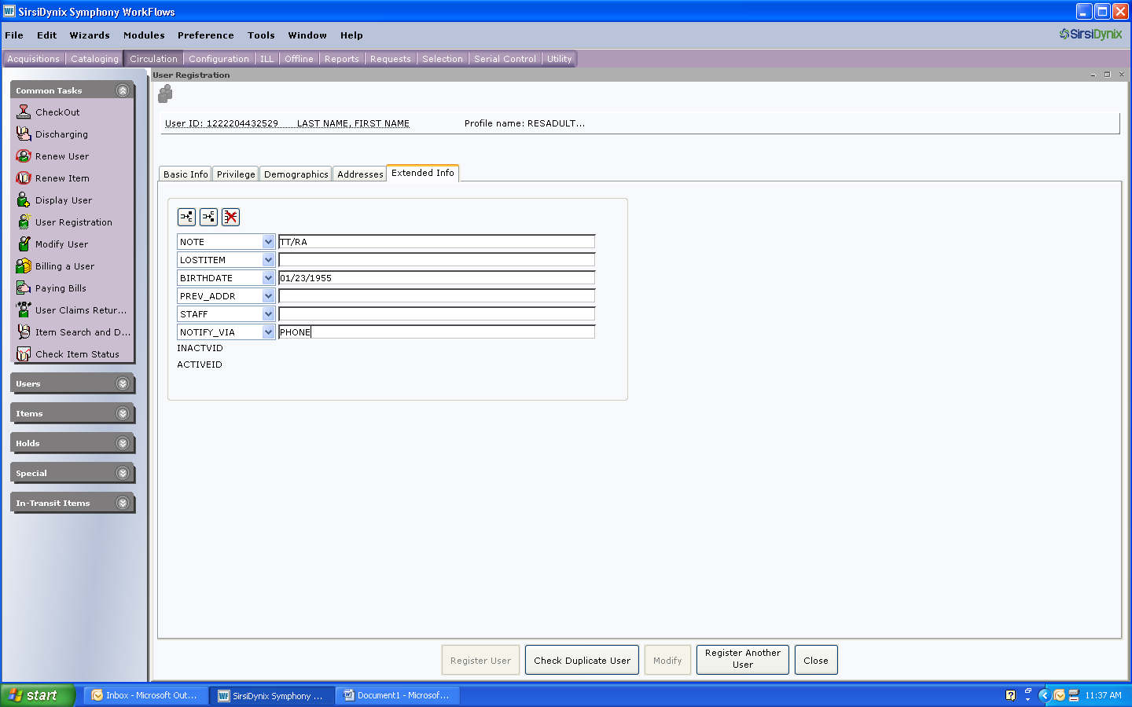

* Your initials and location in the first note line
* The customer’s date of birth
* The customer’s notification preference (PHONE, PAPER or EMAIL)

1. Check duplicate User
2. Register User