**Merging a patron**

1. When locating an account to make a new library card you find that the patron has duplicate accounts, you can merge the accounts into one record.

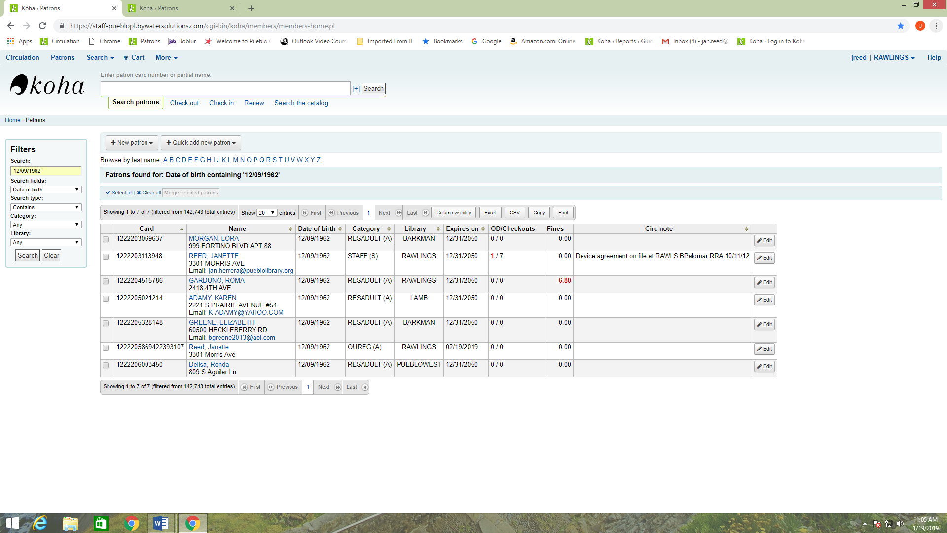

1. To merge the accounts you will check the box at the beginning of each record that you need to merge.

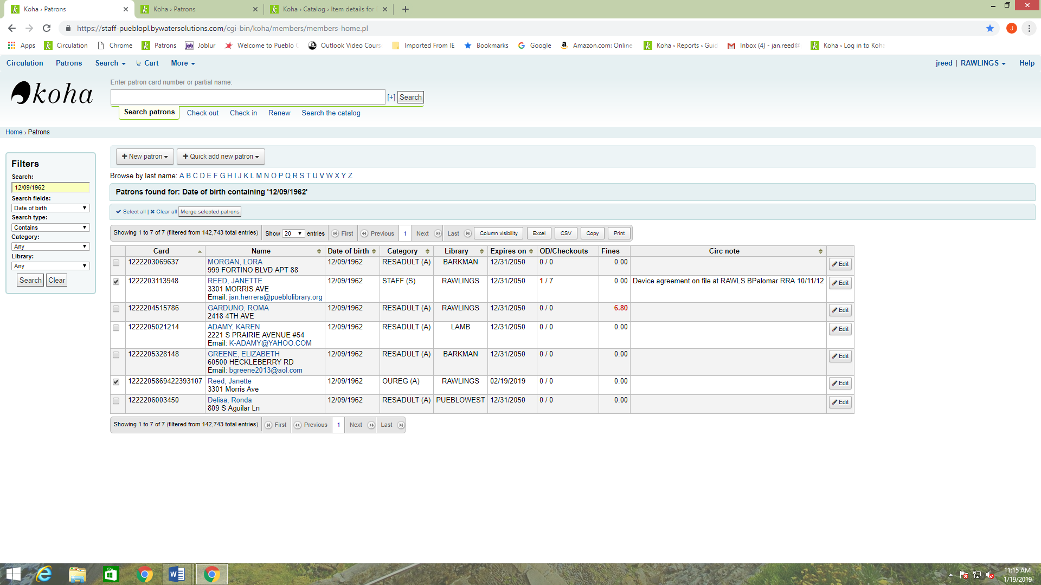

1. You will then click the button that is labeled Merge Selected Patrons.
2. It will ask you which record you want to keep and you will fill in the circle next to that record, and then click the Merge Patrons button at the bottom.

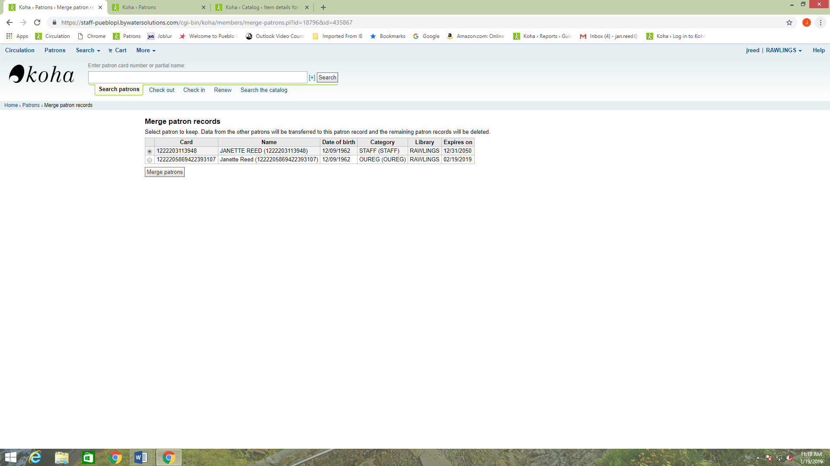

1. All accounts will then merge into the one chosen account.

