**Marking an item Claims Returned**

1. While in the patron’s account click in the Item that is Claims Returned and the item record will come up.

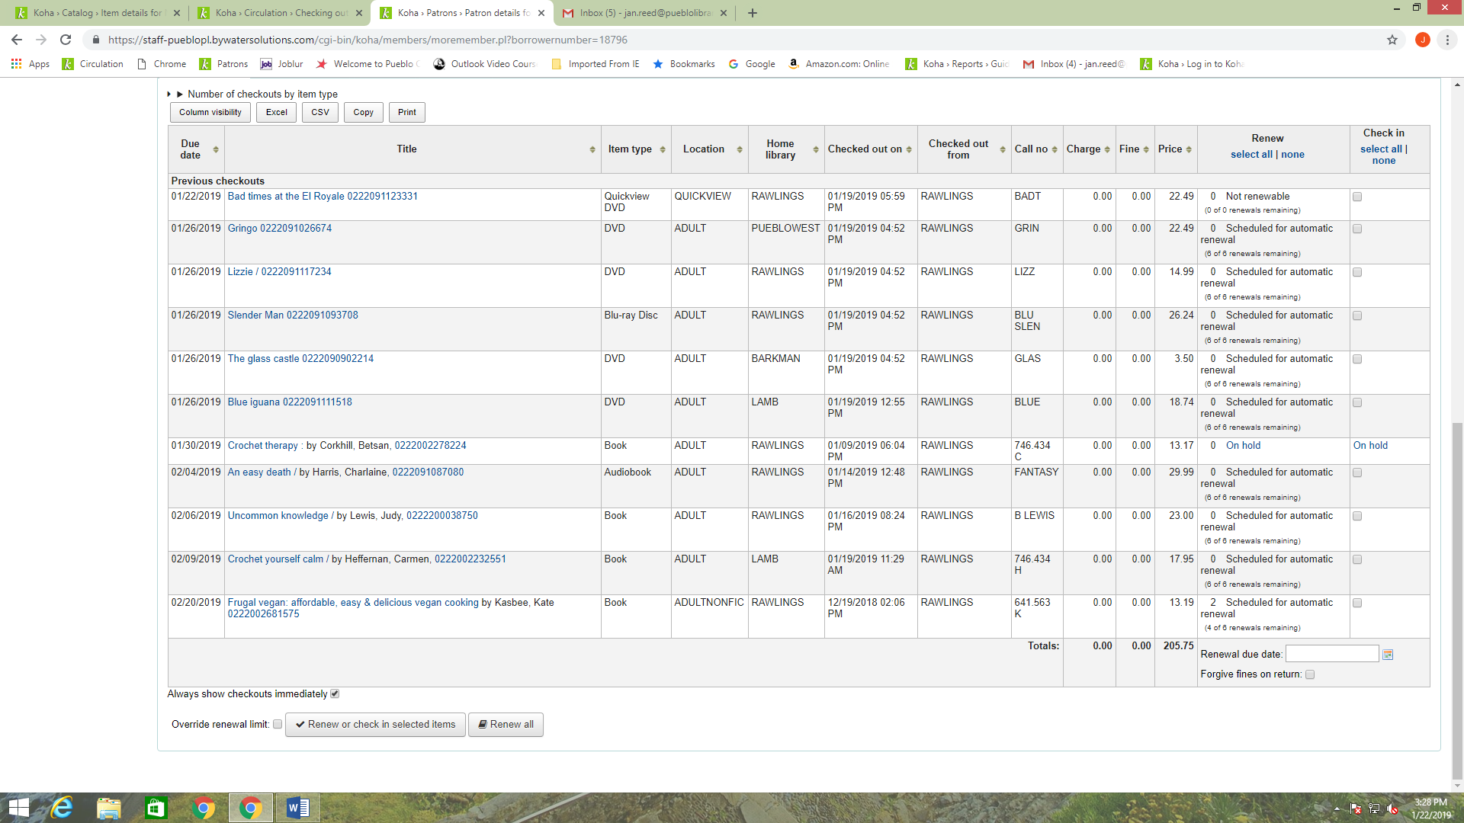

1. Next, go to the window next to Damaged Status and open it up and click on Claims Returned and then click the Set Status button.

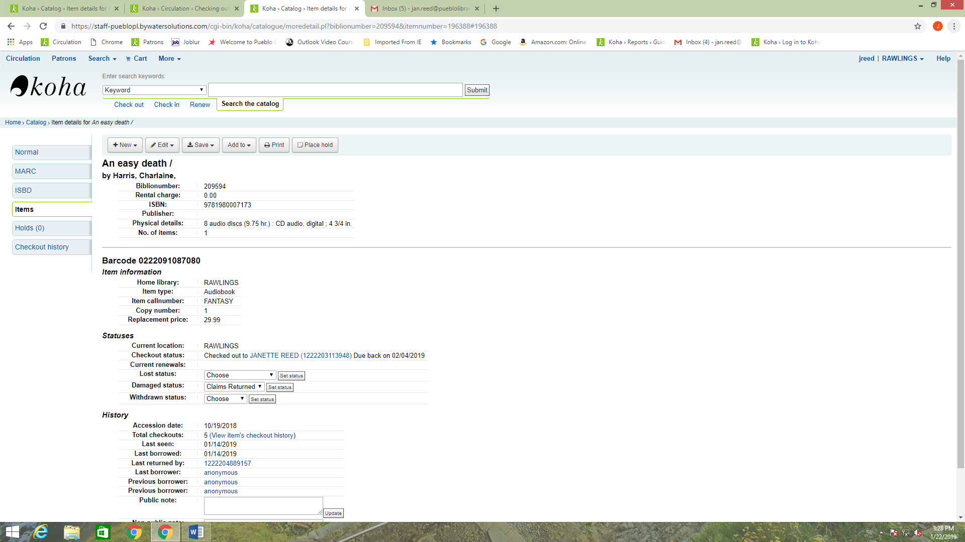

1. You can then go back to the patron’s account by clicking on the account number and name that is next to Checkout Status.

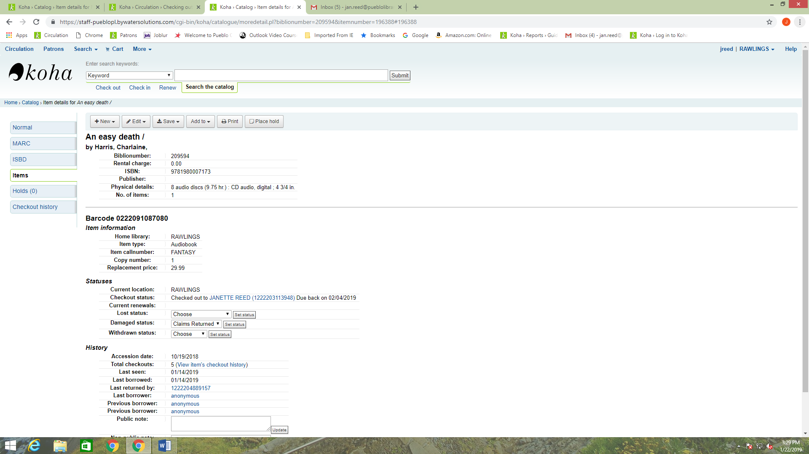

1. Once back in the patron record copy the item number go to the Add Message button that is at the top of the patron record.

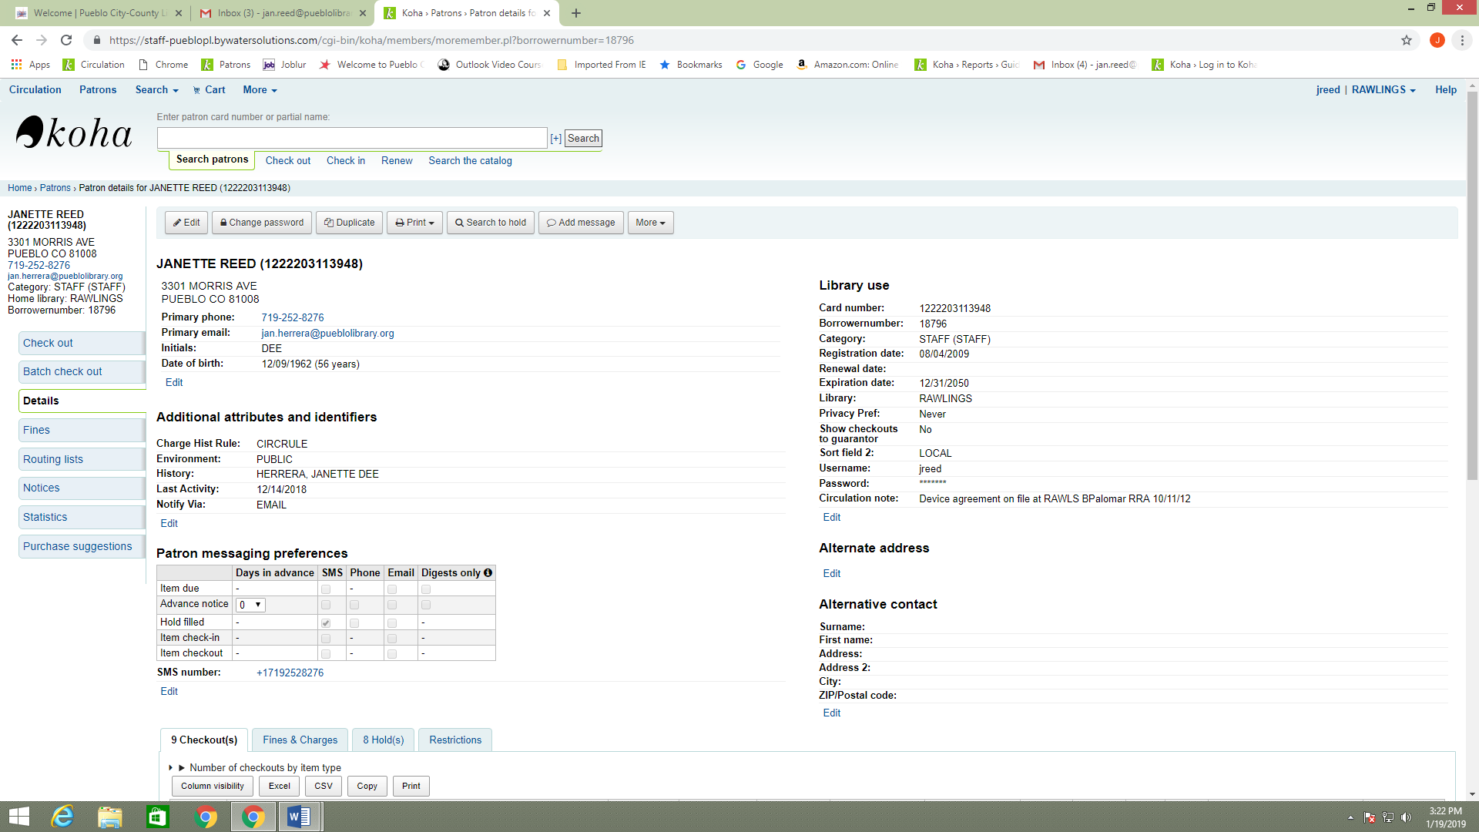

1. You will leave Add a Message as Staff-Internal note, then open the Predefined Notes window and choose Claims Returned.

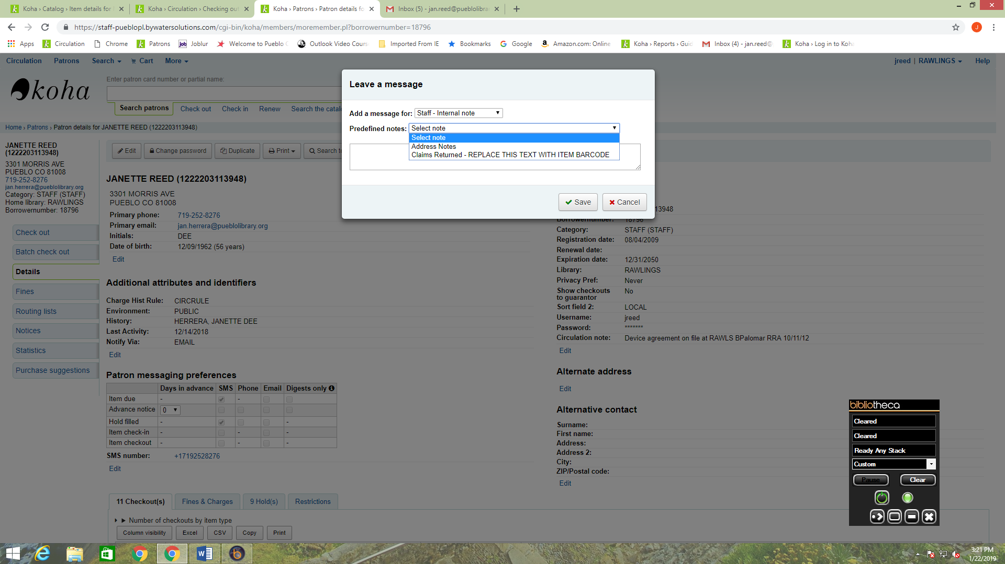

1. The note field will open and you will paste the Item ID number where is says REPLACE THIS TEXT WITH ITEM BARCODE, and then Click on Save.

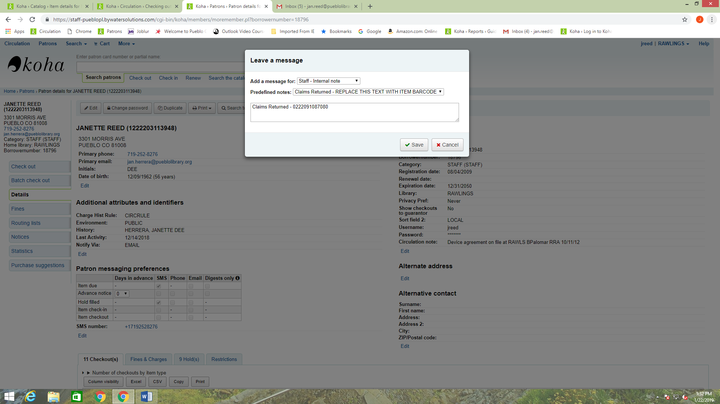

1. The note will then display at the top of the patron record along with the date and the name of the staff person adding the note.

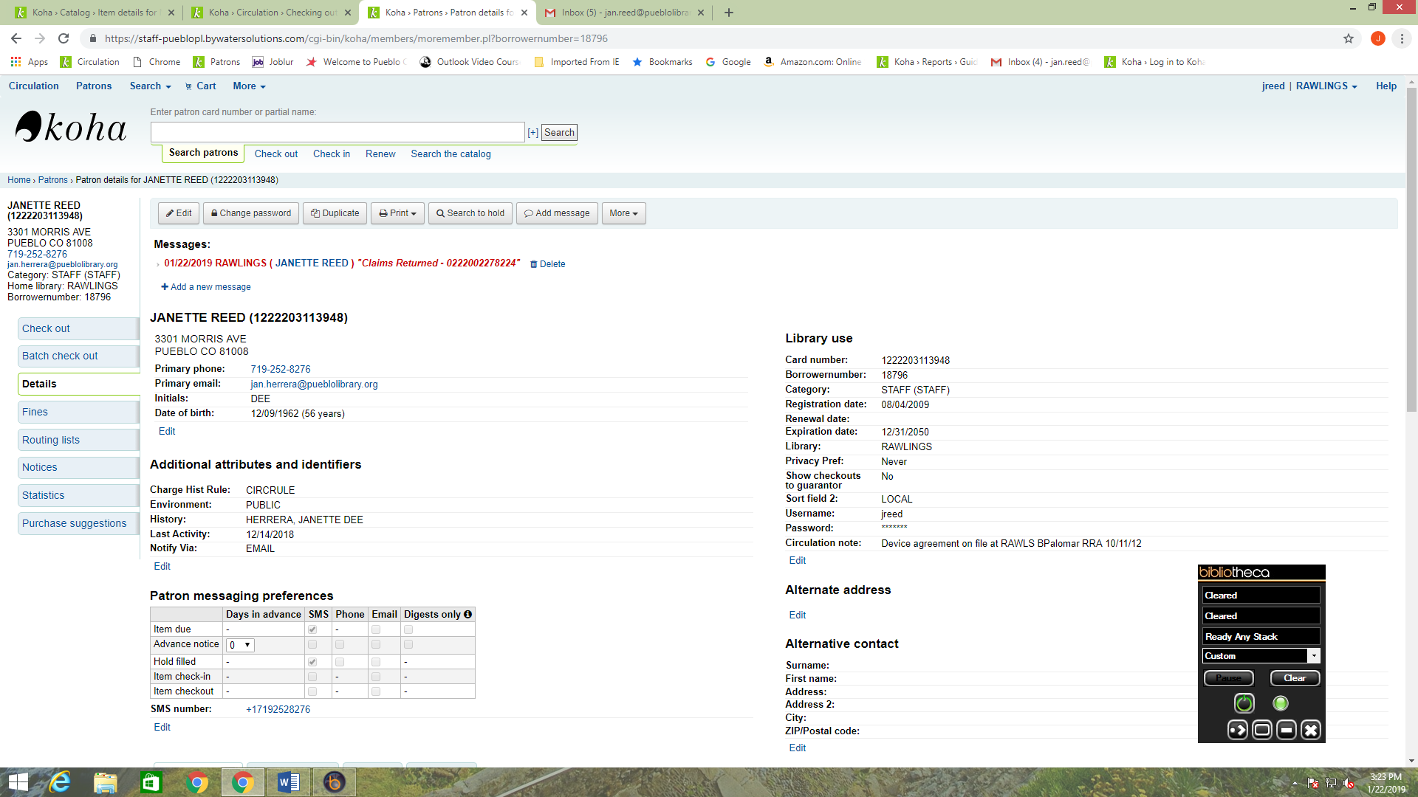

1. Once you have completed this you can then check the item in by checking the box to the right of the item record in the Check in column and clicking on the button marked Renew or Check in Selected items.

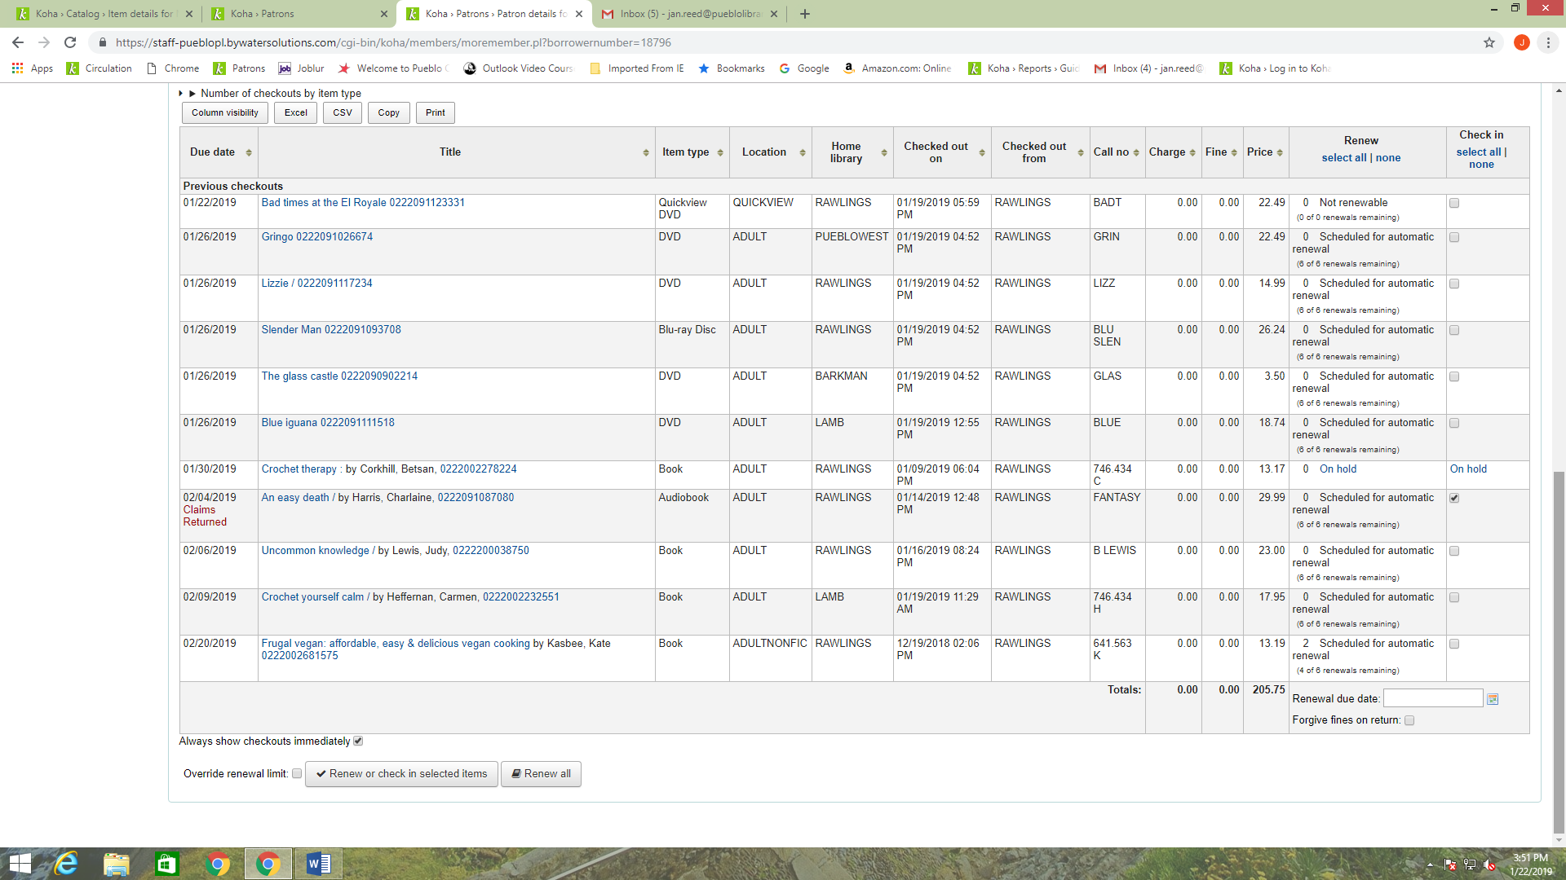

1. Next, mark the item Missing in the item record by clicking on the item number. Opening the window next to Lost Status, click on Missing and then the Set Status button to complete the Claims Return.

