**Walking a patron through making a payment on the library website**

1. Have patron go to the library’s main web page at [www.pueblolibrary.org](http://www.pueblolibrary.org). Once there they can click on one of the links for My Account.

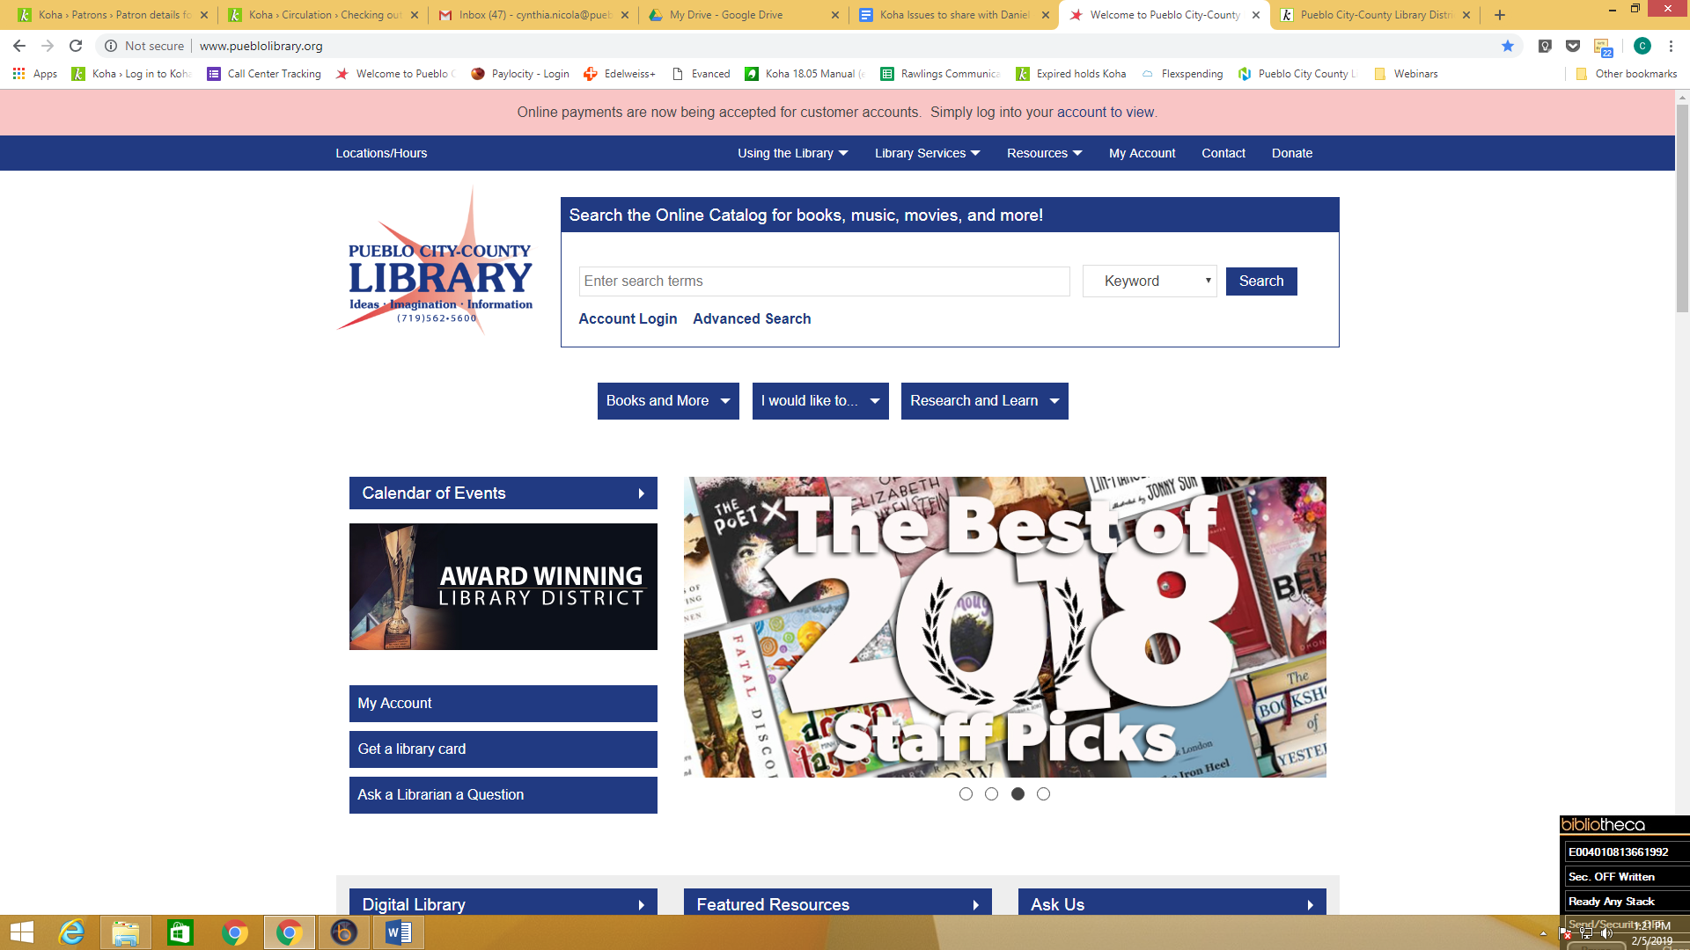

1. Patron will need to log into their account using their library card number and PIN number. We cannot give out the card number over the phone and we can no longer see the PIN.

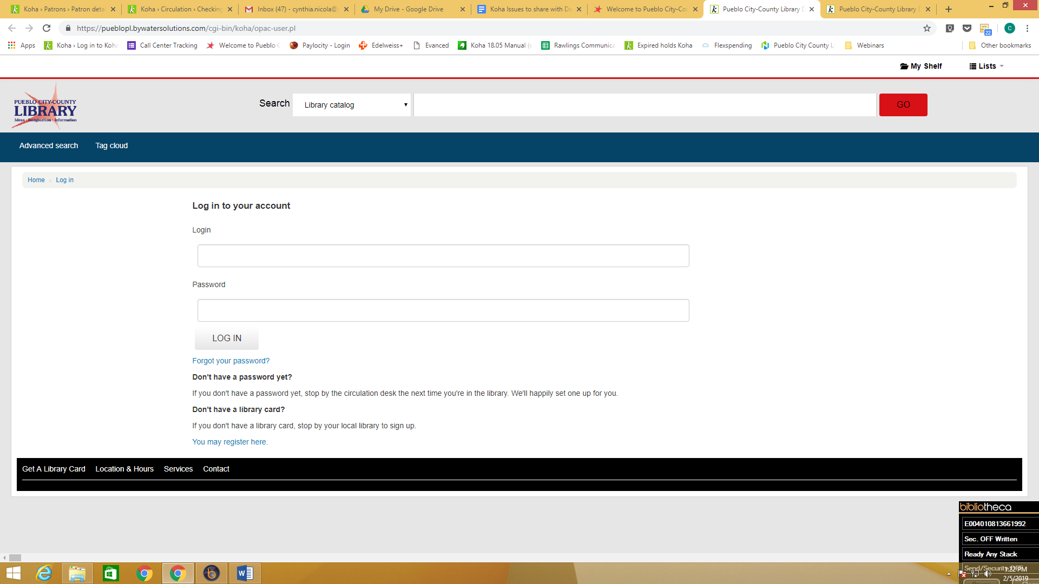

1. Once in the account, the patron will need to click on YOUR FINES, located on the left hand side. Clicking on the FINES tab does NOT give you the option to make a payment.

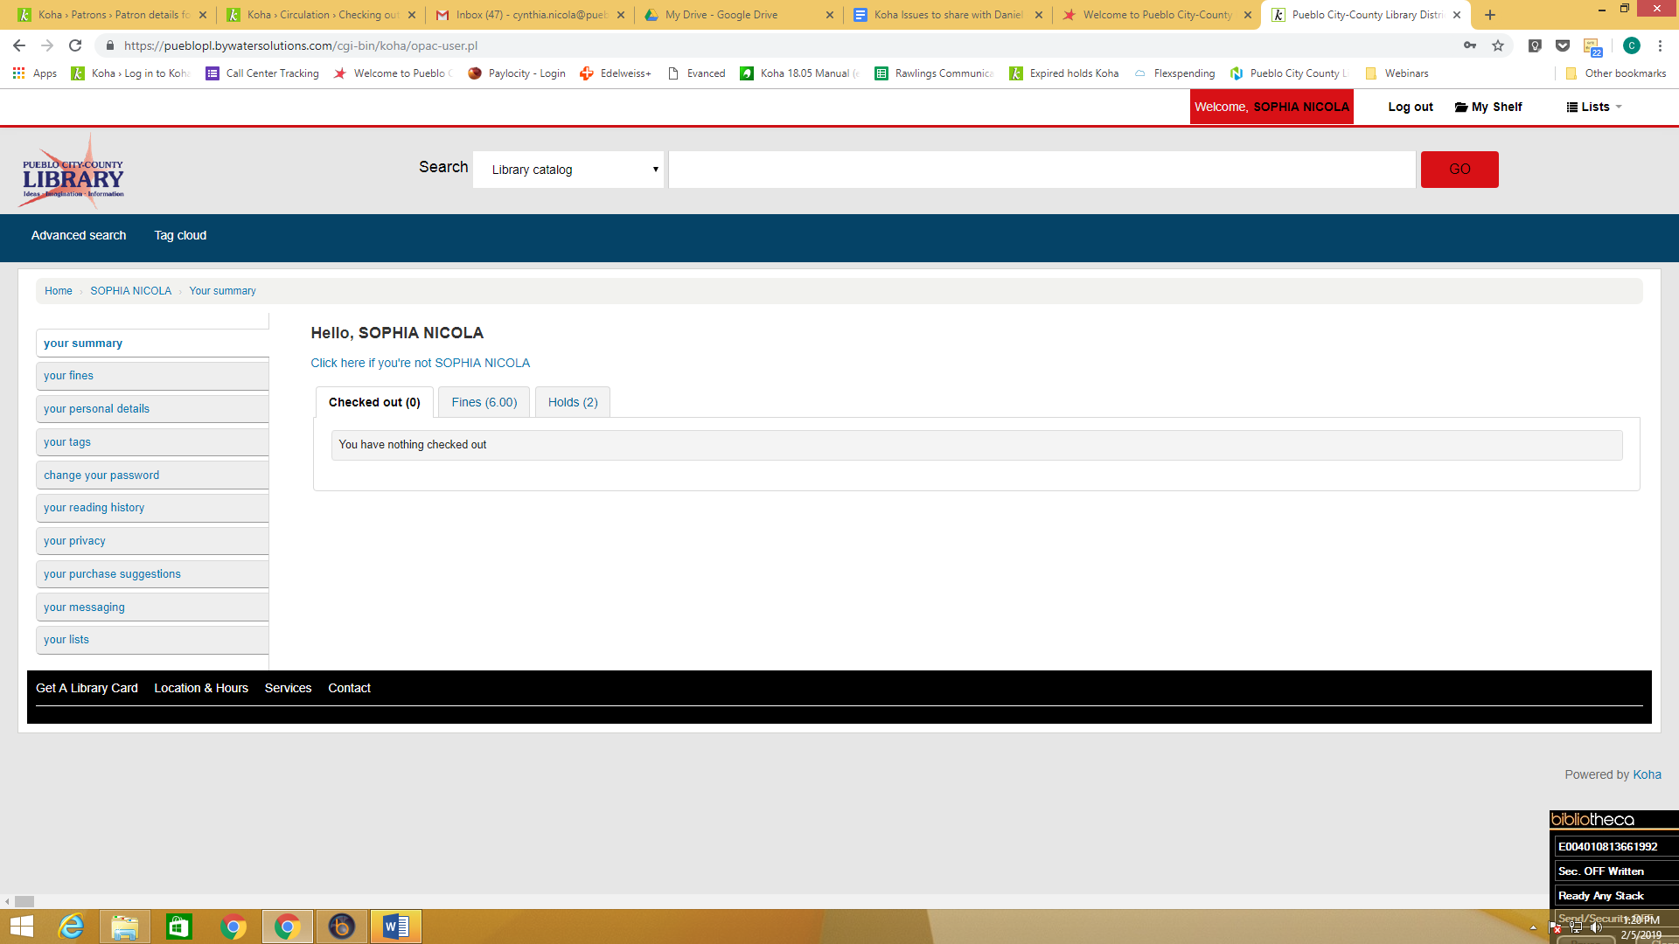

1. The individual fines will then appear. The patron must check the box in front of which bills they want to pay. The MAKE PAYMENT button will not work until the fines to be paid have the box checked.

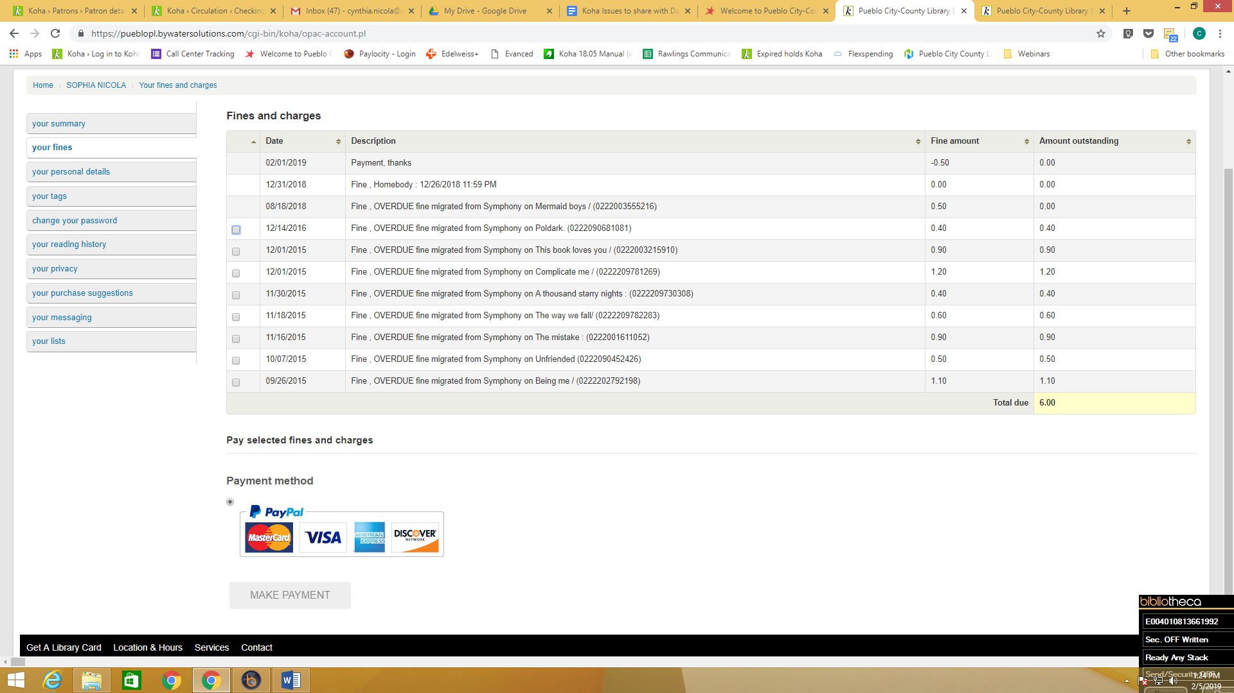

1. Once the fine boxes are checked, the patron can then click the MAKE PAYMENT button. Payment must be at least $2 to use a credit or debit card.

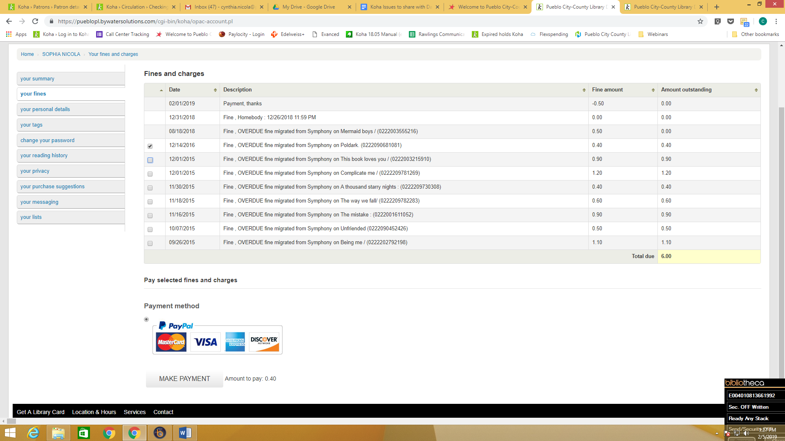

1. The patron will then be taken to the page where they are given the option to use Paypal or use a debit or credit card. The payment will show up on their account immediately. It will also show in Koha on the staff side as well.

