**Making a Library Card without Online Registration**

1. Go to Patrons and then click the button labeled +New Patron. The window will open and you can then choose the patron category (Resadult, Resminor, Unverified, etc.).

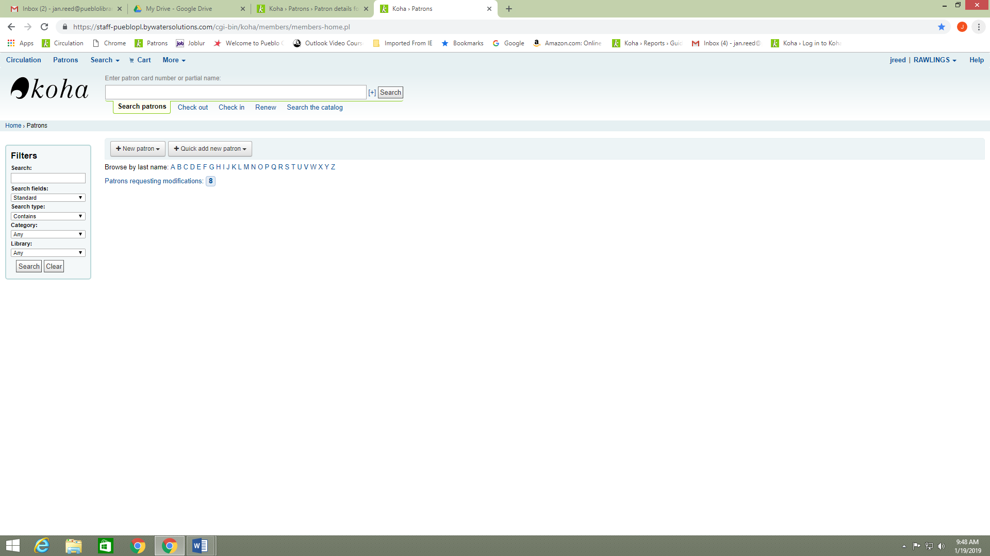

1. When the window opens you will choose the patron status and then proceed to enter the required information and notification preferences.

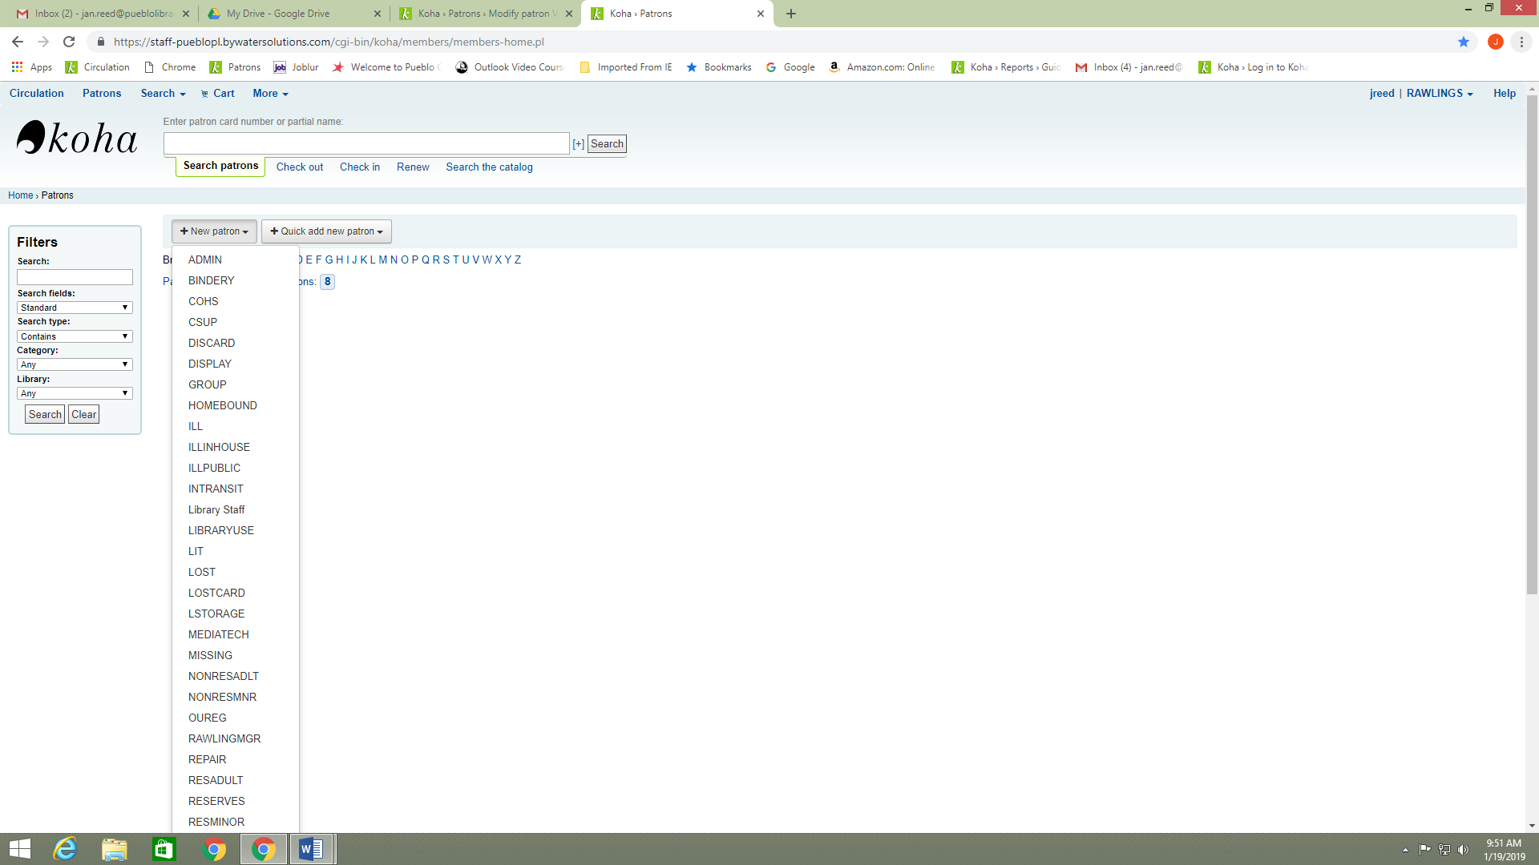

1. Once all information is entered and verified you can click on the Save button located on the upper left corner of the record.

