**Making a Library Card with Online Registration**

1. Go to Patrons and locate the box labeled Filters on the left hand side of the screen.

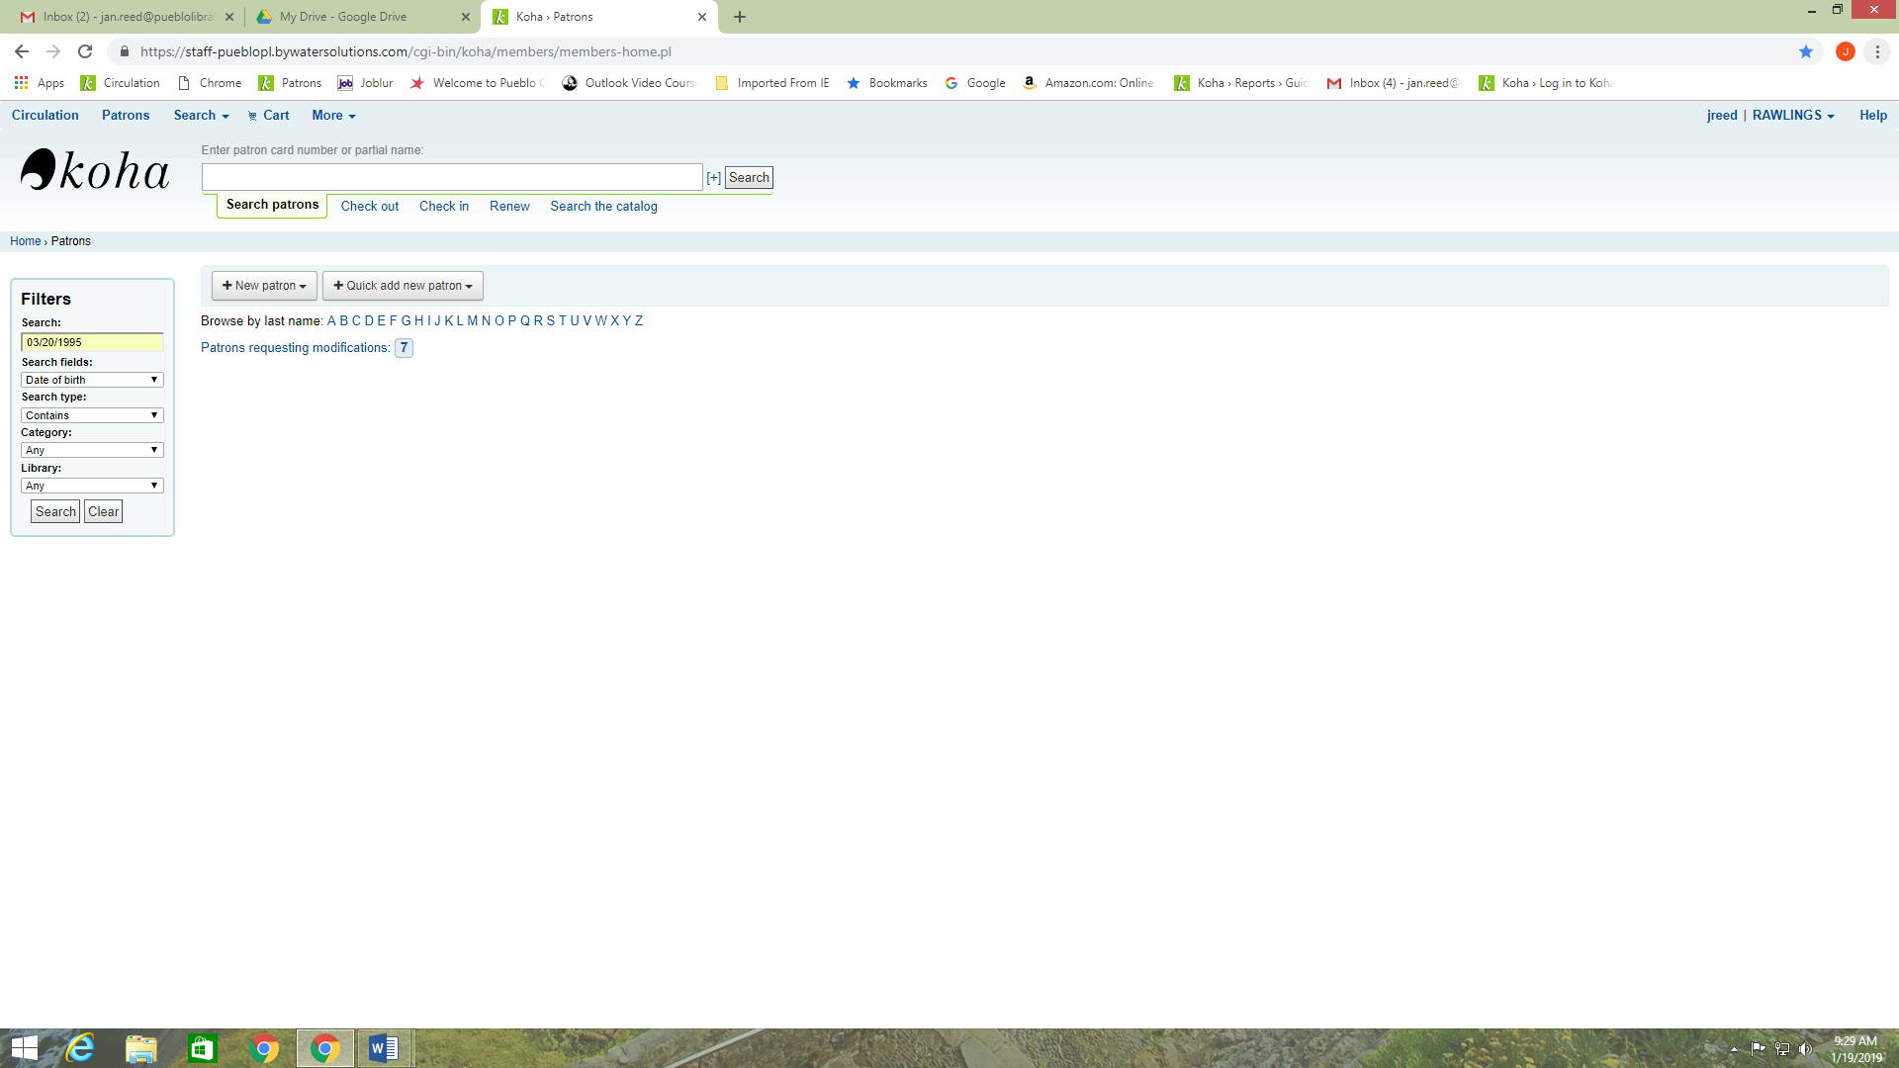

1. Under Search fields select Date of birth and then type in the date under Search. ex. 01/01/1995.
2. Locate the correct person verifying with a valid ID. Be sure to check for duplicates.

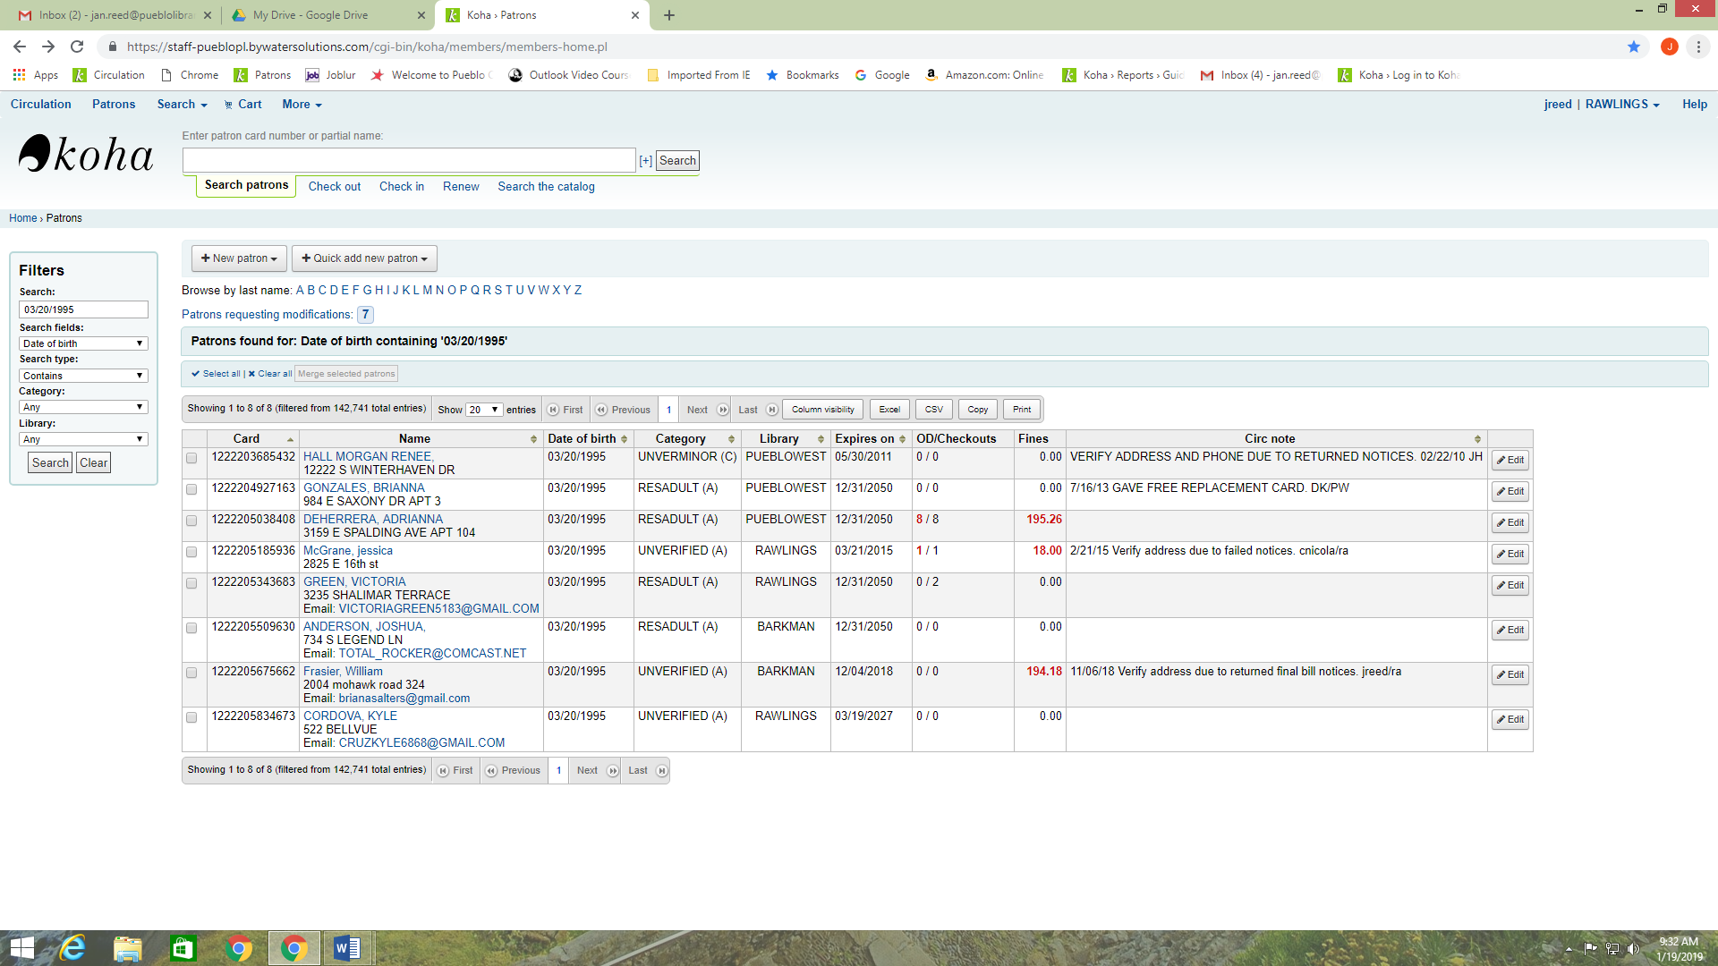

1. Go into the account and click on the Edit button on the upper left corner of the record.

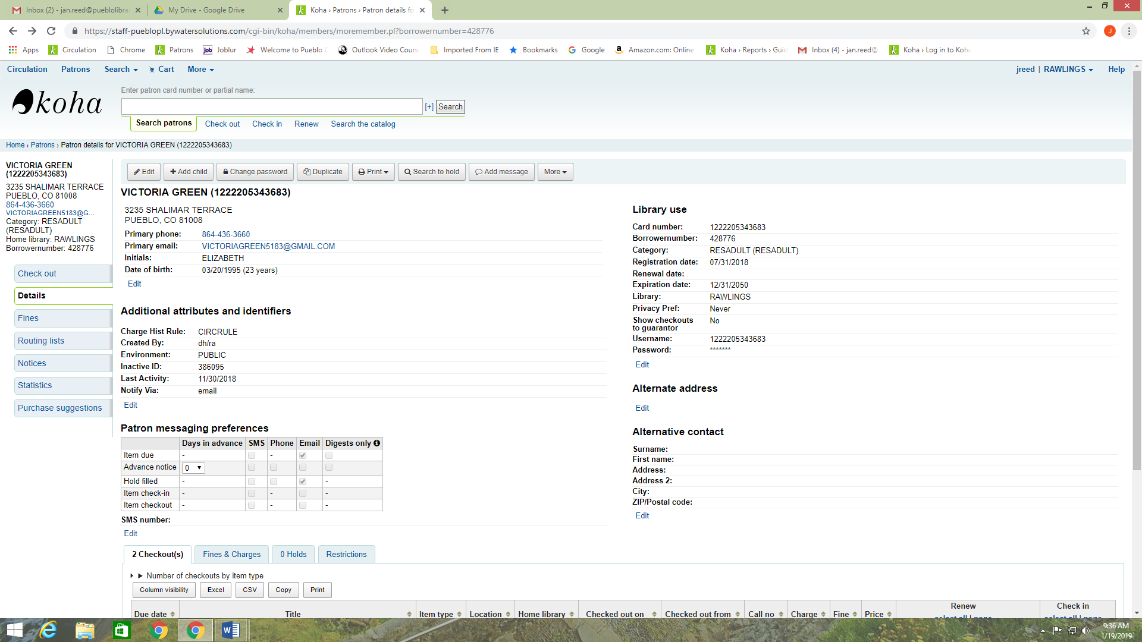

1. Verify that all information entered by the patron matches the information on their ID, then under Library management you can change the patron category (Resadult, Reminor, and Unverified) and also scan the library card number.

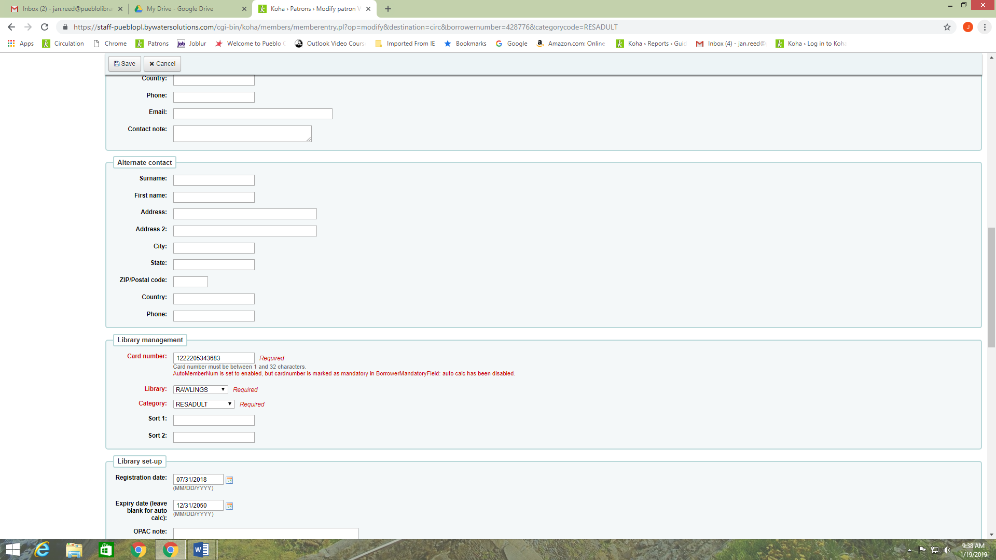

1. At the bottom of the record you can set how the patron prefers to be notified. Phone call, email, or text are the choices. It text is chosen the number has to be entered in the following format, +17191112222.

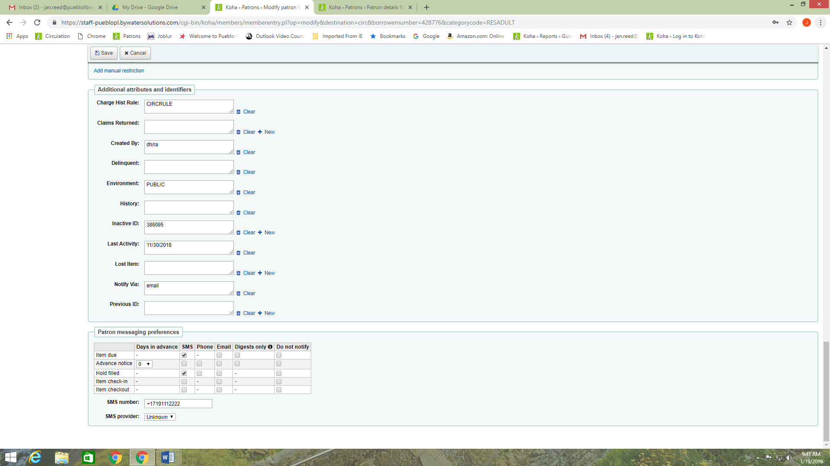

1. Once all information is entered and verified you can click on the Save button located on the upper left corner.