

www.pueblolibrary.org

CIRCULATION PROCEDURES MANUAL

**03.02.01 Library Cards**

PCCLD Library cards are free to applicants who reside or own property within Pueblo County. PCCLD also offers reciprocal borrowing privileges to other Colorado residents who hold a valid Colorado Libraries Collaborate (CLC) library card.

Library customers are expected to present library cards each time materials are checked out from the library. Customers have individual control over their library card and are responsible for materials checked out on their card and any fees associated with it. Card holders are responsible for immediately reporting to the library when their card is lost or stolen. There may be a fee to replace lost or stolen cards. Library cards remain valid until cancelled at the customer’s request or when purged by the library after a period of inactivity.

Registration for a library card is to establish a person’s identity and contact information and to acknowledge responsibility for library materials checked out on a card. Customers are responsible for keeping this information current. The following are requirements to obtain a library card:

1. Adults must present proof of identity and proof of residence. Acceptable proof shall consist of one identification piece with a photo that includes the applicant’s name and current address (e.g., a Colorado Drivers License) or two pieces of identification containing the applicant’s name and current address. The parent or legal guardian of minors must also present the same proof of identity and residence to obtain a library card for children under age 18.
2. There is no age requirement to obtain a library card; however, the signature of a parent or legal guardian is required on applications for children under age 18.
3. Adults assume responsibility for material checked out to their library cards, and for any materials checked out to their child’s card.

Library cards may also be necessary for access to online library services.



www.pueblolibrary.org

LIBRARY CARDS

**Overview**

PCCLD library cards may be obtained and used at any PCCLD facility. Fines and fees on the account are the responsibility of the account holder. All items checked out prior to the card being reported lost or stolen are the financial responsibility of the card holder. Cardholders are expected to present their library card or valid picture ID in order to check out materials or obtain account information. Library cards that have not been used for five years are automatically purged from the system.

**Types of Cards**

*Resident Adult/Minor*

Resident cards are issued to customers who reside or own property in Pueblo County. Customers 18 years of age and older are registered with the profile RESADULT while those 17 and younger are registered with the RESMINOR profile.

The parent or legal guardian should be present when children 17 and younger apply for a card. The parent or legal guardian’s signature is required for a minor to receive a library card, and the parent or legal guardian assumes financial responsibility for materials checked out on their minor’s library card.

*Non-resident Adult/Minor (CLC users)*

The CLC program involves a network of libraries throughout the state. Colorado residents who live outside of Pueblo County may obtain a library card at PCCLD by verifying that they are a Colorado resident and hold a valid CLC card. PCCLD participates in this program and issues library cards to non residents using the NONRESADULT and NONRESMINOR profiles. Access to certain licensed databases is only available to non-resident users while inside a PCCLD facility. Nonresident customers are not eligible for Interlibrary Loan services.

*Unverified*

If proof of address cannot be provided at the time of registration, a library card with an UNVERFIED profile is issued. An unverified library card allows the customer to check out two items at a time and access to limited library services. The privilege expires 30 days from the registrations date. Once the current address has been verified, the card’s unverified status will be removed and full library privileges are activated.

*Special*

People in temporary living arrangements such as foster shelters, group homes, those with extended stay hotel arrangements, etc., who have no permanent residence may be issued a card with a SPECIAL profile with a 3 month expiration date. This is to allow the library to collect updated contact information once a permanent residence is established. Please indicated “Temporary Residence” in the note field.

*Homebound*

Extended loan periods are available to customers who are physically unable to visit the library regularly. Homebound patrons are typically represented by another individual who acts on their behalf using their library card. Due to the extended checkout period, homebound patrons are not eligible for renewals. When homebound status is no longer needed, the library requests that customers notify the library of the change in status so that a regular card may be issued.

*Staff*

Staff cards are issued to PCCLD employees. Staff is not charged fines on overdue material; however, staff cardholders are responsible for lost items and damage to library materials. Card usage may be monitored by management and does not fall under the confidentiality policy.

**Identification Requirements**

In order to protect both customers and the library’s collection, customers must present valid identification before a library card is issued. Acceptable proof consists of one piece of photo identification that includes the applicant’s name and current address or two pieces of identification containing the applicant’s name and current address.

Acceptable forms of identification include:

* Driver’s License
* State issued ID Card
* Employer ID
* Military ID
* School ID
* Consulate card
* Passport
* Permanent Resident Card
* Alien Registration Card

Acceptable forms of proof of address (PO Box not acceptable) include:

* Mortgage papers
* Rent receipt
* Phone bill
* Pay stub
* Printed check or deposit slip, imprinted with current address
* Utility bill
* Credit card statement
* Vehicle Registration
* Voter registration card
* Property tax assessment notice
* Mail postmarked within the last 30 days
* Letter from shelter for group home on letterhead

*Note: Items that can be self-generated, such as business cards, are not acceptable for address verification.



www.pueblolibrary.org

CIRCULATION PROCEDURES MANUAL

**User Registration**

The process of issuing a library card is called user registration. For each new user, staff creates a computer record of the customer which includes the customer’s name, address, library card number, phone number, email address (if applicable) and birth date.

User registration is an educational process in which staff should share information and expectations with the customer. It is likely that is the customer’s first interaction with PCCLD, so it is important to make the customer feel welcome. Our goal is to provide excellent customer service as we provide information about the library’s circulation procedures. Children should be treated with the same courtesy and respect that we show adults.

**Registration Overview**

1. Request a picture ID and current address verification.
2. Search the database by name to ensure that the person is not already a customer and check for duplicate names.
3. Determine which profile to use for the customer.
4. Enter library card barcode and patron information
5. Ask patron to sign library card acknowledging financial responsibility.
6. Give patron library brochures and explain policies as needed.

**Issuing a Library Card**

1. Proof of identity and residence is required to obtain a PCCLD library card. Request picture identification and proof of local address.
2. See if the customer already has a card by checking for duplicate names in the database. **Do not generate a new record if the patron is already registered.** Check carefully for name variations and old addresses.
3. Click on the display user wizard. Click on User Search. Enter the customer’s last name and the first one to three letters of the customer’s first name. This will search all registered users and will help identify spelling variations of a first name.

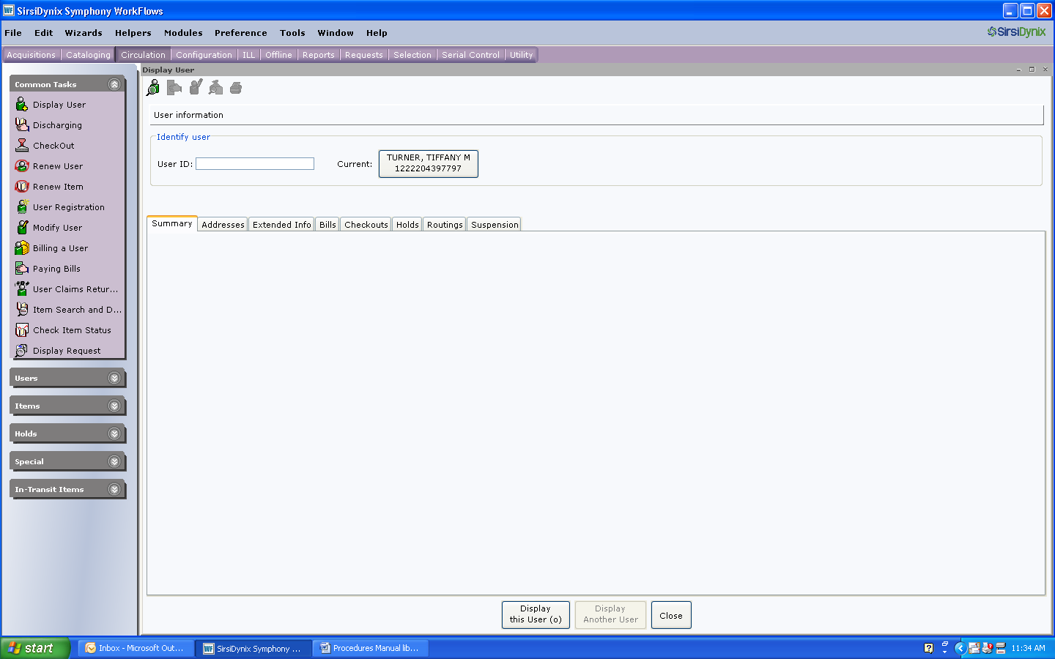

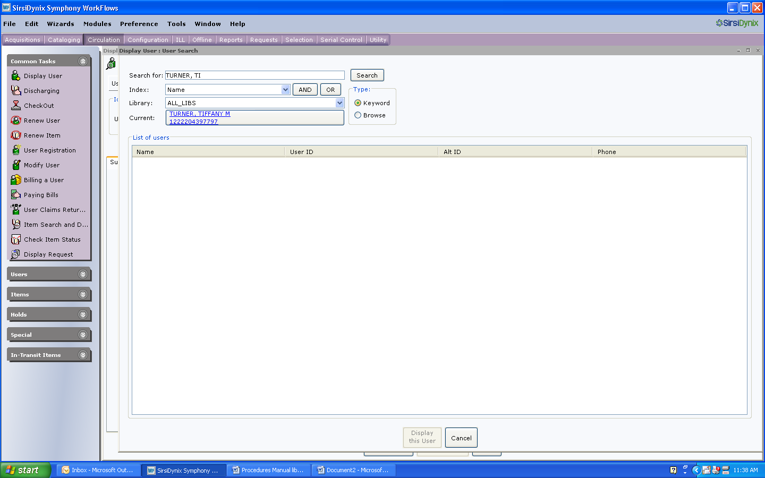

1. View matching names to determine if the customer has previously been issued a card.
2. If no matches are apparent, issue a new card.

**Duplicate Names**

If you find a duplicate name, compare the customer’s birthdate, address and/or phone number to determine if this is a duplicate user. If you have questions about the status of a possible duplicate card, check with a supervisor or senior staff member before issuing a card.

**Patron already has a card. To issue a replacement card**:

1. Check account notes and check for outstanding transactions.
2. If there are bills on the account, inform the customer and negotiate fines/charges. (If there are lost items, refer to Lost Item procedures).
3. Notify the customer of the 50 cent charge for the replacement card.
4. To issue the replacement card, click Modify User.

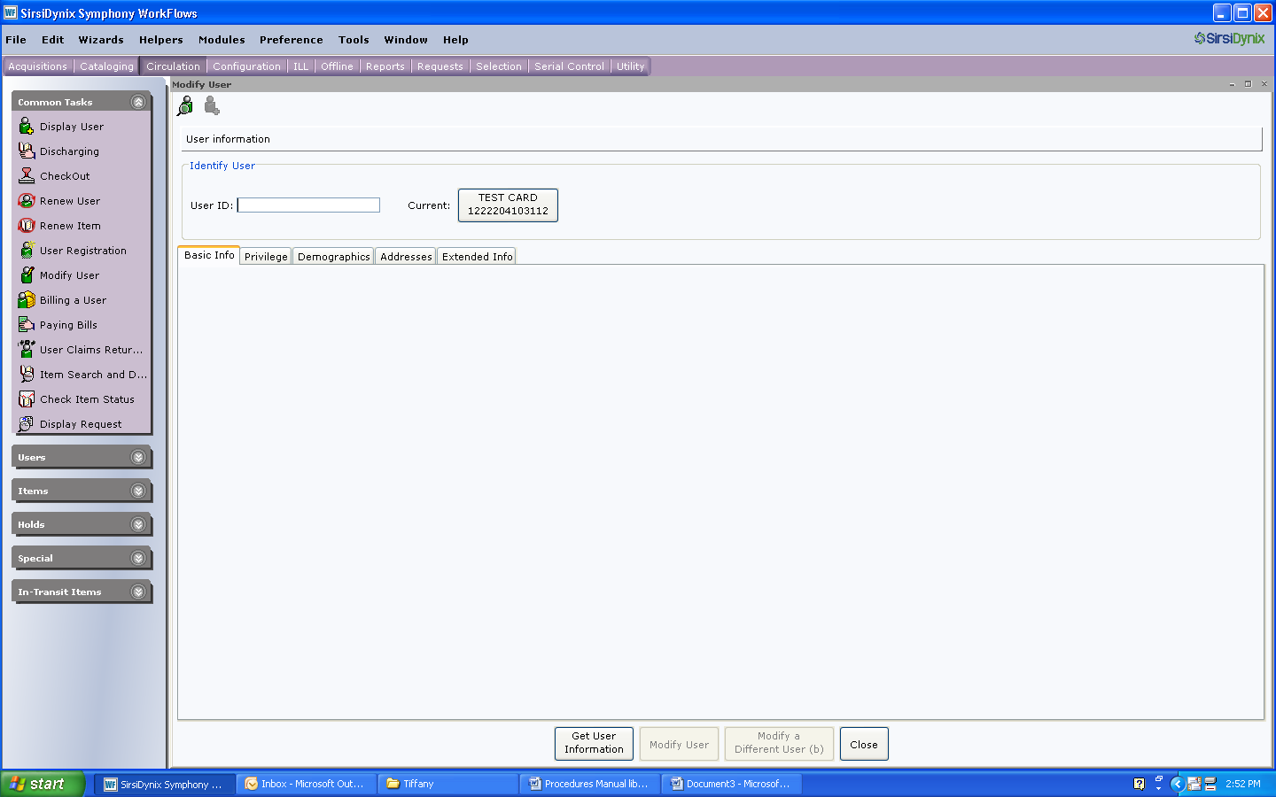

1. On the Basic Info tab, scan new card number over existing card number.

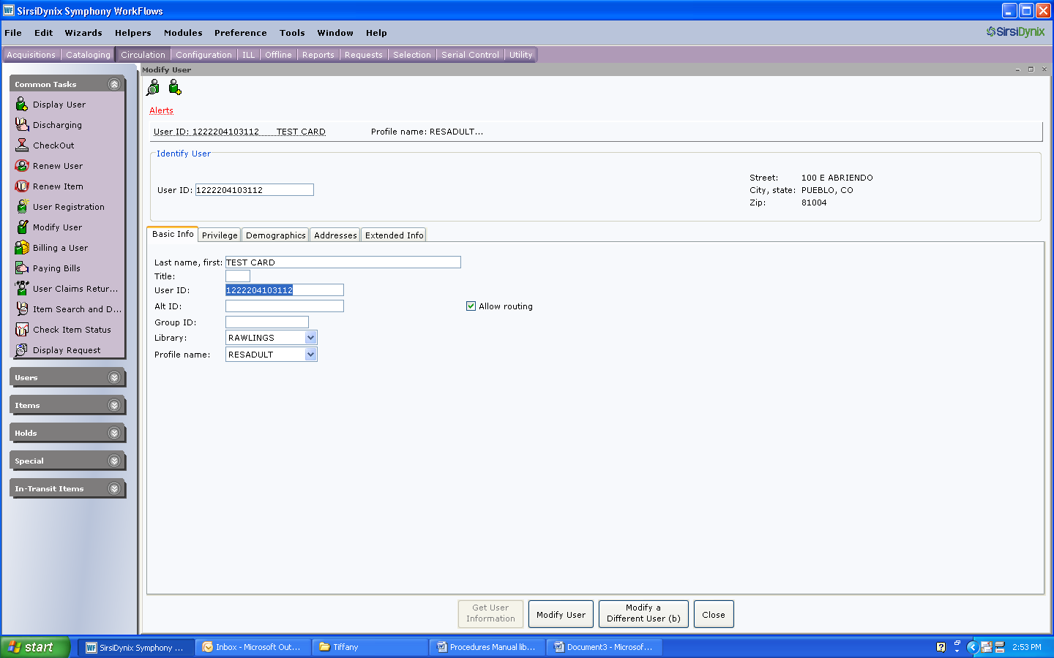

1. Check the privilege, demographics and addresses tabs to update information.
2. If you are processing a replacement card, the privilege may have expired.
   1. Click the Privilege tab.
   2. Enter NEVER in the privilege expires box.
   3. Enter the override code.

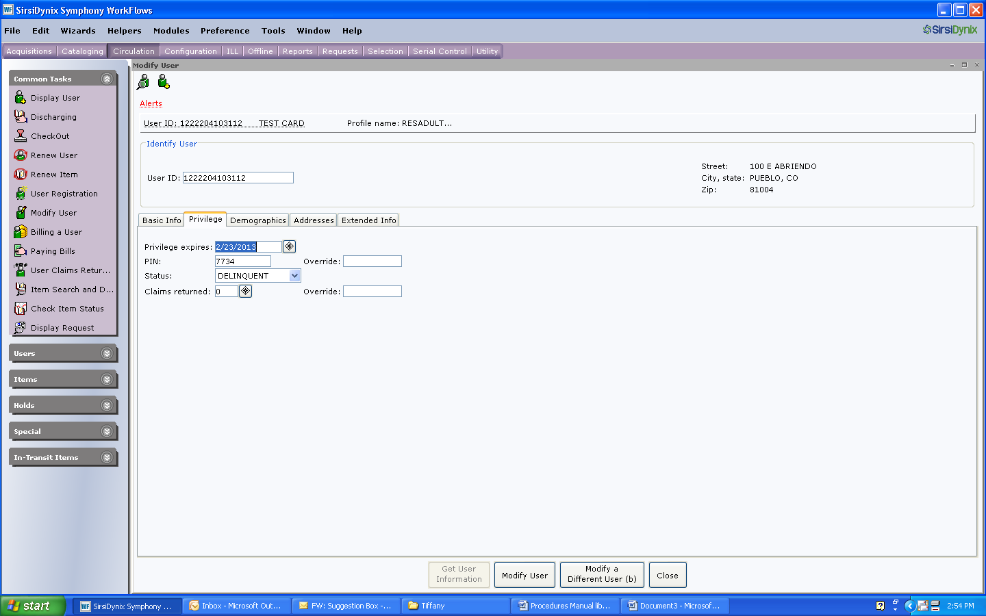

1. After making the account changes, click on Modify User.

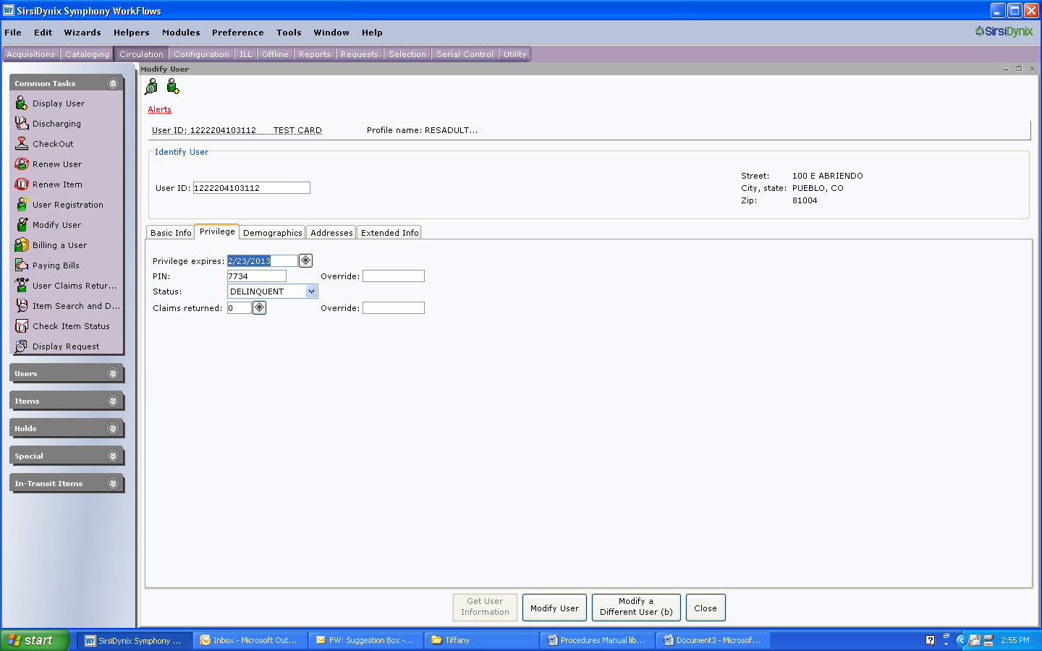

1. Click Close.
2. **Scan the new card again to verify the new account number.**

**New Cardholder**

1. Click on the User Registration Wizard.

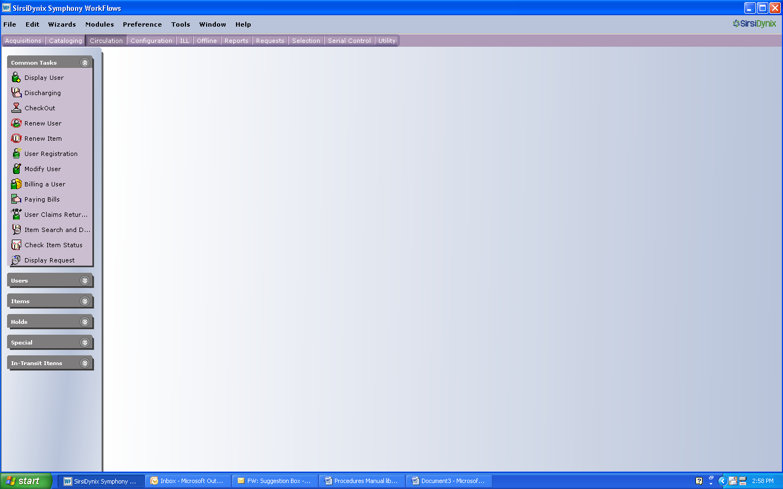

1. Scan the barcode for the new card.
2. On the Basic Info Tab, all of the following information should be entered in upper case letters. Enter last, first and full middle names. It is important to enter the middle name to avoid confusion over duplicate names.
3. Enter a comma after the patron’s last name. This is important because it impacts the way names appear on written notifications that are sent to customers.
   1. Do not use other punctuation, except a hyphen for hyphenated names.
   2. Do not skip spaces in names (ex: ONEAL, MCCONNELL, etc.)
   3. Do not include apostrophes in names.
   4. Put JR, SR, III, etc. at the end of the name sequence. (ex: SMITH, JOHN A JR
4. Select the appropriate profile. To change the profile, click on the arrow box, scroll to the appropriate name and click the correct category.

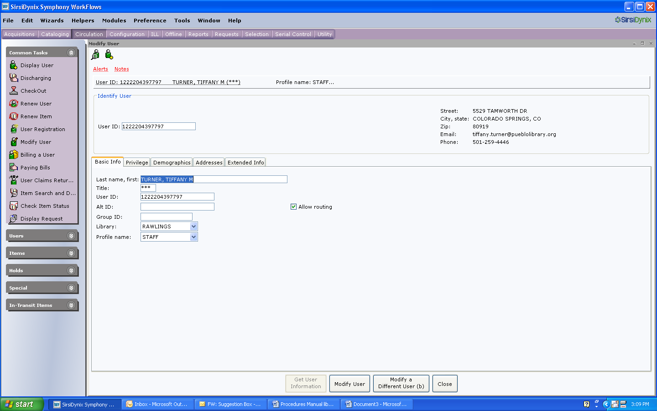

1. Click on the privileges tab.
   1. The privilege expiration date should default NEVER. Enter a 30 day expiration date for UNVERFIED or SPECIAL profiles.
   2. Change the PIN to the customer’s eight digit birthdate, with no spaces or dashes, (ex: 07051962) unless the patron requests an alternate PIN.
   3. Enter the override code to change the PIN.
2. Click the Demographics tab.
   1. Tab to Birthdate and enter mm/dd/yyyy.

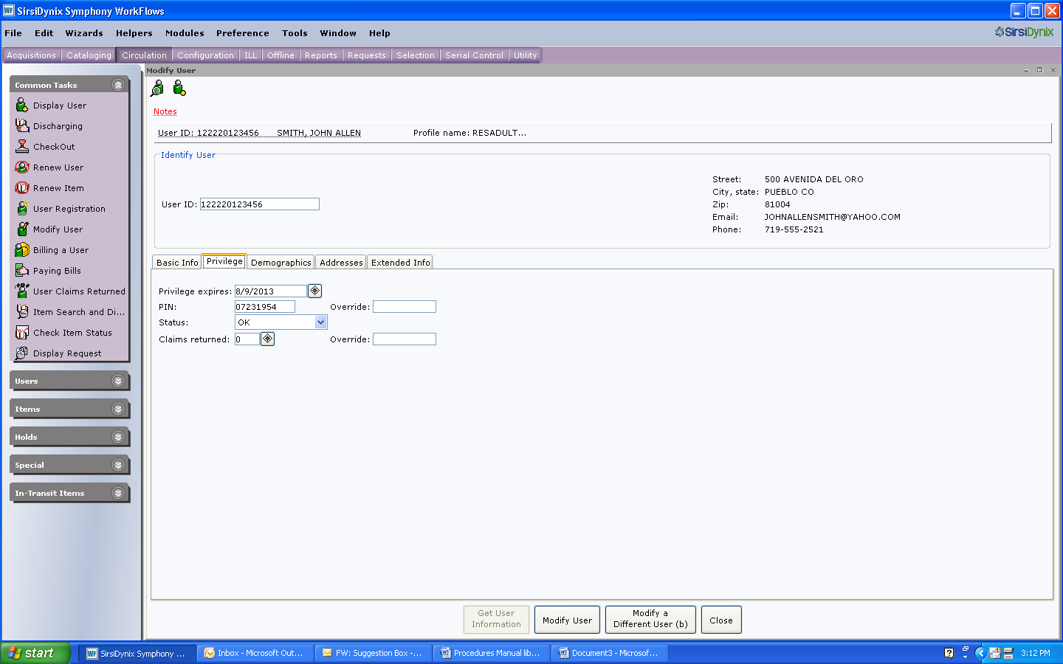

1. Click on the addresses tab.
   1. Tab to street and enter address. Do not use symbols or punctuation.
   2. Abbreviate for street, drive, etc. For example, ST, RD, CT, LN, PL, CIR, AVE.
   3. Use APT for apartment. Ex: APT 2 or APT C.
   4. A physical address is required; however, a PO box may be listed in Address 1 as a mailing address, as long as the physical address is also listed in Address 2.
   5. Tab to City/State and enter city and state. Abbreviate Colorado as CO.
   6. Tab to Zip and enter zip code.
   7. Tab to phone and enter one phone number. Be sure to hyphenate between the area code, prefix and number. (ex: 719-562-5600)
   8. Tab to email and enter email address.

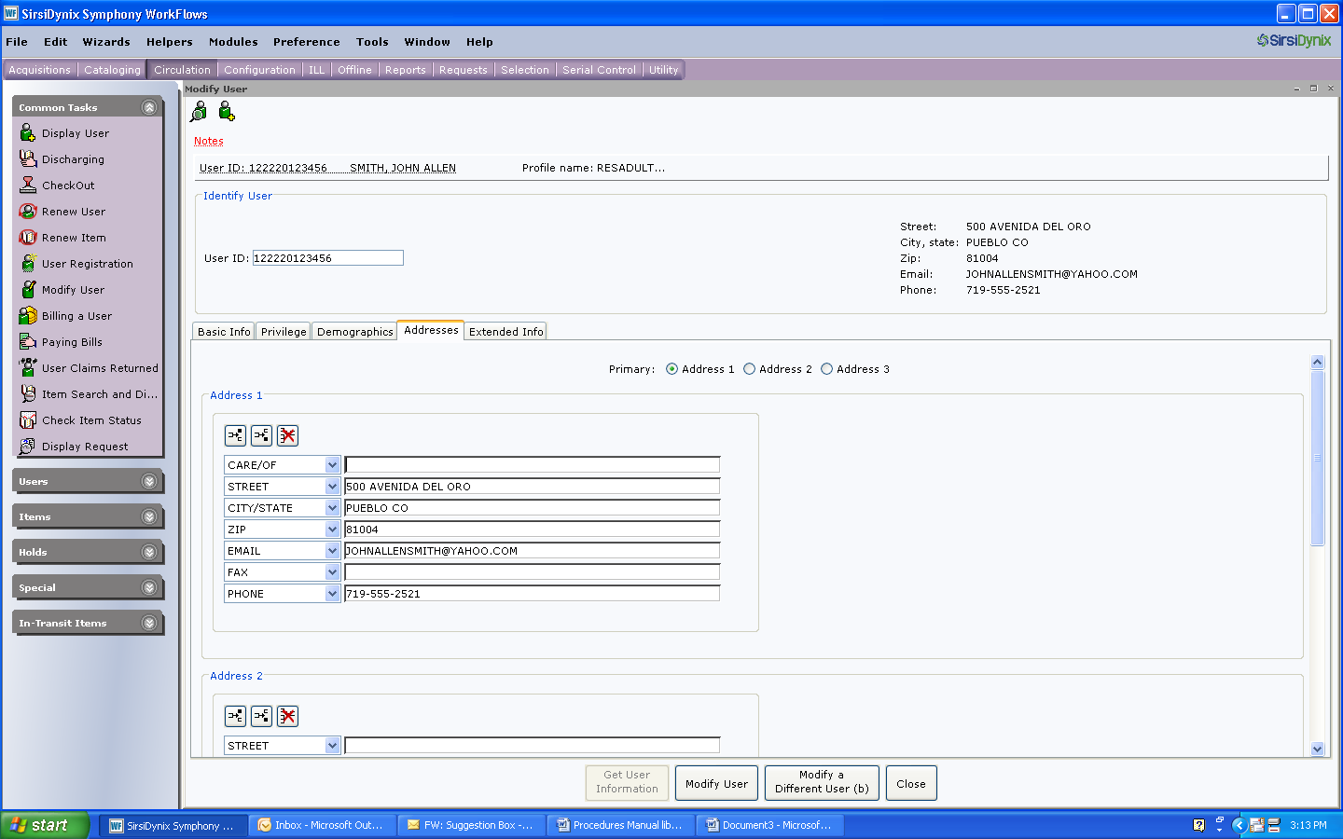

1. Click on the extended info tab.
   1. In the note field, enter staff initials and location. Ex: TT/RA
   2. In the notify via field, enter the customer’s notification preference. Ex: PHONE, EMAIL or PAPER. Paper notifications should only be used under exceptional circumstances.

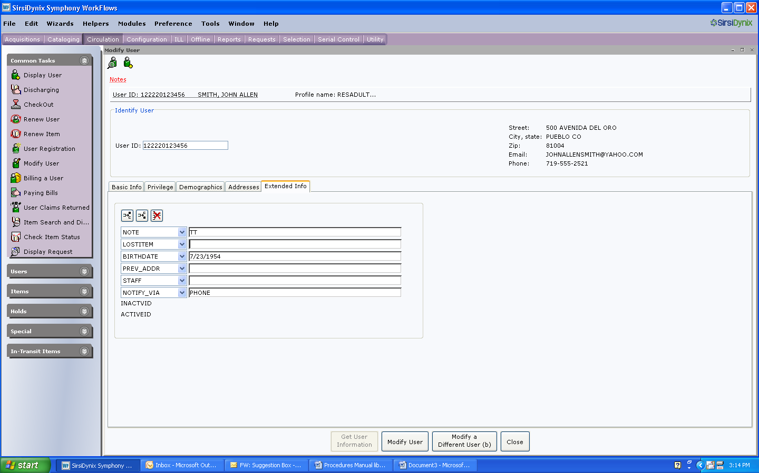

1. Click on Check Duplicate User. Investigate possible duplicate accounts if necessary.
2. Click Register User.
3. Ask the customer to sign their library card. If a child is too young to write, the parent may print the child’s name on the card. Emphasize that by signing the card, the cardholder accepts responsibility for items checked out on the account and fines and fees that accrue on the account.
4. Give the customer the library brochure and highlight library policies (checkout limits, loan periods, phone renewals, branch locations, the importance of reporting cards lost/stolen, and the importance of keeping contact information current).

**Lost/Replacement Cards**

This section pertains to handling situations dealing with lost/stolen cards.

**Patron calls to report card lost/stolen**

1. Click Modify User.
2. Access the customer’s account by searching his/her name
3. Change profile to LOSTCARD.

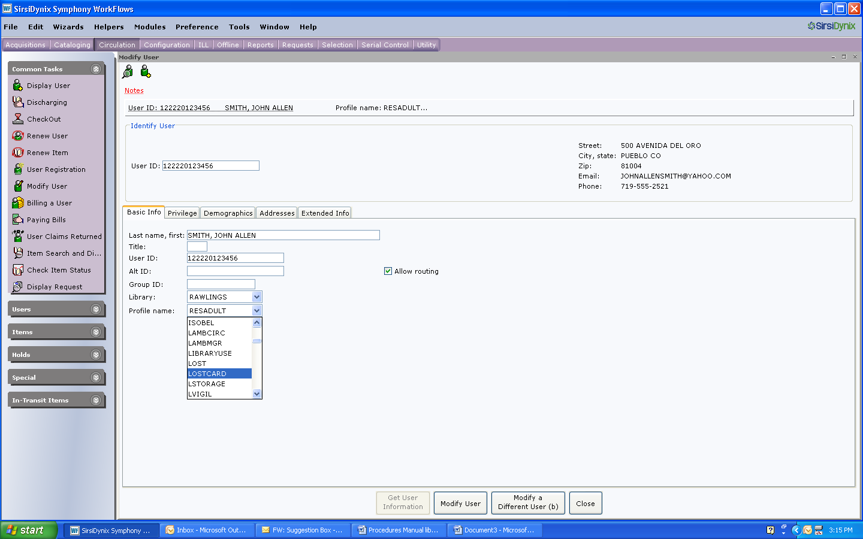

1. Add the following account NOTE, including date, initials and branch location: “Customer reported card lost/stolen. Check ID.”

Note: If a patron later calls to report that they have found their card, ask them to bring a picture ID on their next visit to the library. After you have checked the customer’s identification, change the account back to its regular profile.

**Issuing a Replacement Card**

Replacement cards are issued for .50 cents. When a replacement card is issued, previous numbers remain attached to the customer’s account and will display in the note field.

1. Verify customer’s identification.
2. Click Modify User.
3. Click User Search to browse for customer by name.
4. Scan new card number over old card number on the Basic Info tab.
5. Charge .50 for the replacement card.

**Library Card found at library location**

1. Verify the card is active. If not, cut up and discard.
2. Call the customer to let them know we have their card. Let them know where to pick it up and that we will hold the card for 30 days before discarding it.
3. Add the following note, including date, initials and location: “Library card found at ______.”
4. If you cannot reach the patron, place the card in the lost file and hold for thirty days.

**Returning card found a library to patron**

1. Verify customer’s ID.
   1. Adults are required to present a picture ID.
   2. Minors may verify their account information if they do not have ID.
2. Remove lost card notes from customer’s record.
3. Change the profile from LOSTCARD to the customer’s regular profile.

**Change of Address**

Requests for change of address should be handled as follows:

* In person – ask to verify the customer’s ID; however, if patron does not have verification, accept their word if they present their library card.
* Telephone or email request – Change address as requested. Verification is not required.

**To Change an Address:**

1. Select Modify User.
2. Search using patron’s name or user ID.
3. Select Addresses tab and insert correct information.
4. When updating a customer’s postal or email address, delete any account notes requesting address updates.

Note: Although a customer may be updating their address, it is important to inform them of any other account actions, such as holds, overdues or bills. This is also a good time to review and update email addresses, phone numbers, etc.

**Extended Information**

To place notes on a customer’s account, use the Extended Information tab in Register User or Modify User. When entering account notes, be sure to enter the date, your initials and branch location.

It is important to remember that account notes may be read by the customer. Be sure to keep content factual and do not write anything that might be offensive or an opinion. Example: 7/26/10 Explained high demand policy to customer. He understands that we won’t waive fines again. Tt/ra” rather than “7/26/10 Mr. Jones is off his meds today and is a nut case. Tt/ra”.

**Add Notes**

1. Click Modify User.
2. Search for customer by name or user ID.
3. Select Extended Information tab.
4. Place cursor in the existing note field.
5. User Before/After helper. The most current note should always be on top, so most often, you will use the Before helper arrow.

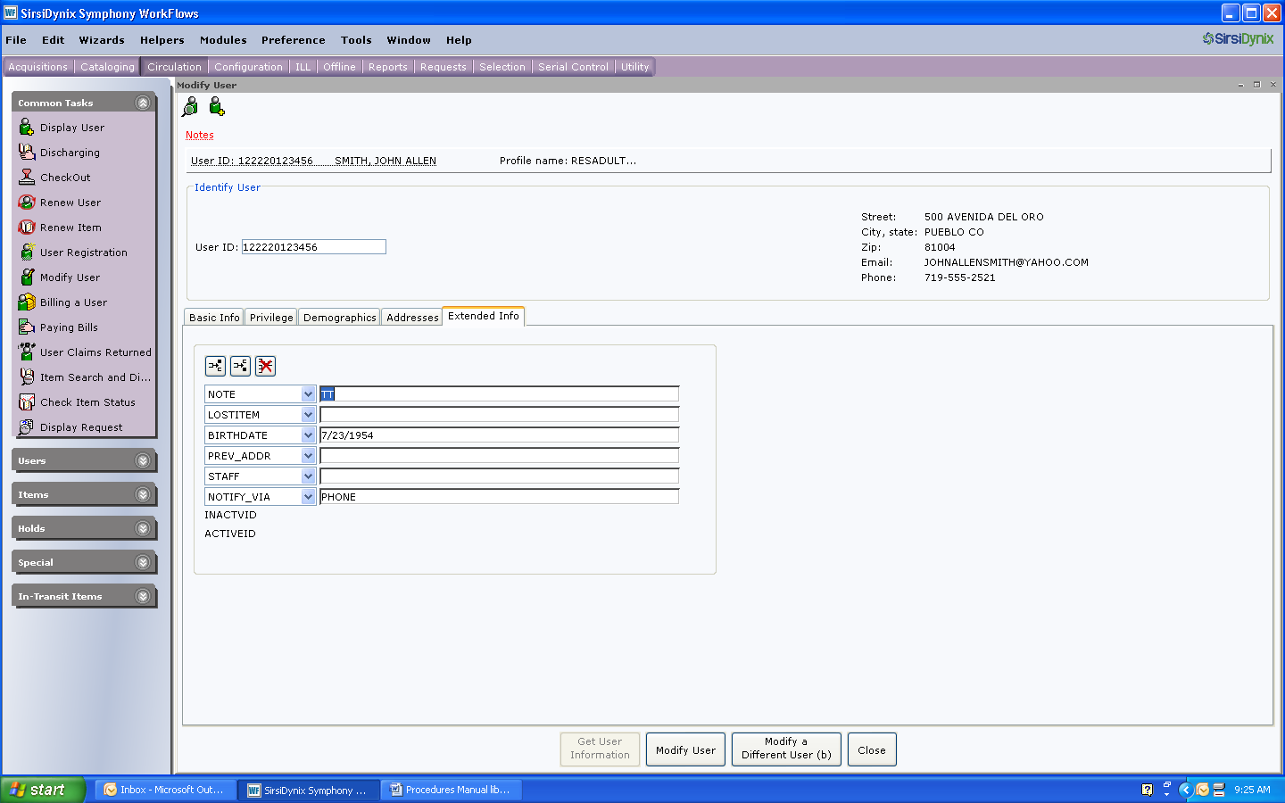

1. Click on the down arrow in the new field and select NOTE.
2. Enter the note and click Modify User.

**Delete Notes**

1. Follow steps1-3 above.
2. Place cursor in note field to be deleted, or highlight note.
3. Click Delete Row.