**Instructions for overriding and replacing a restriction on a patron account.**

If you need to override a restriction on an account you can remove the restriction to checkout and then replace the restriction by following the instructions below.

1. If there is a restriction to override you will click on where is says view restrictions or click on the tab at the bottom of the record that says Restrictions.

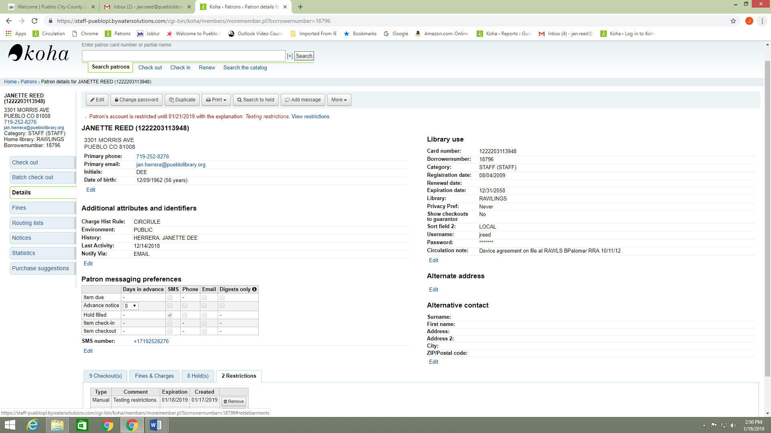

1. Note the reason for restriction and the expiration date so that you have the information when adding back the restriction.
2. You will see a box with the restriction and to the right will be a button that says Remove that you can click on to remove the restriction.

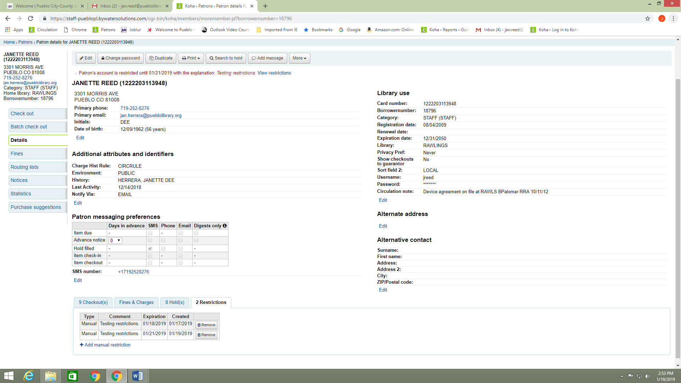

1. Proceed with the checkout.
2. After checkout click on the Restriction tab and add a manual restriction. Put in the explanation for the restriction and the expiration date for the restriction.

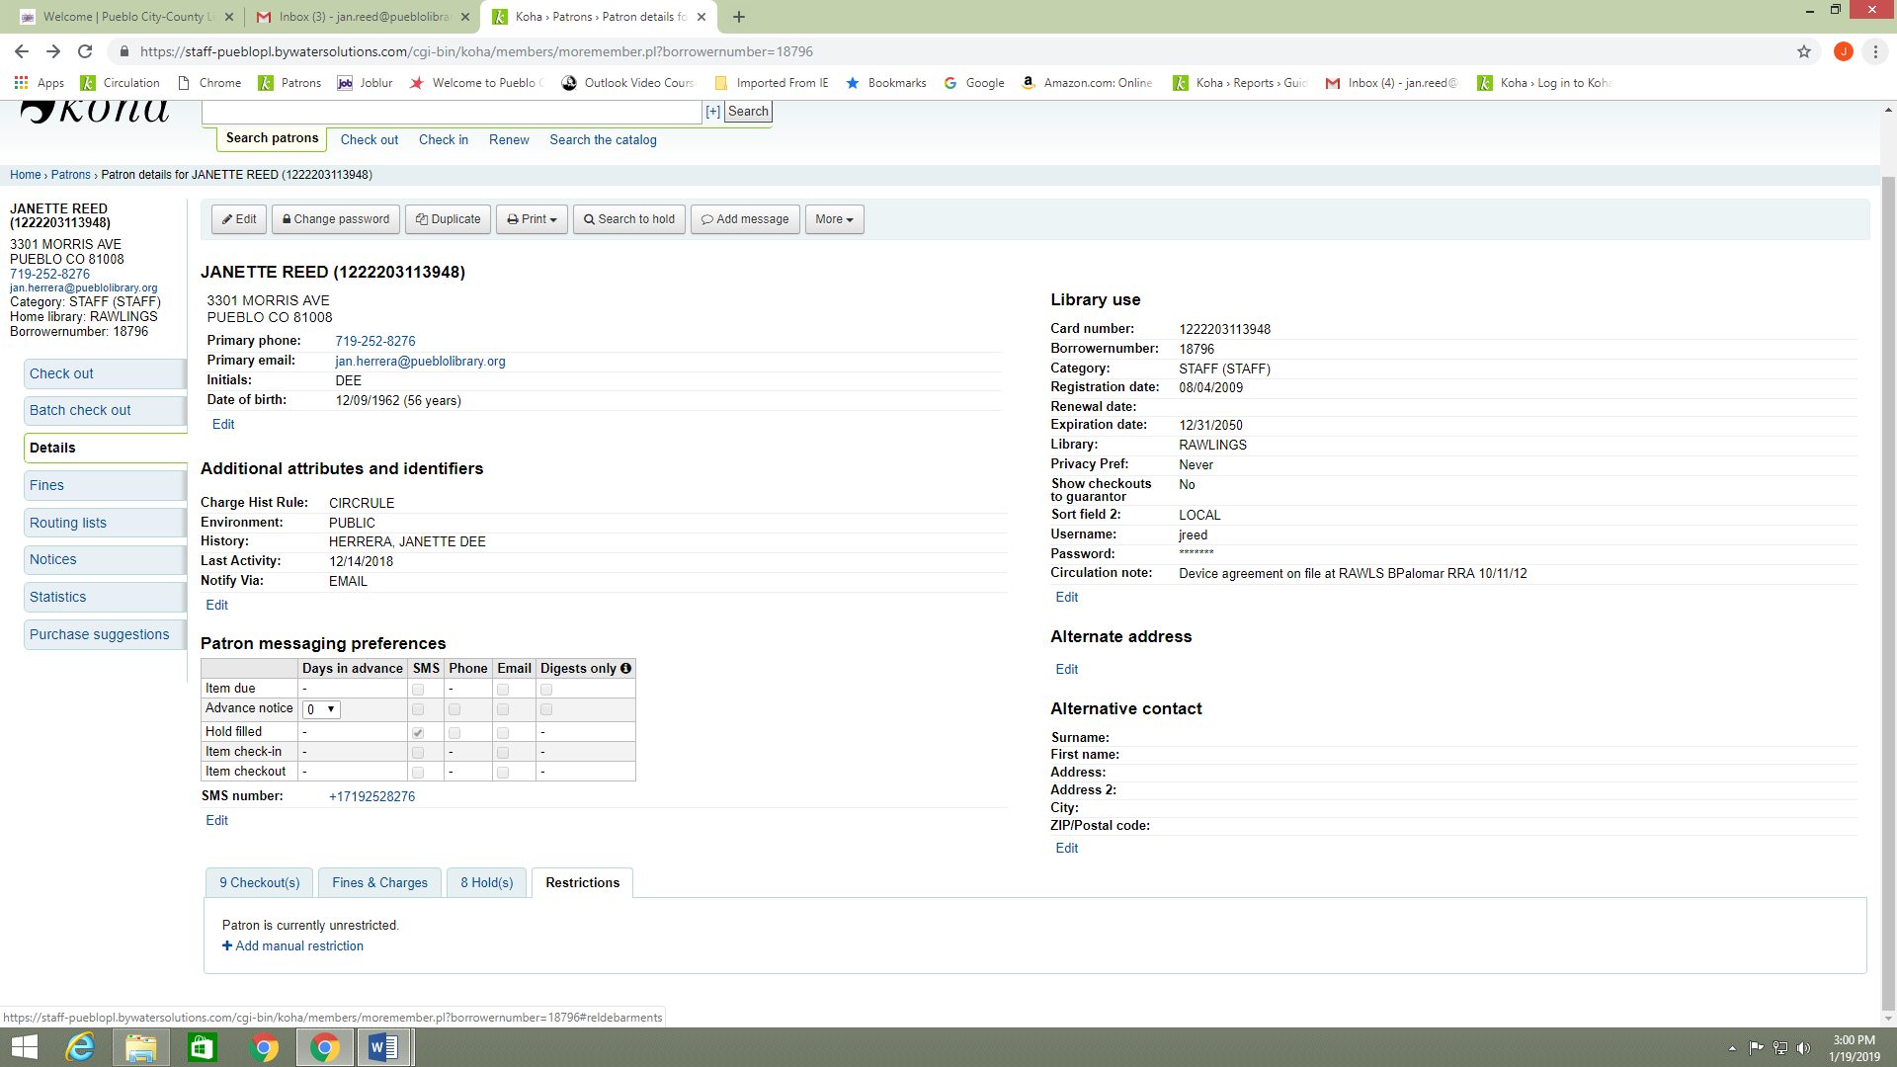

1. Lastly, click the add restriction button. You will see the restriction at the top of the patron record.

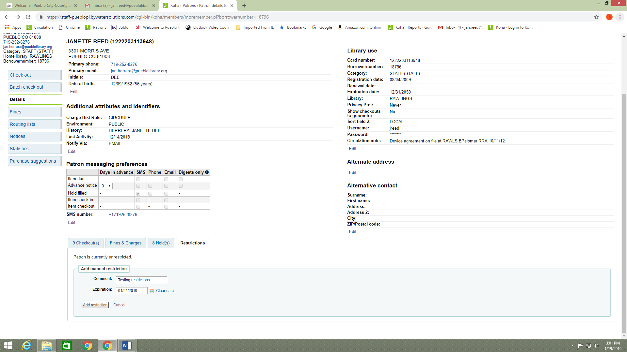

1. You will see the restriction at the top of the patron record.

