**How to renew an item**

Although patrons cannot renew items online or on the kiosk, staff can override and renew items that don’t have holds or are Quickview or Quickread items.

1. When in the patron record open the checkouts tab and show check outs.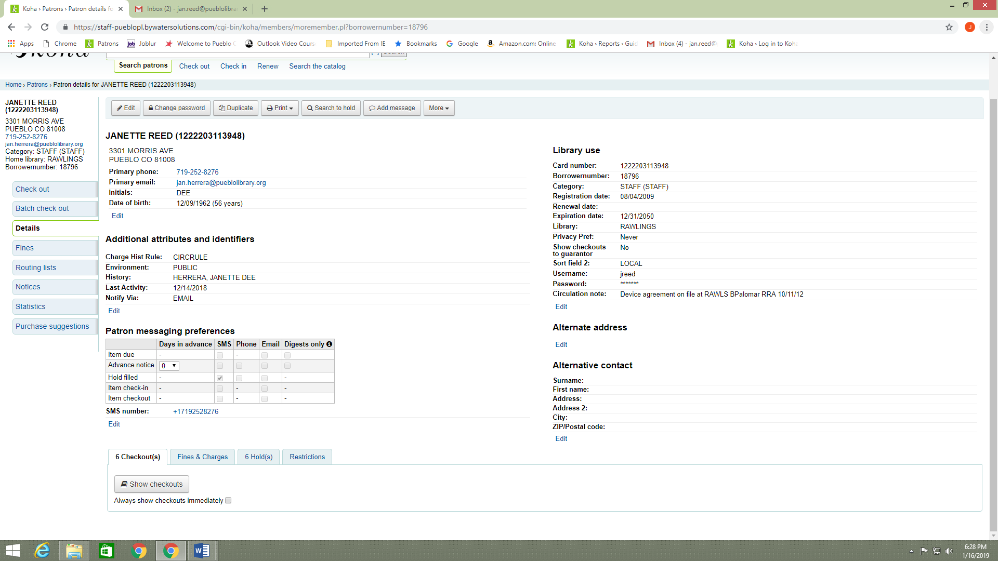
2. At the bottom of the screen you will click the small box next to override renewal limit. This will open the renewal column with check boxes next to items that are available to renew.

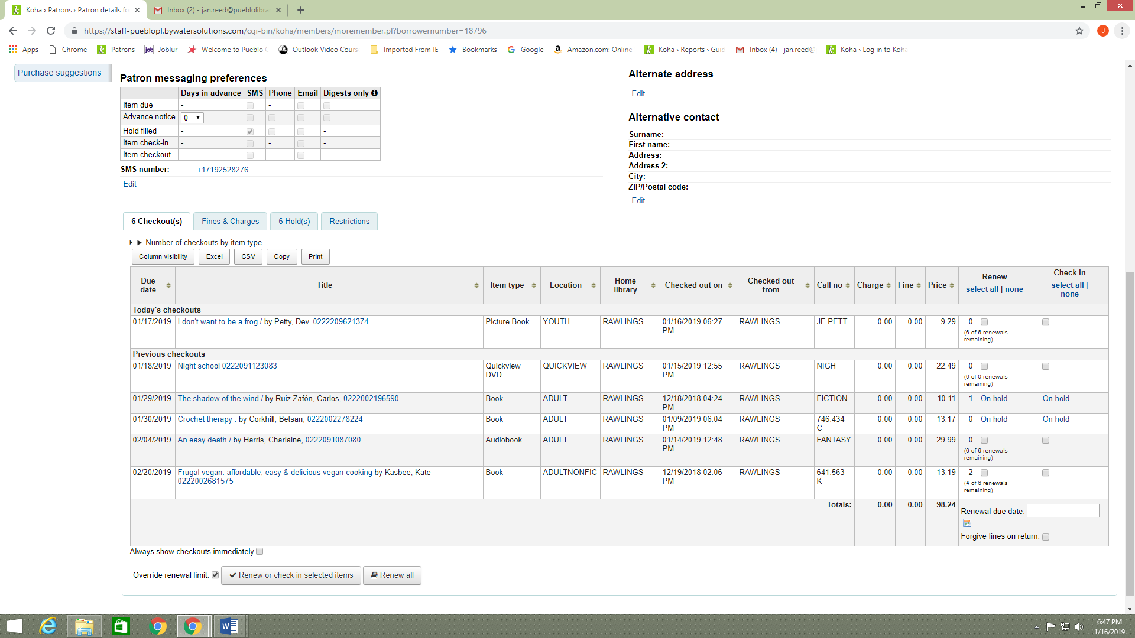

1. Click in the box for the items you want to renew and then go back to the bottom of the screen and click the button that says Renew or Check in Selected Items.

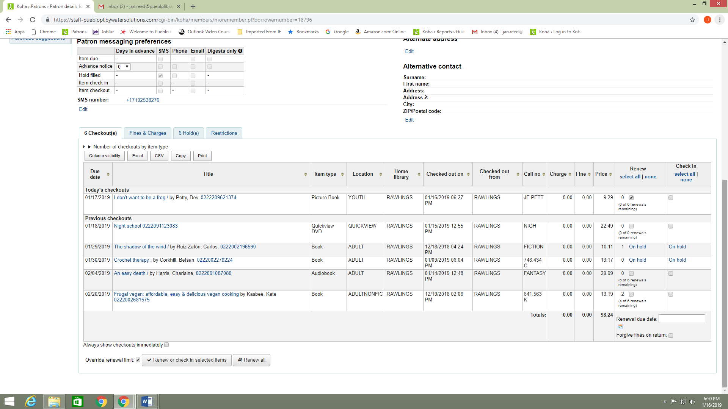

1. If you want to renew everything you can click on the Renew All button.



1. The new due date will show up in the Renew column next to the item renewed, as well as the due date column.

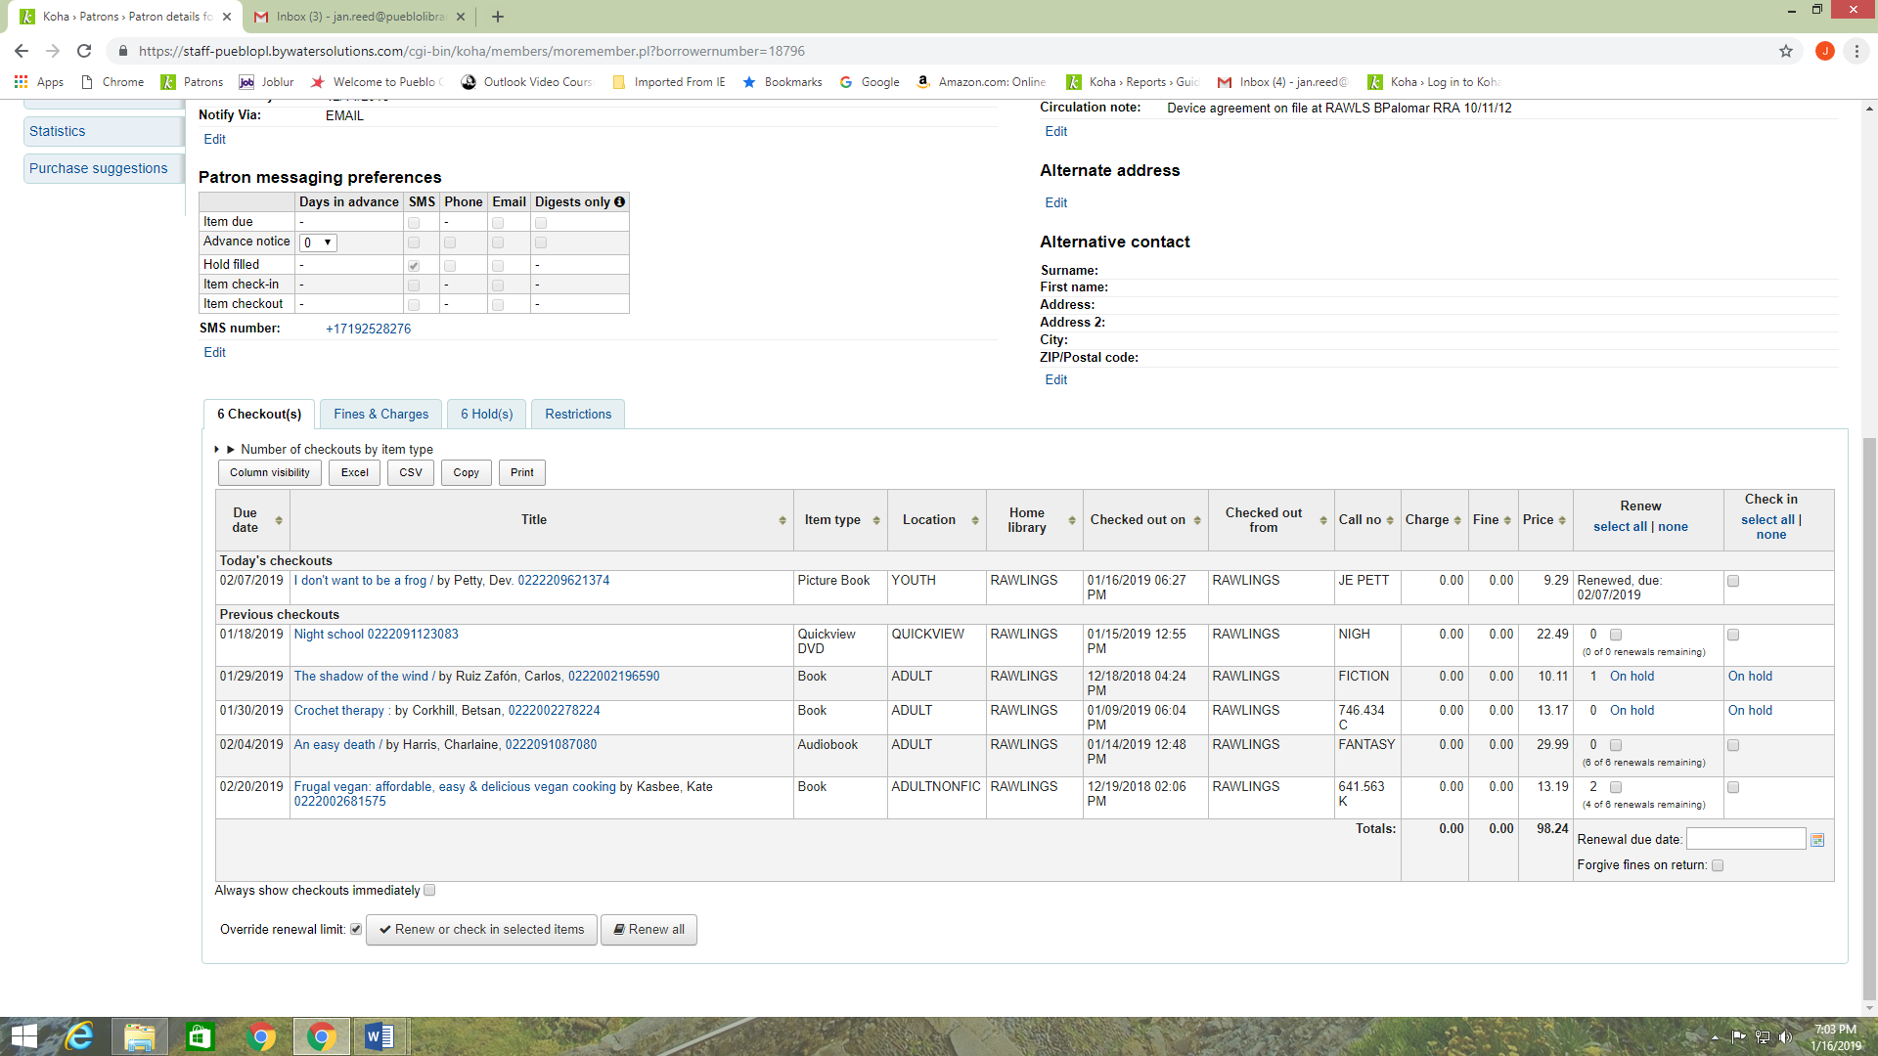

1. Another way that you can renew for patrons, if they have the item with them, is to use the Renew option that is under the search box at the top of the screen.

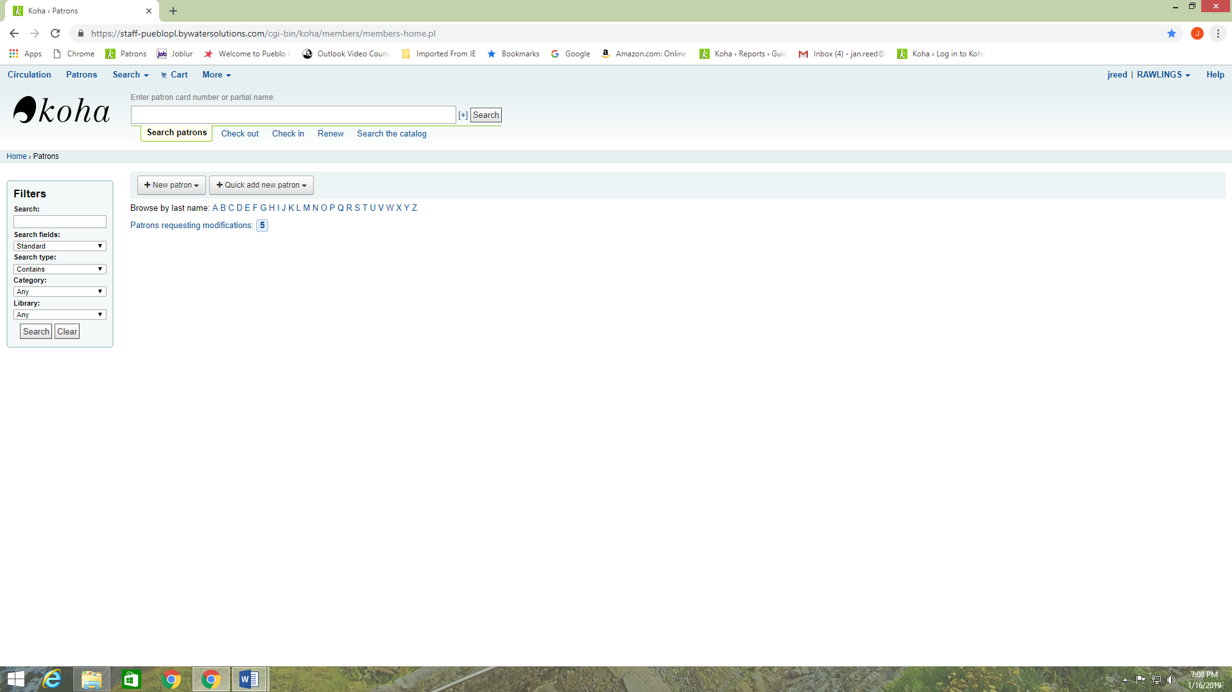

1. You will scan the item barcode and then the yellow screen will display Override and renew or Continue without renewing. Choose your option and then the information will display on the account as mentioned above.

