**How to print a receipt for a payment made at desk or self-check**

1. Pull up patron’s account. Click on the fines button on the left-hand side of the screen.

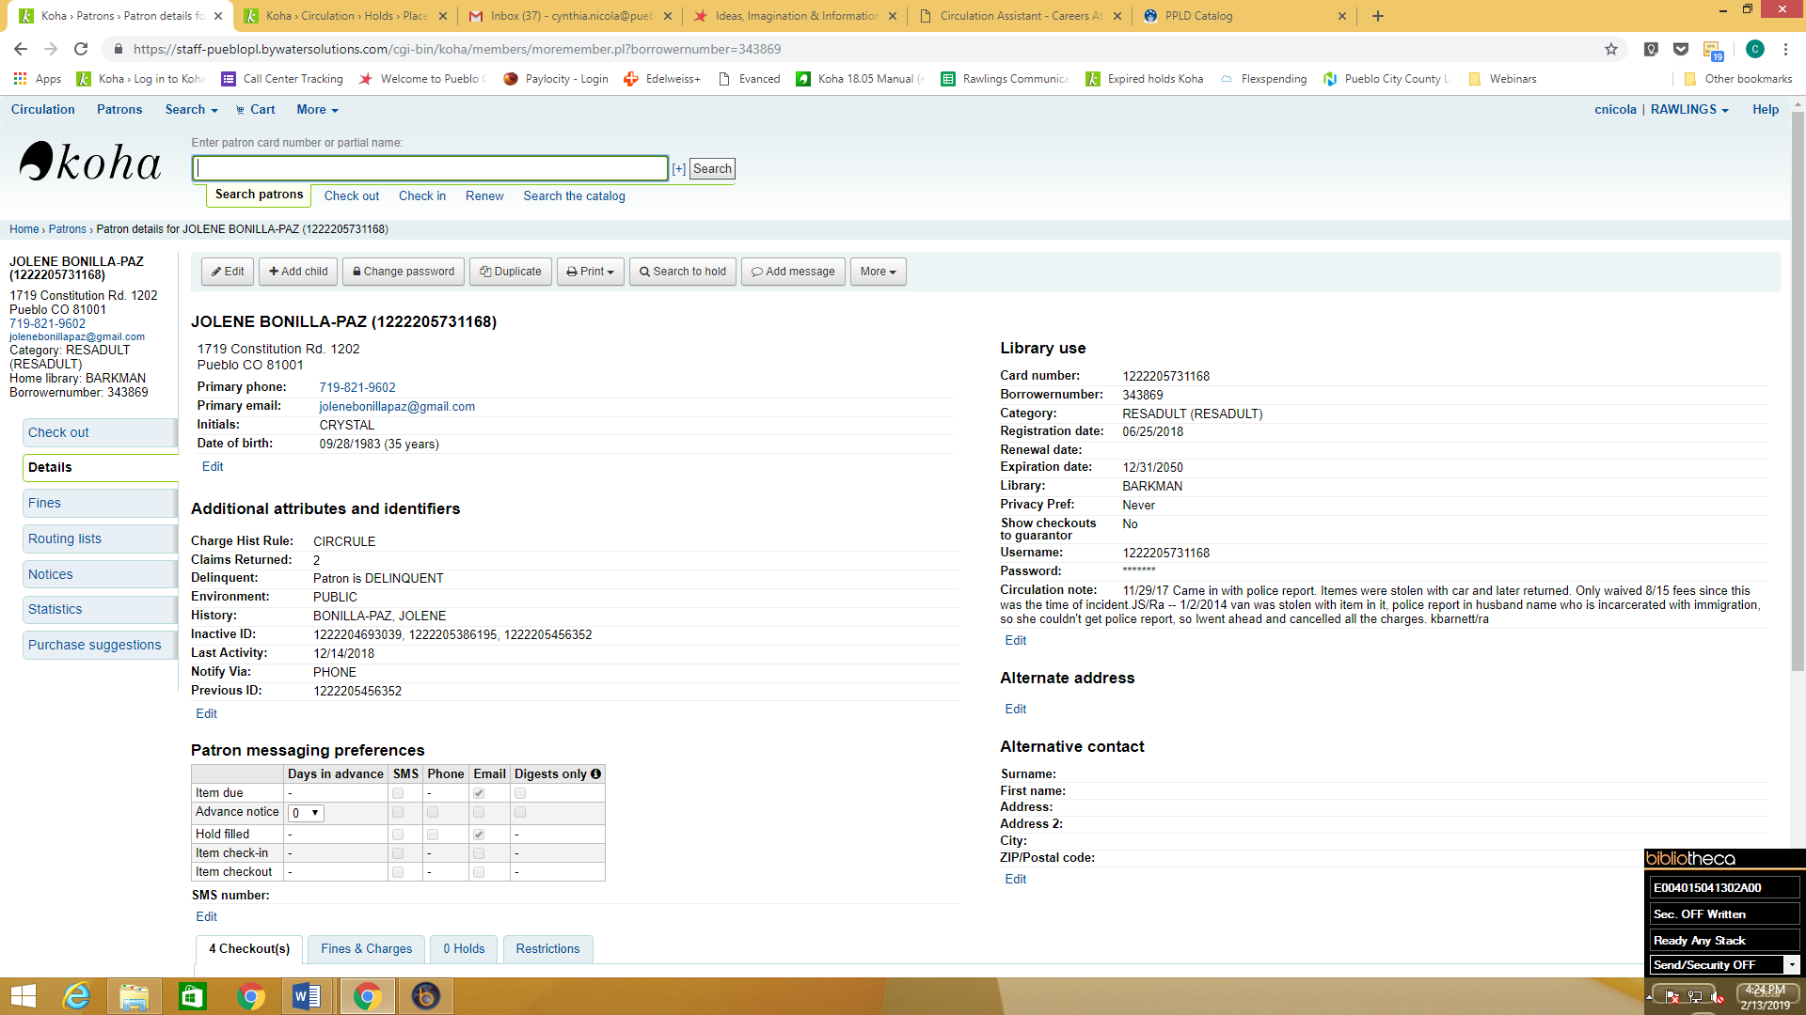

1. Next, click on the account button.

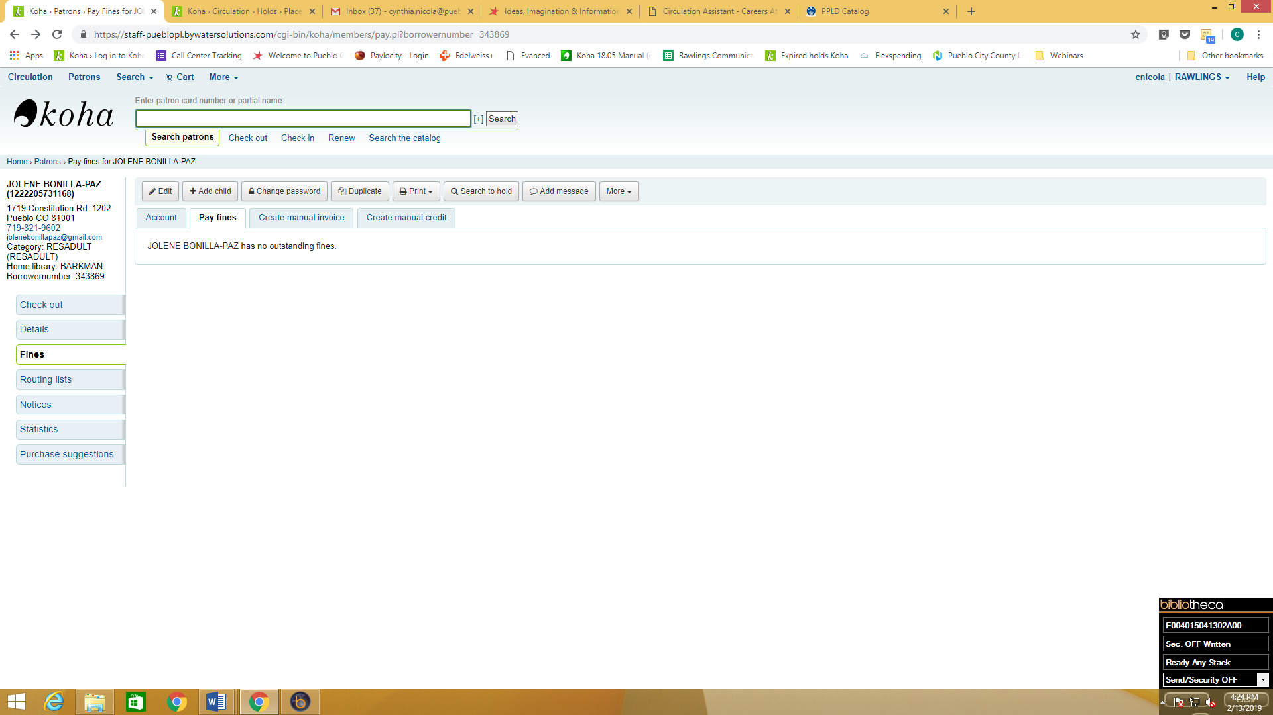

1. You can then choose to print all payments by clicking the print button located above the fines paid area.

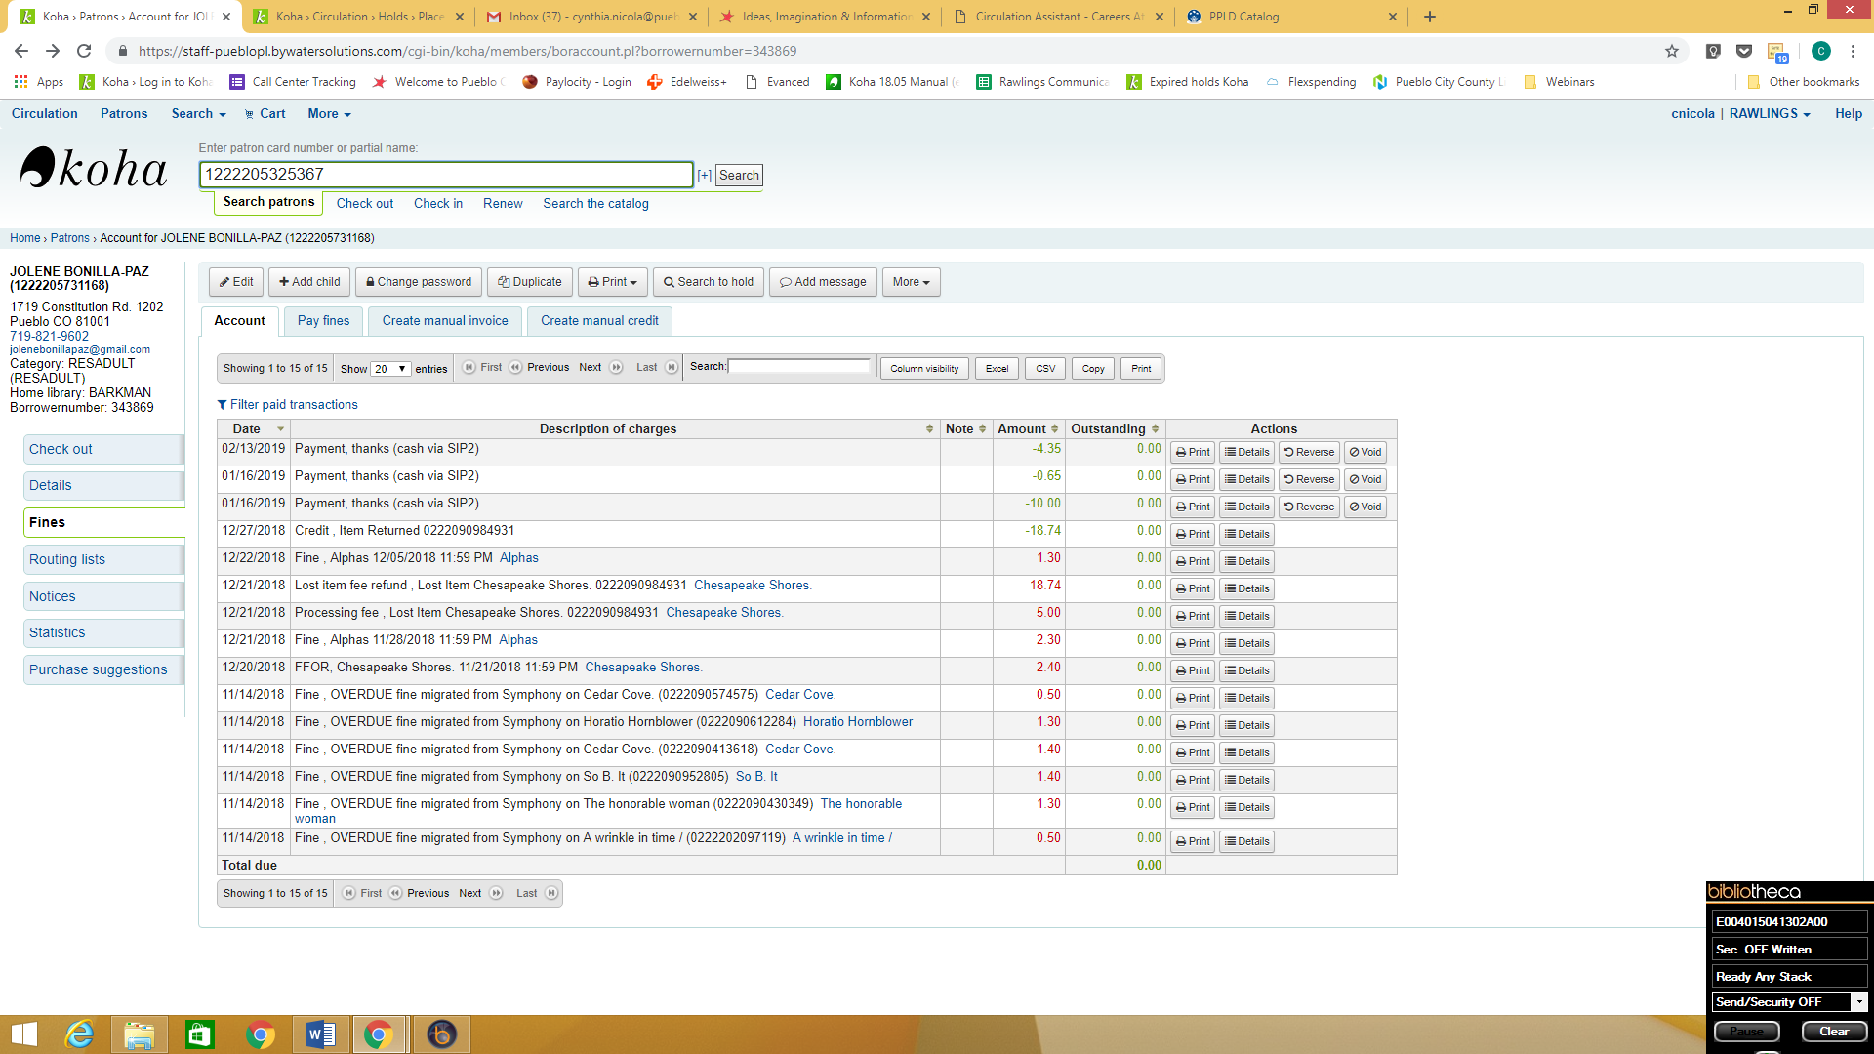

1. The fines paid will print on a full sheet of paper from a regular printer.

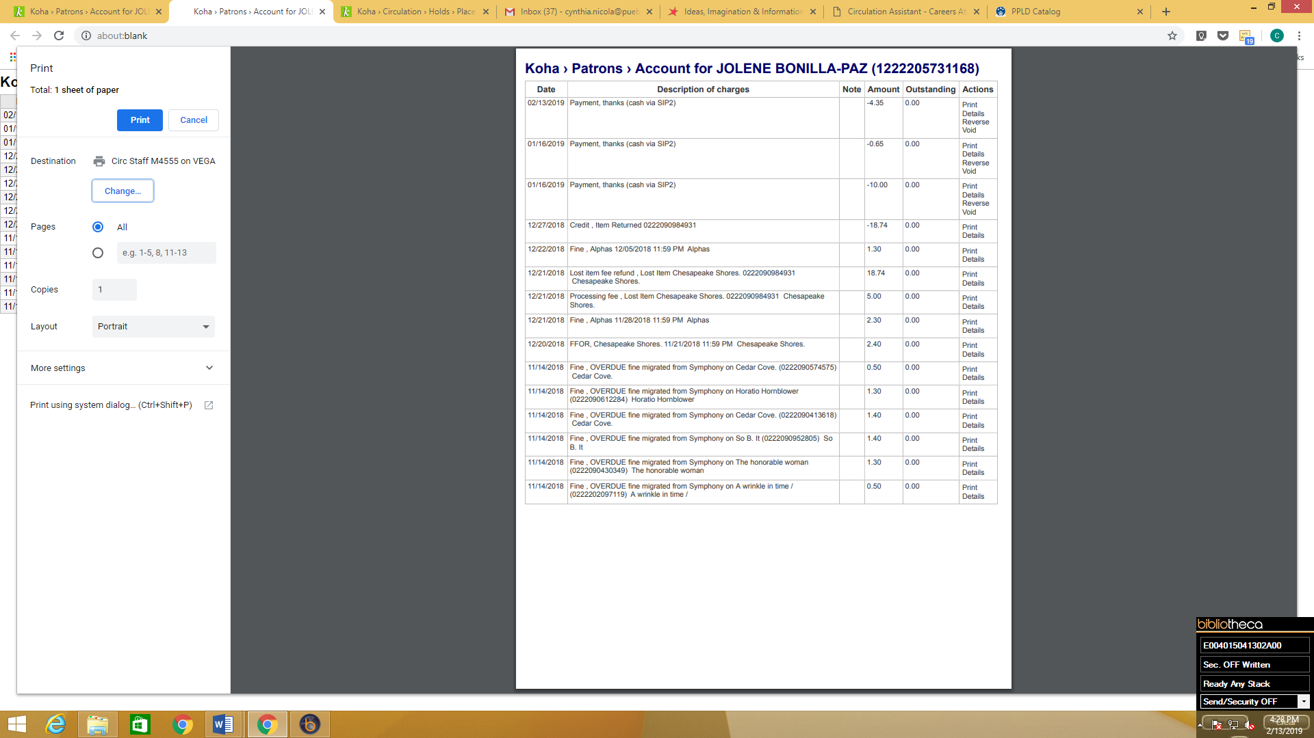

1. Or you can print a specific payment by choosing the print button to the right of the item paid.



1. The individual fine paid will print from your receipt printer.

