**How to change your library location**

1. Go to main screen in KOHA. In the upper right hand corner of the web page you will see your login name and location.

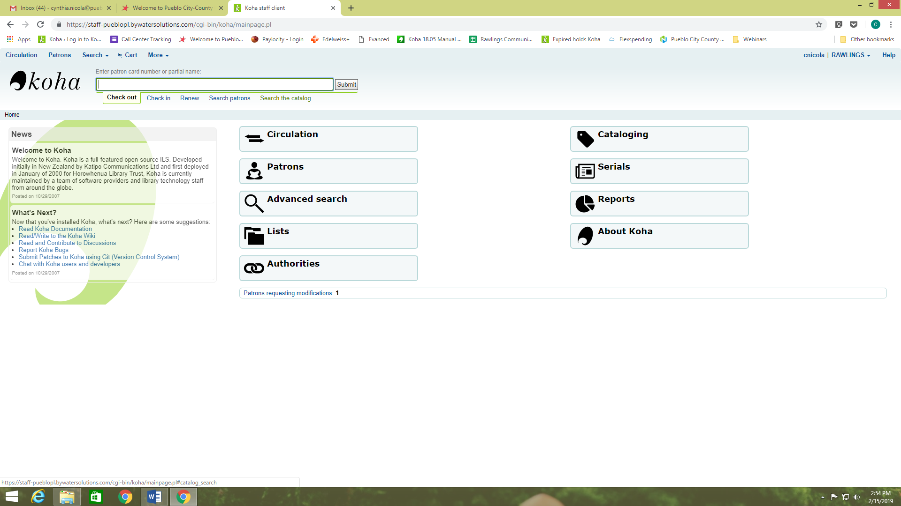

2. Click on the library location and a drop down menu will appear. Click on Set Library.

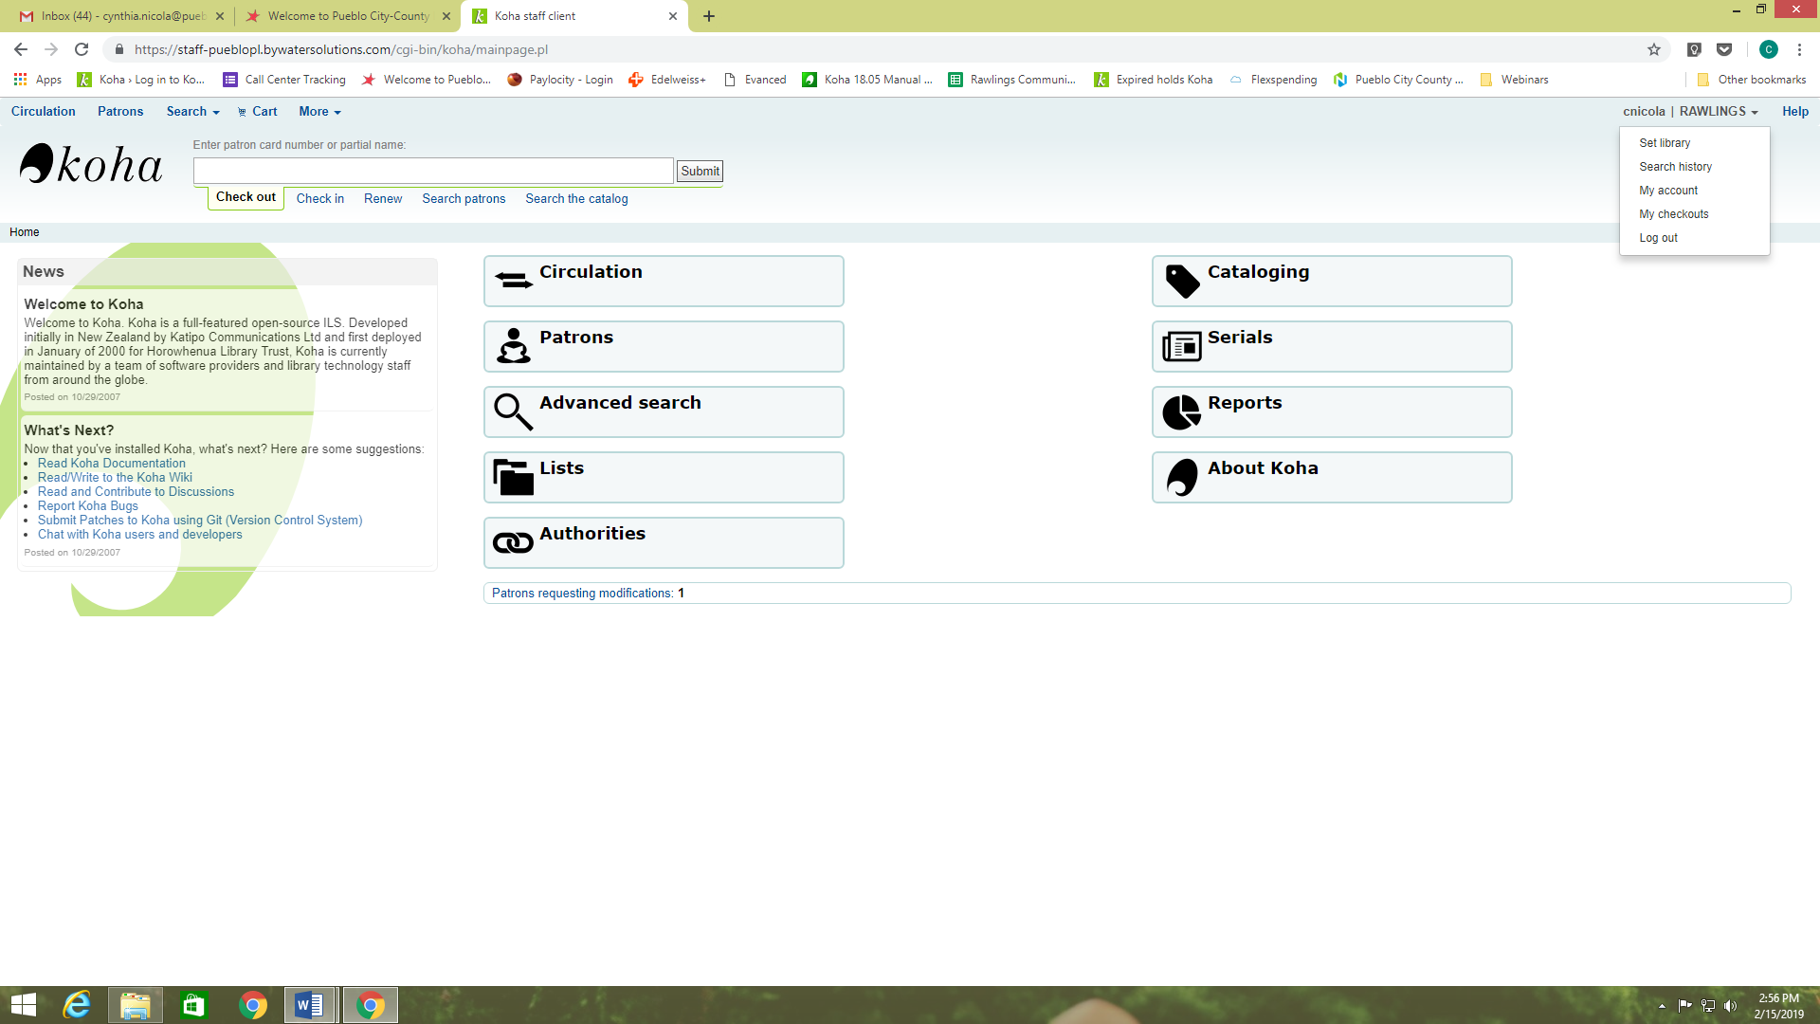

3. Once the new page appears you click on the Choose Library field and a new drop down menu appears with other library locations.

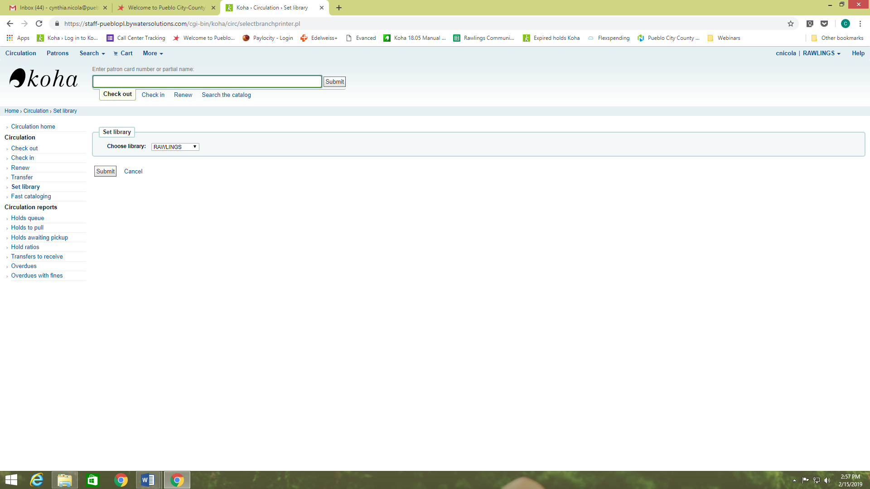

4. From the drop down menu, choose your current location and then click the submit button.

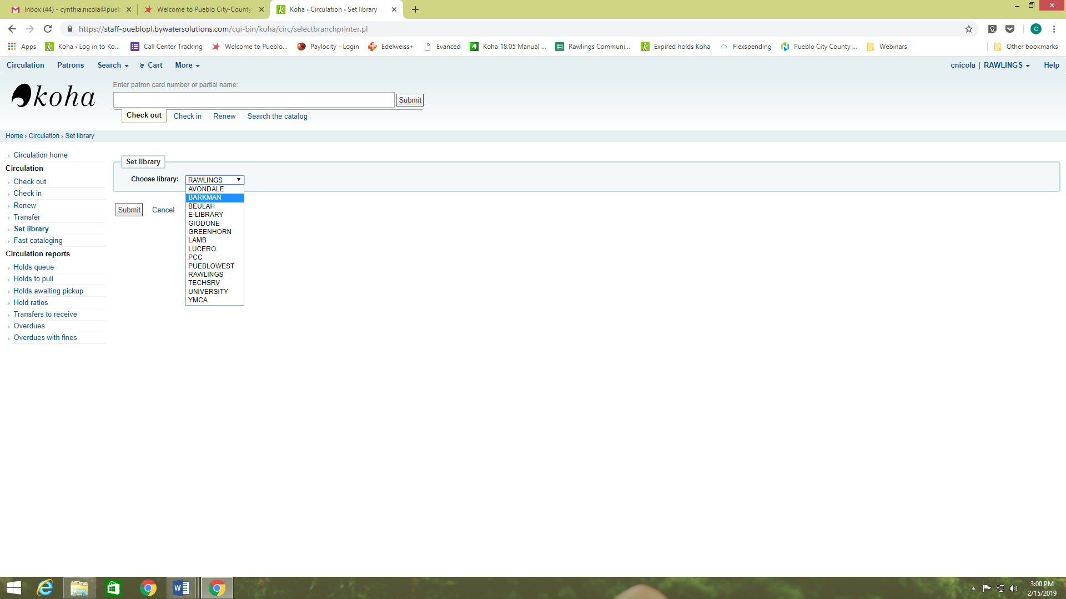

5. Your current location should now show in the upper right hand corner.

