**How to Print out an Expired Holds List**

To print out the expired holds list go to the Bywater link

<https://staff-pueblopl.bywatersolutions.com/cgi-bin/koha/reports/guided_reports.pl?reports=33&phase=Run%20this%20report>

Note: Do not use the KOHA reports to get the expired holds list because it is not the most current. Use the Bywater link which will look like the KOHA page but is the most current expired holds.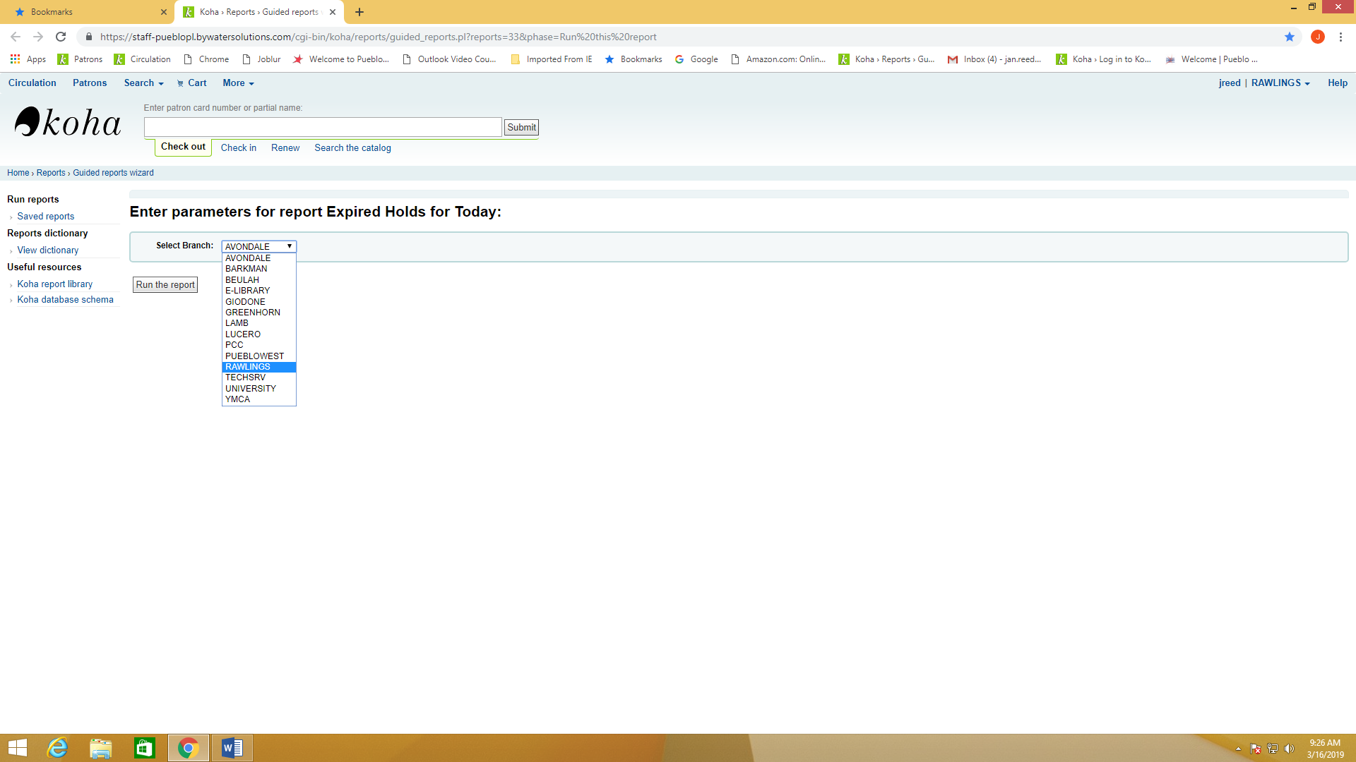

1. Sign in just as you would in KOHA if needed. You should see the heading, Enter parameters for report Expired Holds for Today. You will select the branch you want the expired holds list for. Once you have chosen the branch, click on the Run the report button and the report will generate.

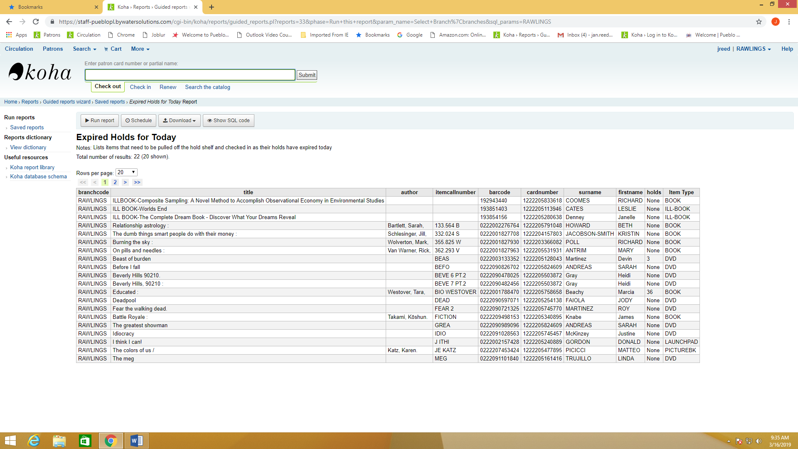

1. Next, you will select the Download option from the taskbar above the report. Once you open the menu and see Open Document Spreadsheet you can click on that option to open an Excel spreadsheet.

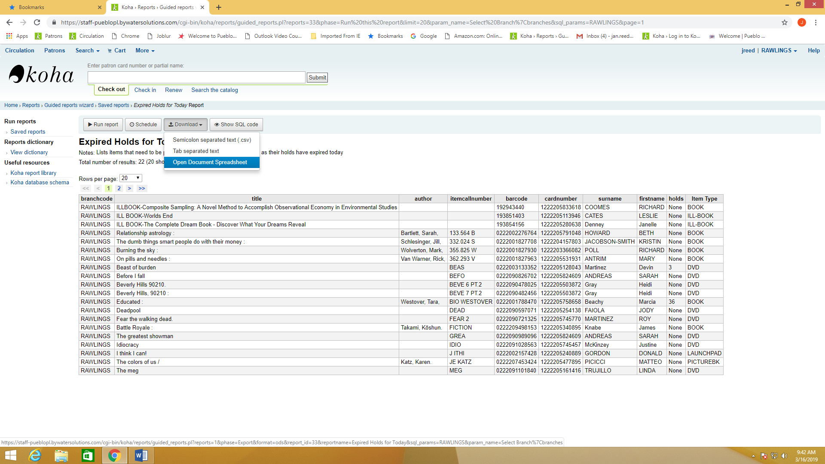

1. To open the Excel report you will click on the box in the bottom left corner of the screen and click open.

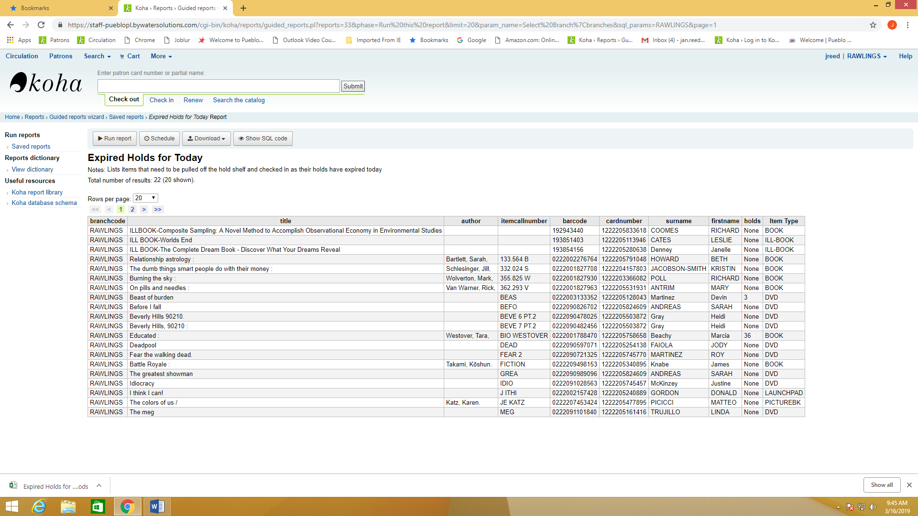

1. When the Excel document open click on the Enable Editing button at the top of the screen so that you can modify the document to include only needed columns. Once you get your Excel document, if you know how to clean up the document and take out what you don’t need you can stop here. If not you can continue on for detailed instruction on how to clean up the document before printing.

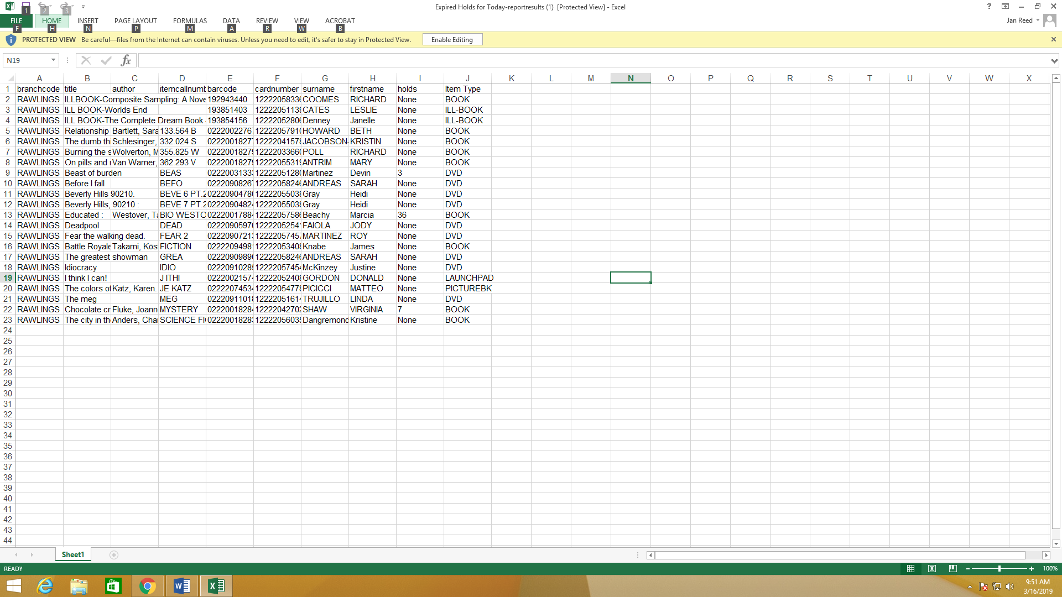

1. To clean up the document, you can delete columns that are not needed, by right clicking at top of the column where you see the letters A, B, C and so on. You will see a menu that has a delete option that you can click. Columns that can be deleted would be Branch code, Author, item call number, card number and the holds column.

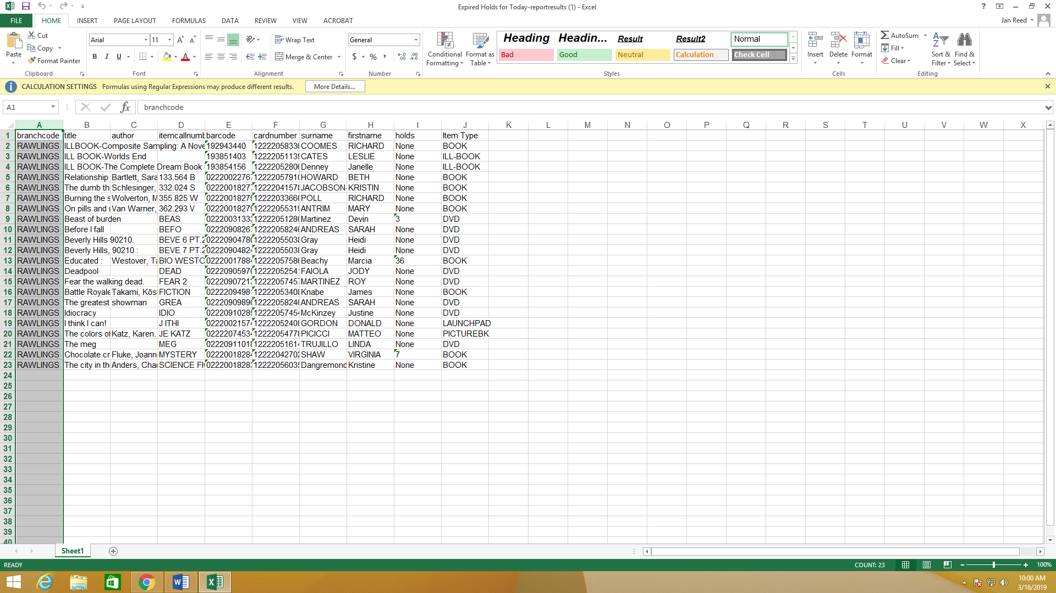

1. To expand the columns so you can see all of the information you need before printing, place your mouse on the line between the columns and hold and drag to the right as far as needed to see all information you want displayed.

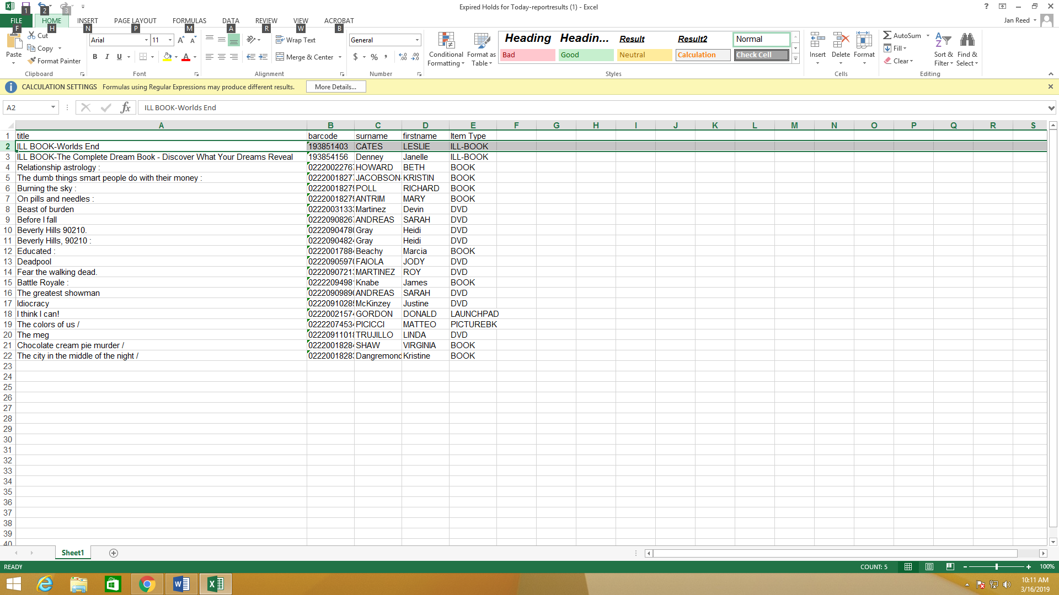

1. Once you have it the way you want it you can print out the list. If you change the orientation to Landscape when printing it is easier to read, but the choice is up to you.

