Creating a Manual Invoice

1. To create a manual invoice when you are in the patron’s account go to the Fines button to the left of the patron record.

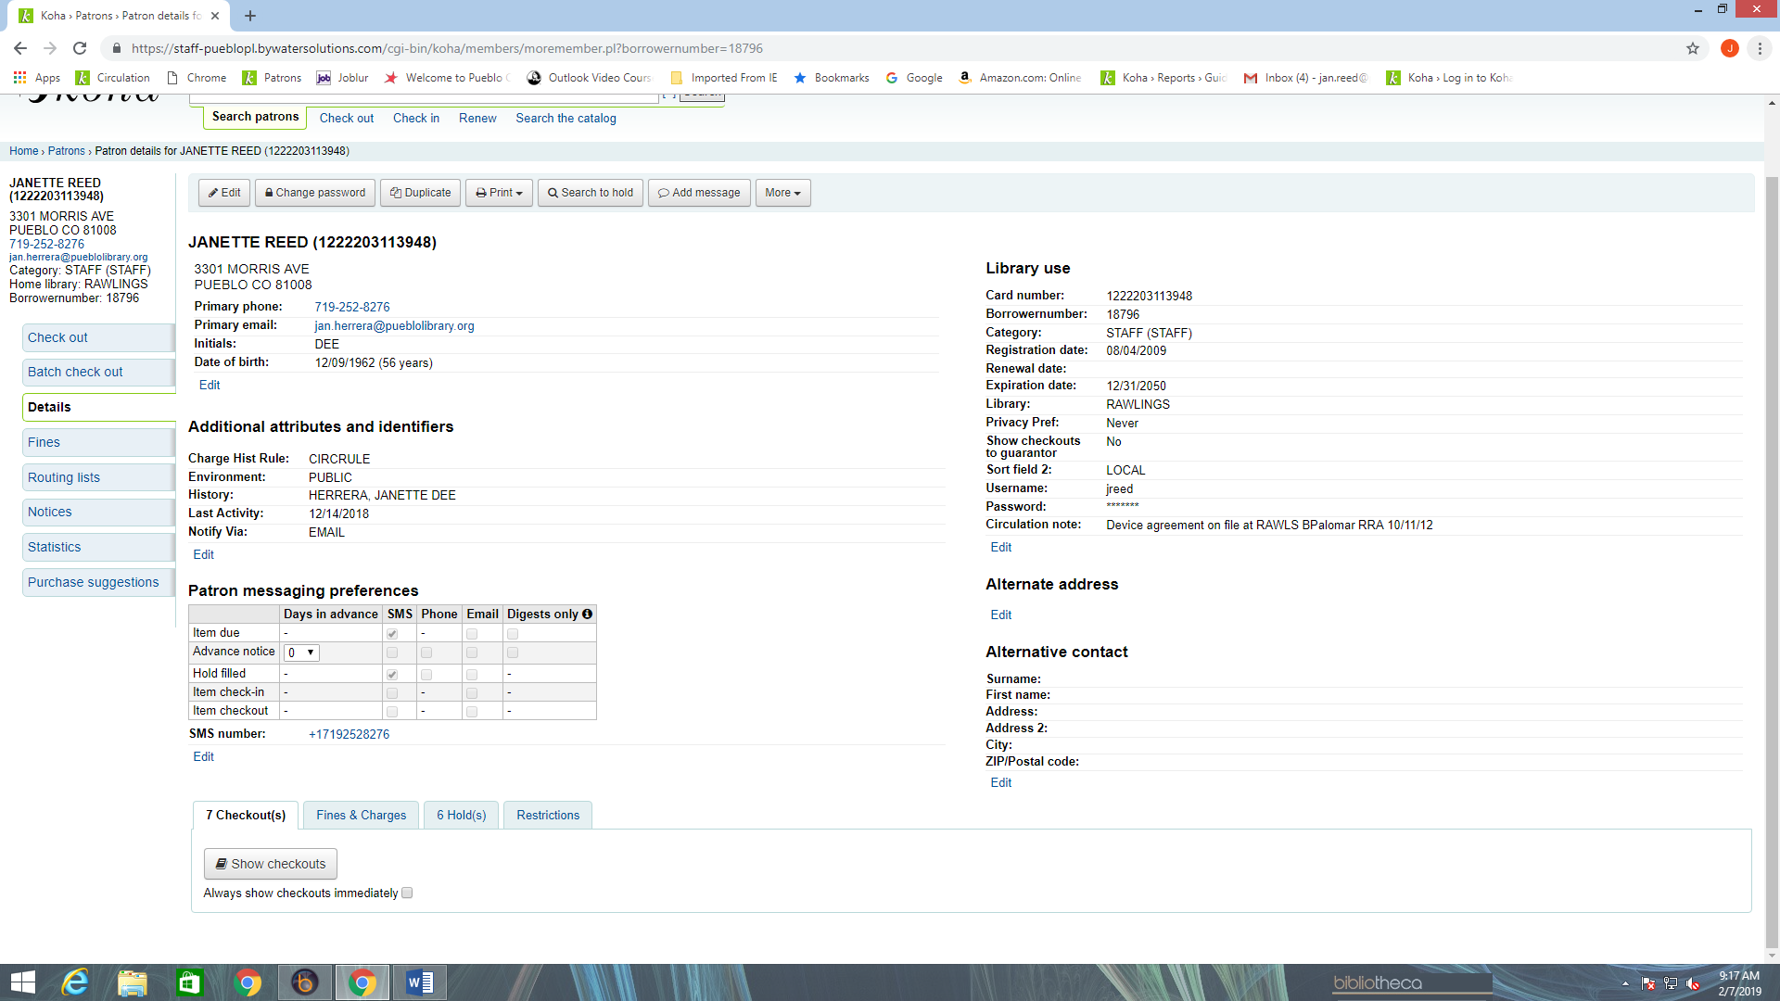

1. After clicking on the Fines button you will be directed to the Fines screen that has tabs for different functions, one of the tabs is Create Manual Invoice. Click this tab to open the form.

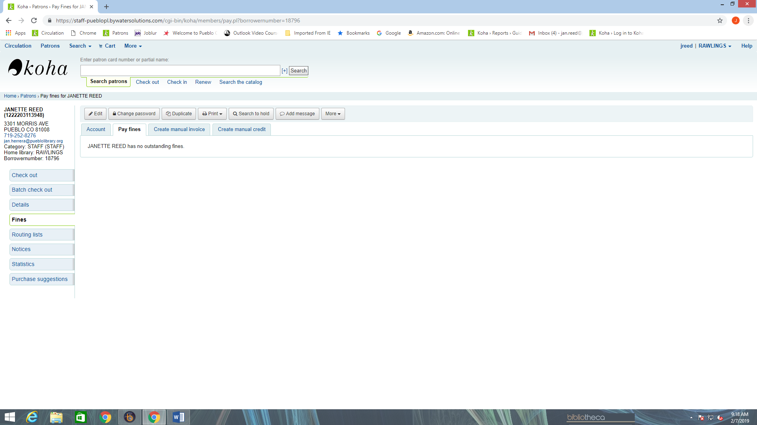

1. Once the form for Manual Invoice opens you will see a window that you can open next to Type.

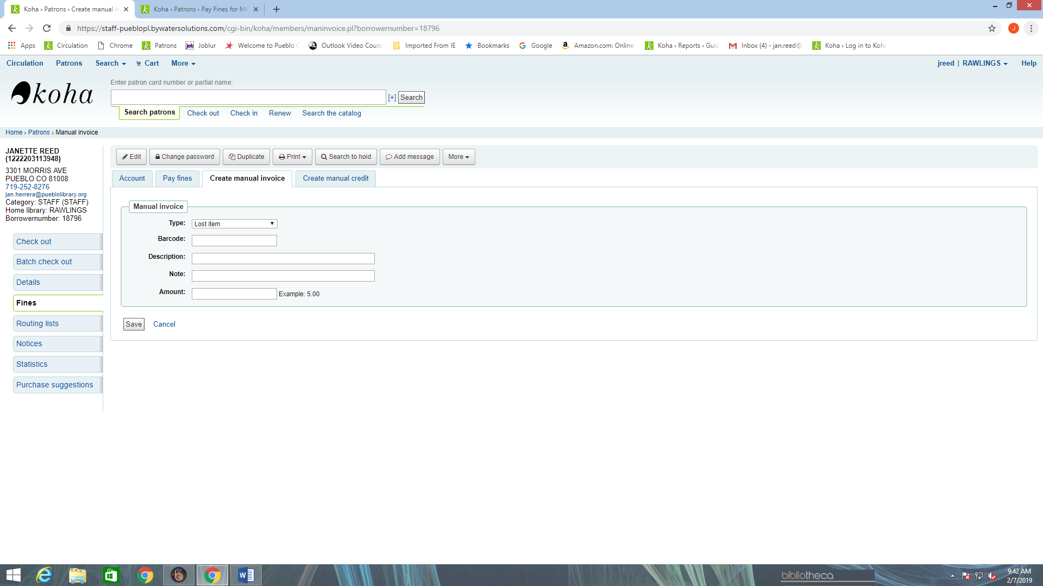

1. If you open the window you will see various preset categories to name your invoice.

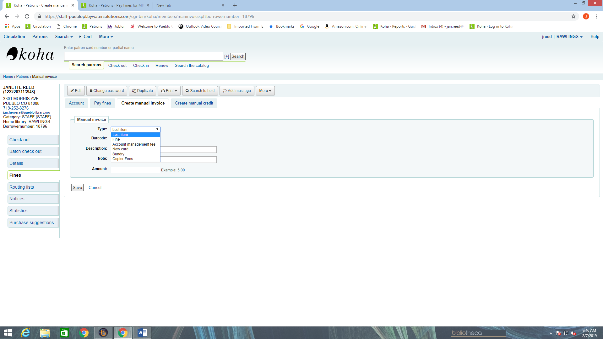

**Types of invoices:**

**Lost item** - Used for lost material to be manually charged to patron’s account.

**Fine** – Used for manually charging a fine to patron’s account.

**Account Management Fee** – Used to charge a patron’s account for missing pieces or damaged items. Missing pieces might be missing chargers, adapters, battery case covers or similar.

Note: Refer to portal document Replacement Costs for individual cost of miscellaneous items that are parts of multi part materials.

**New Card** - Not used at this time.

**Sundry** - Not used at this time.

**Copier Fees** – Charging copies to patron account.

1. You can choose the appropriate category for your manual invoice and then enter the barcode of the item associated with the fee being charged to the patron. The Description will automatically populate and you do not need to manually enter the code.

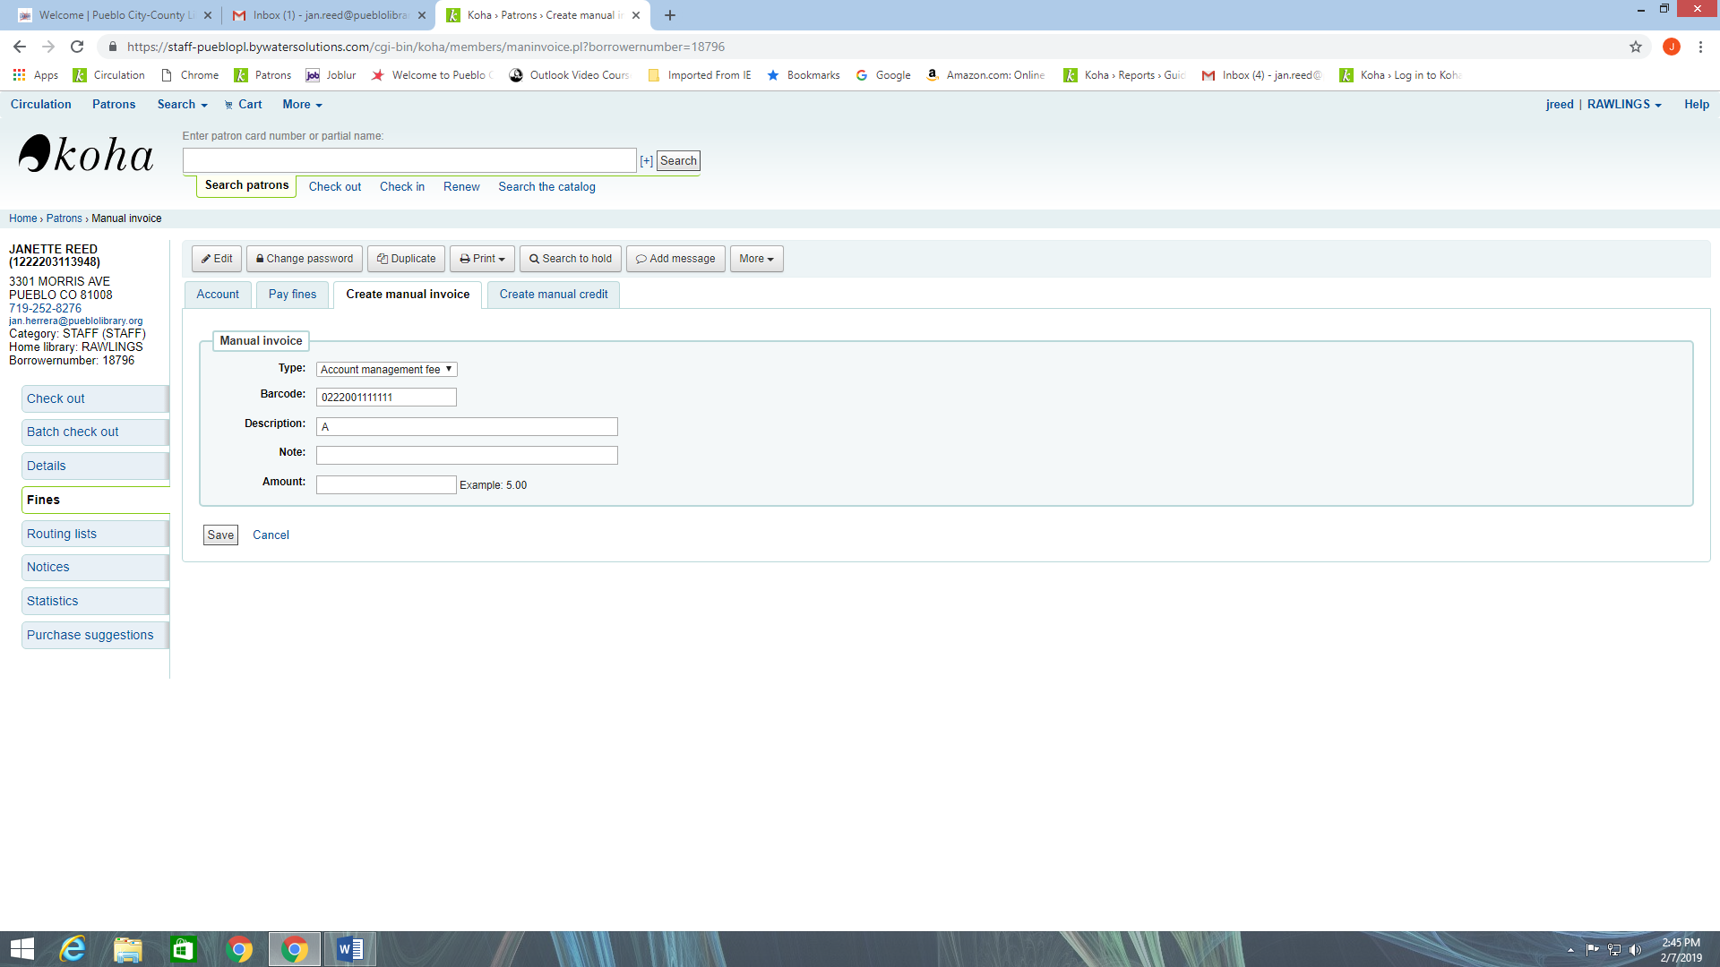

1. You can enter a description of the fine in the Note field if need.

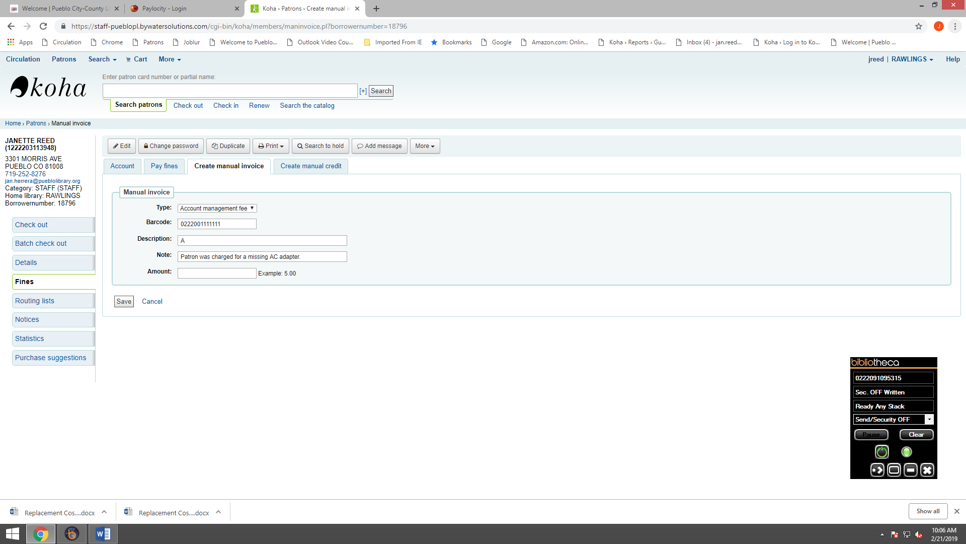

1. Next you will enter the cost of the item being charged in the Amount field and click the Save button to add charge to the account.

