**Checking out an ILL**

1. Pull up the patron’s account and click check out.

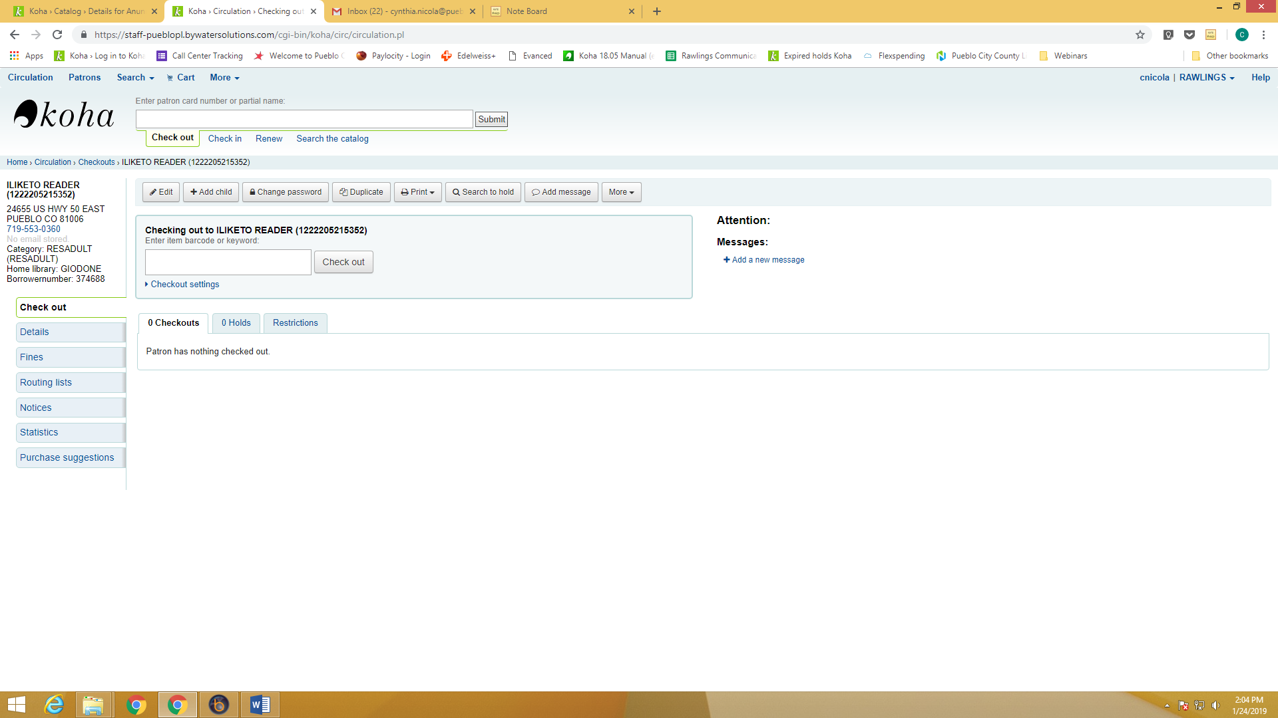

1. Click on CHECK OUT SETTINGS.

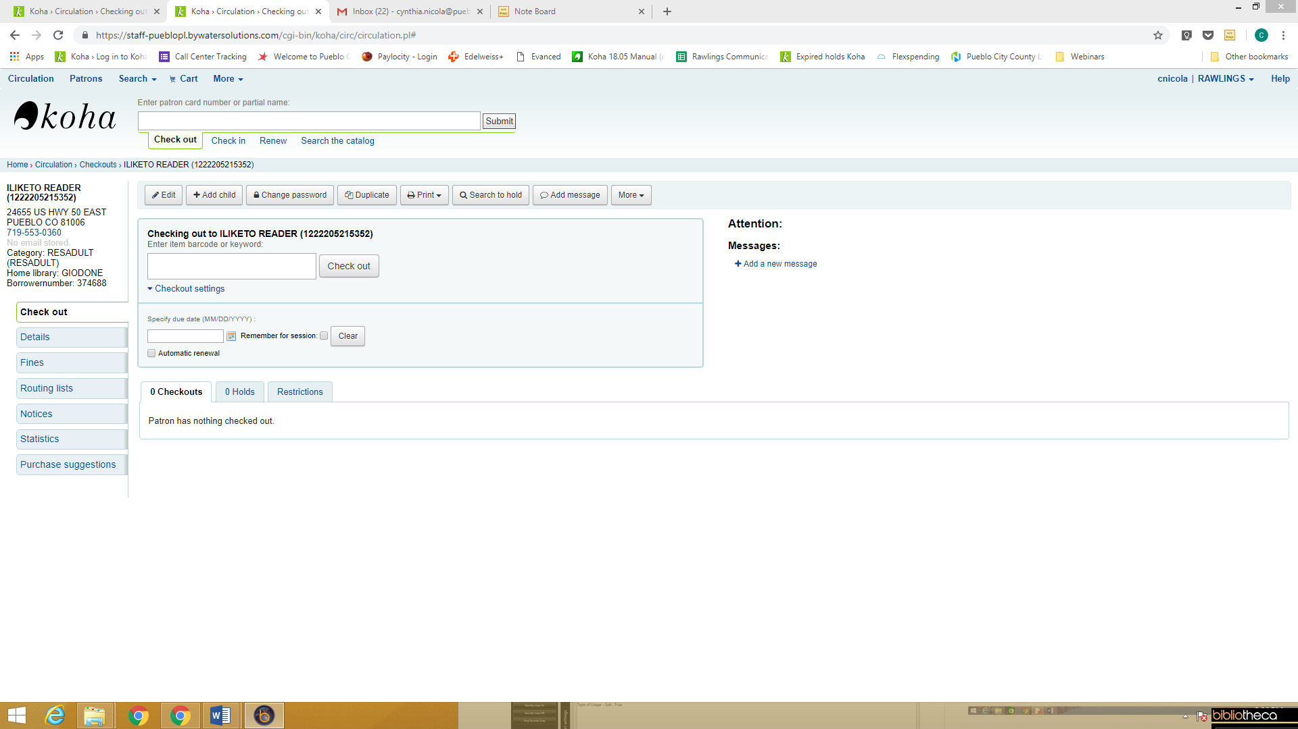

1. Adjust the checkout day to the date on the ILL paperwork attached to the item.

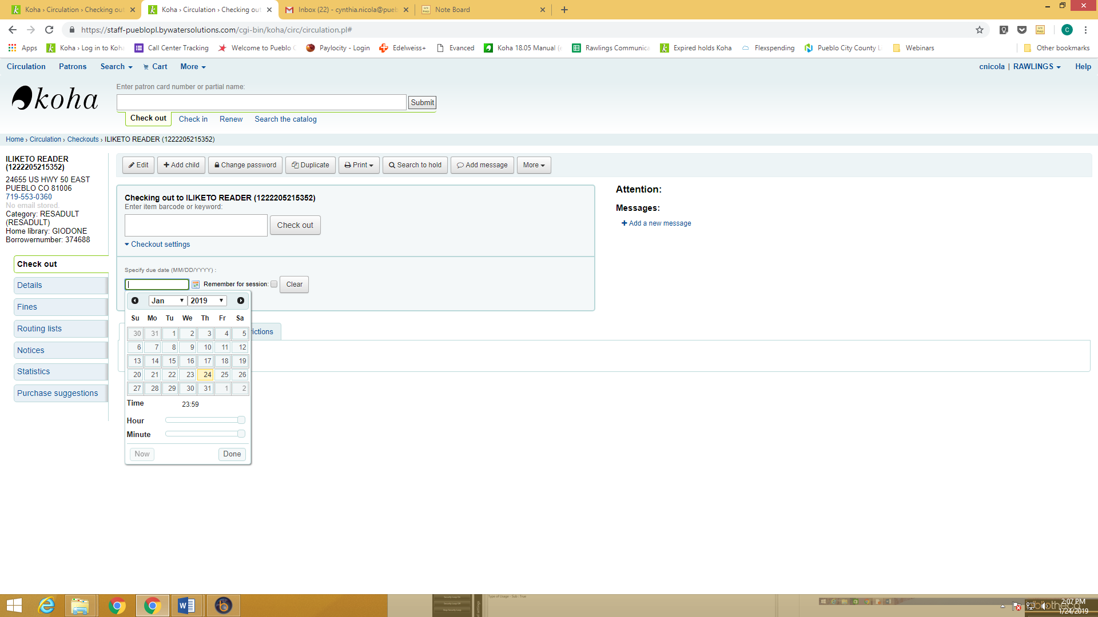

1. Continue with the checkout as normal.

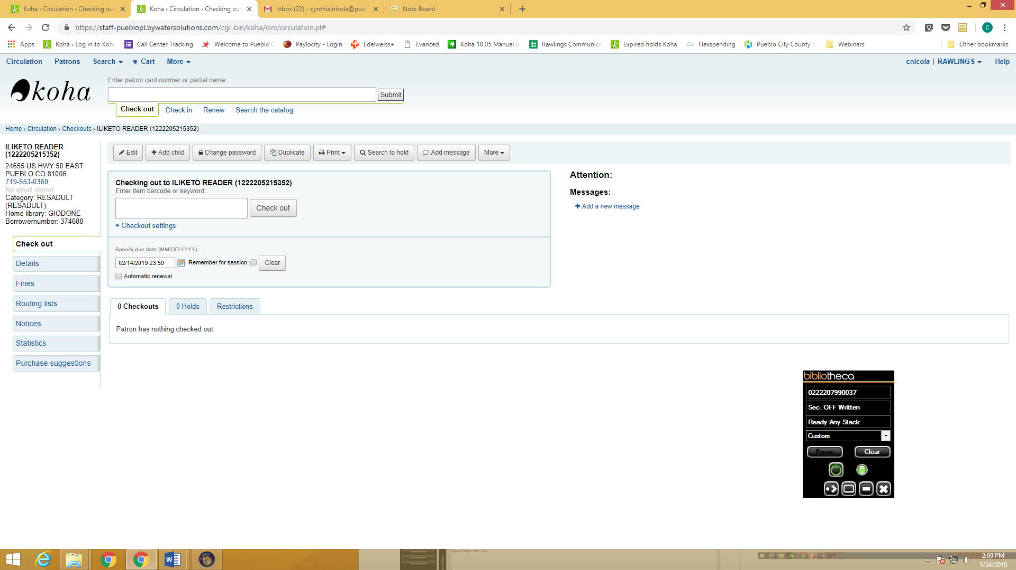

Note: If you forget to adjust the date, just check in the item and recheck it out to the patron with the adjusted date.