**Changing the location of a hold that has already been trapped**

The hold location can also be changed if it *has already been trapped* although this is a different process.

1. When in the patron record, click on the Hold tab and locate the hold that is waiting that you want to change the location of pickup.

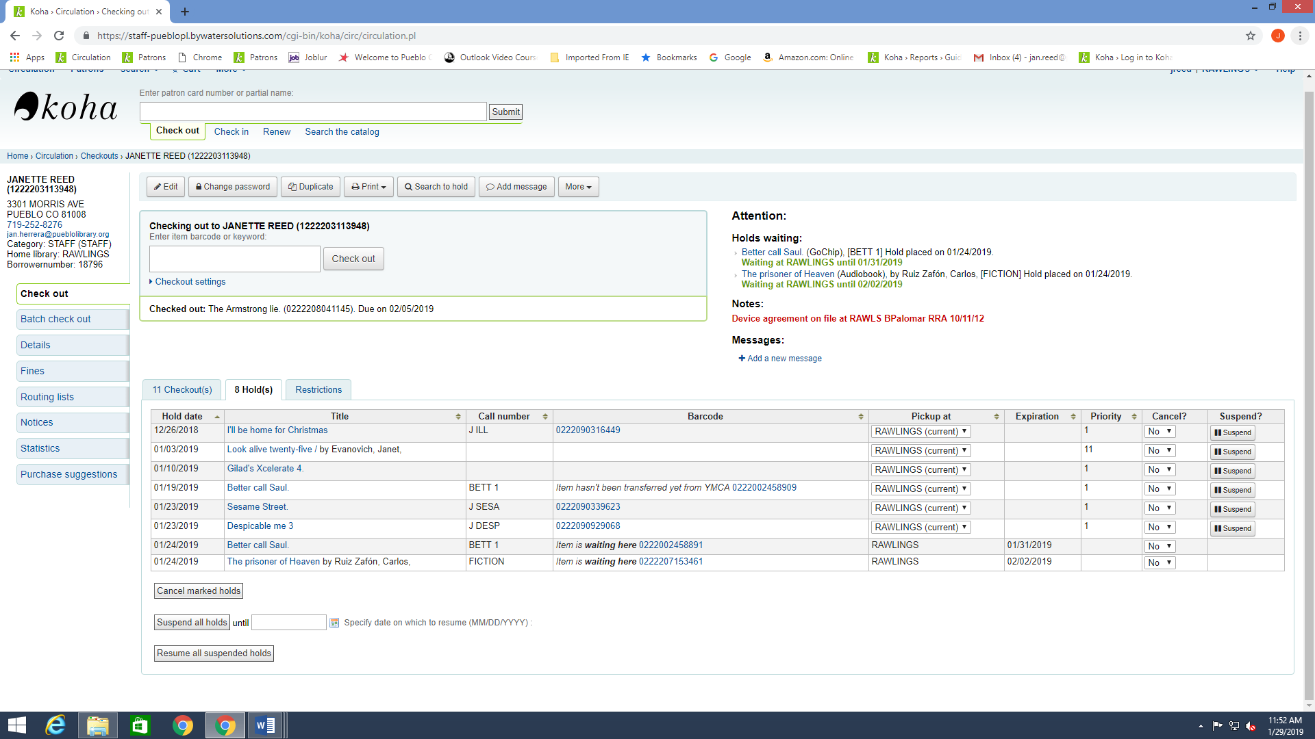

1. Click on the item number of the hold that is Waiting and the item record will open. Once in the record click on the Hold button on the left hand side of the screen.

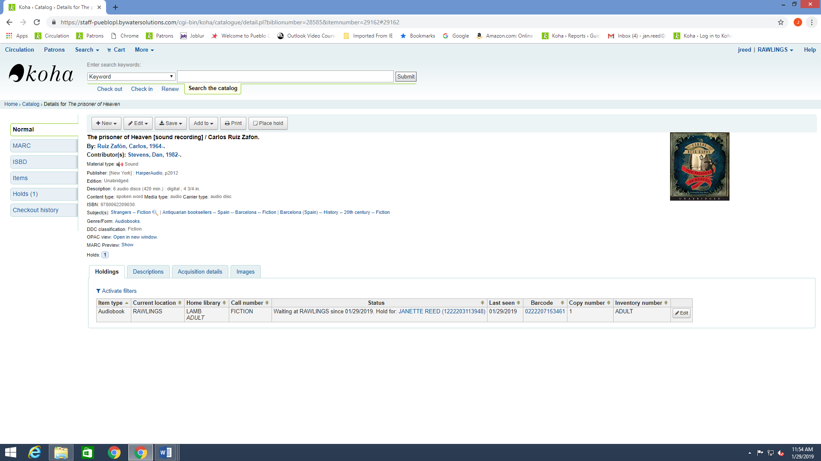

1. Update: The screen with existing holds will now display. Locate the patron from your list of waiting holds. In the very last column you will see a button marked **Revert Waiting Status**.

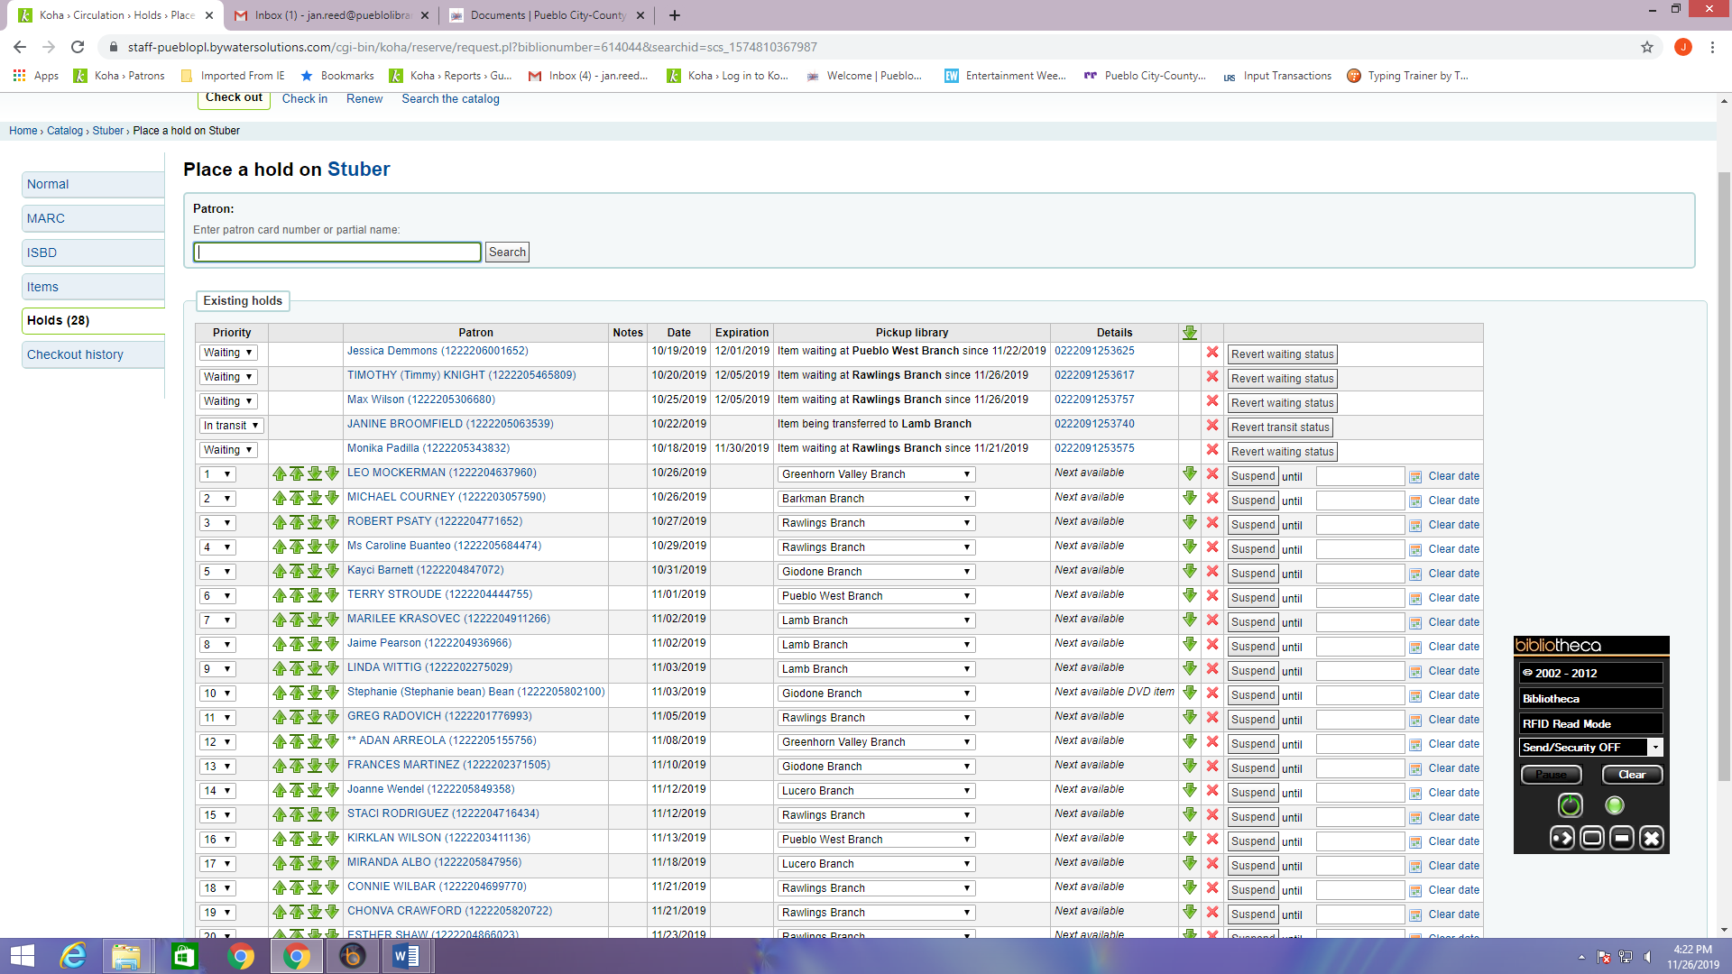

1. Update: Once you click this button you can now change the hold location and then click **Update** at the bottom of the screen to complete the process.

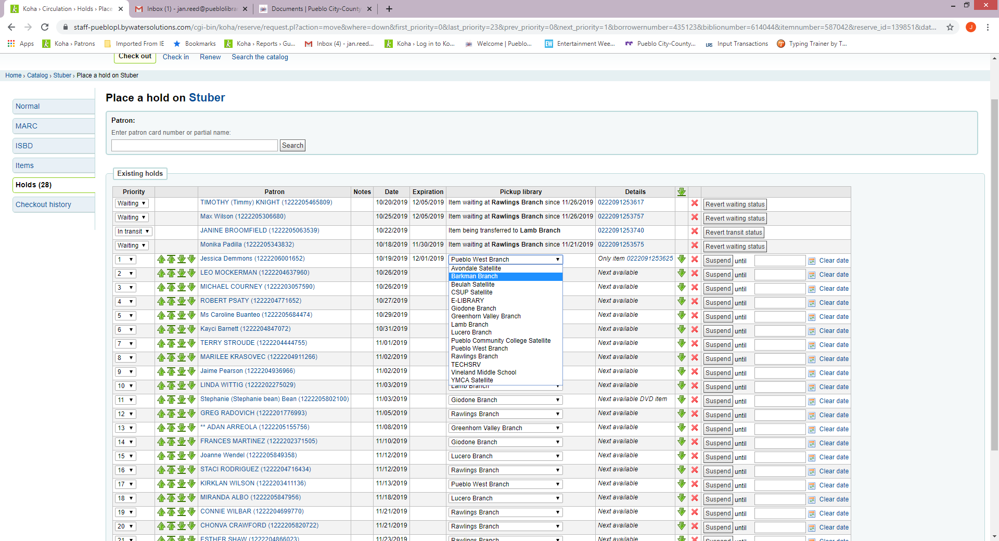

1. You can now trap the item or put it on the AMH to be sorted into the correct bin for transfer.