**Changing the Location of an item on hold**

The location of an item can be changed if it *has not yet been trapped* by following these directions.

1. When in the patron account click on the Holds tab and locate the hold that you want to modify the location.

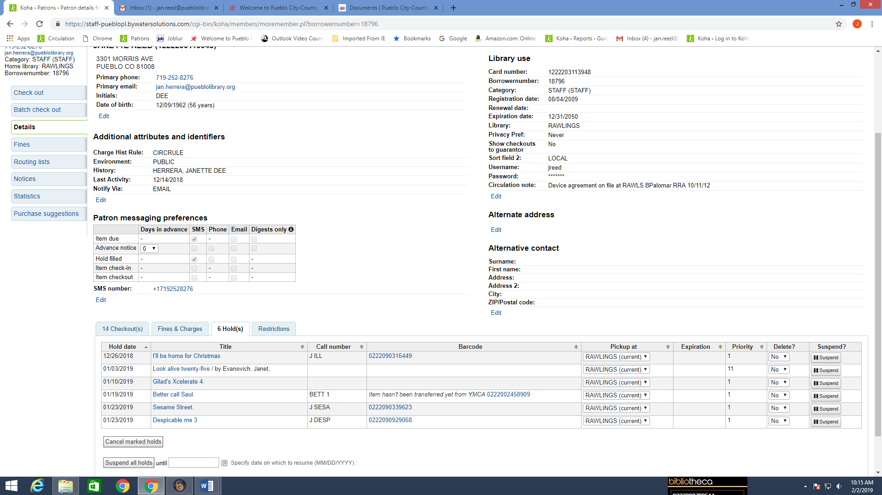

1. Once you locate the hold go to the Pickup at column and open the window with the location and choose the new location.

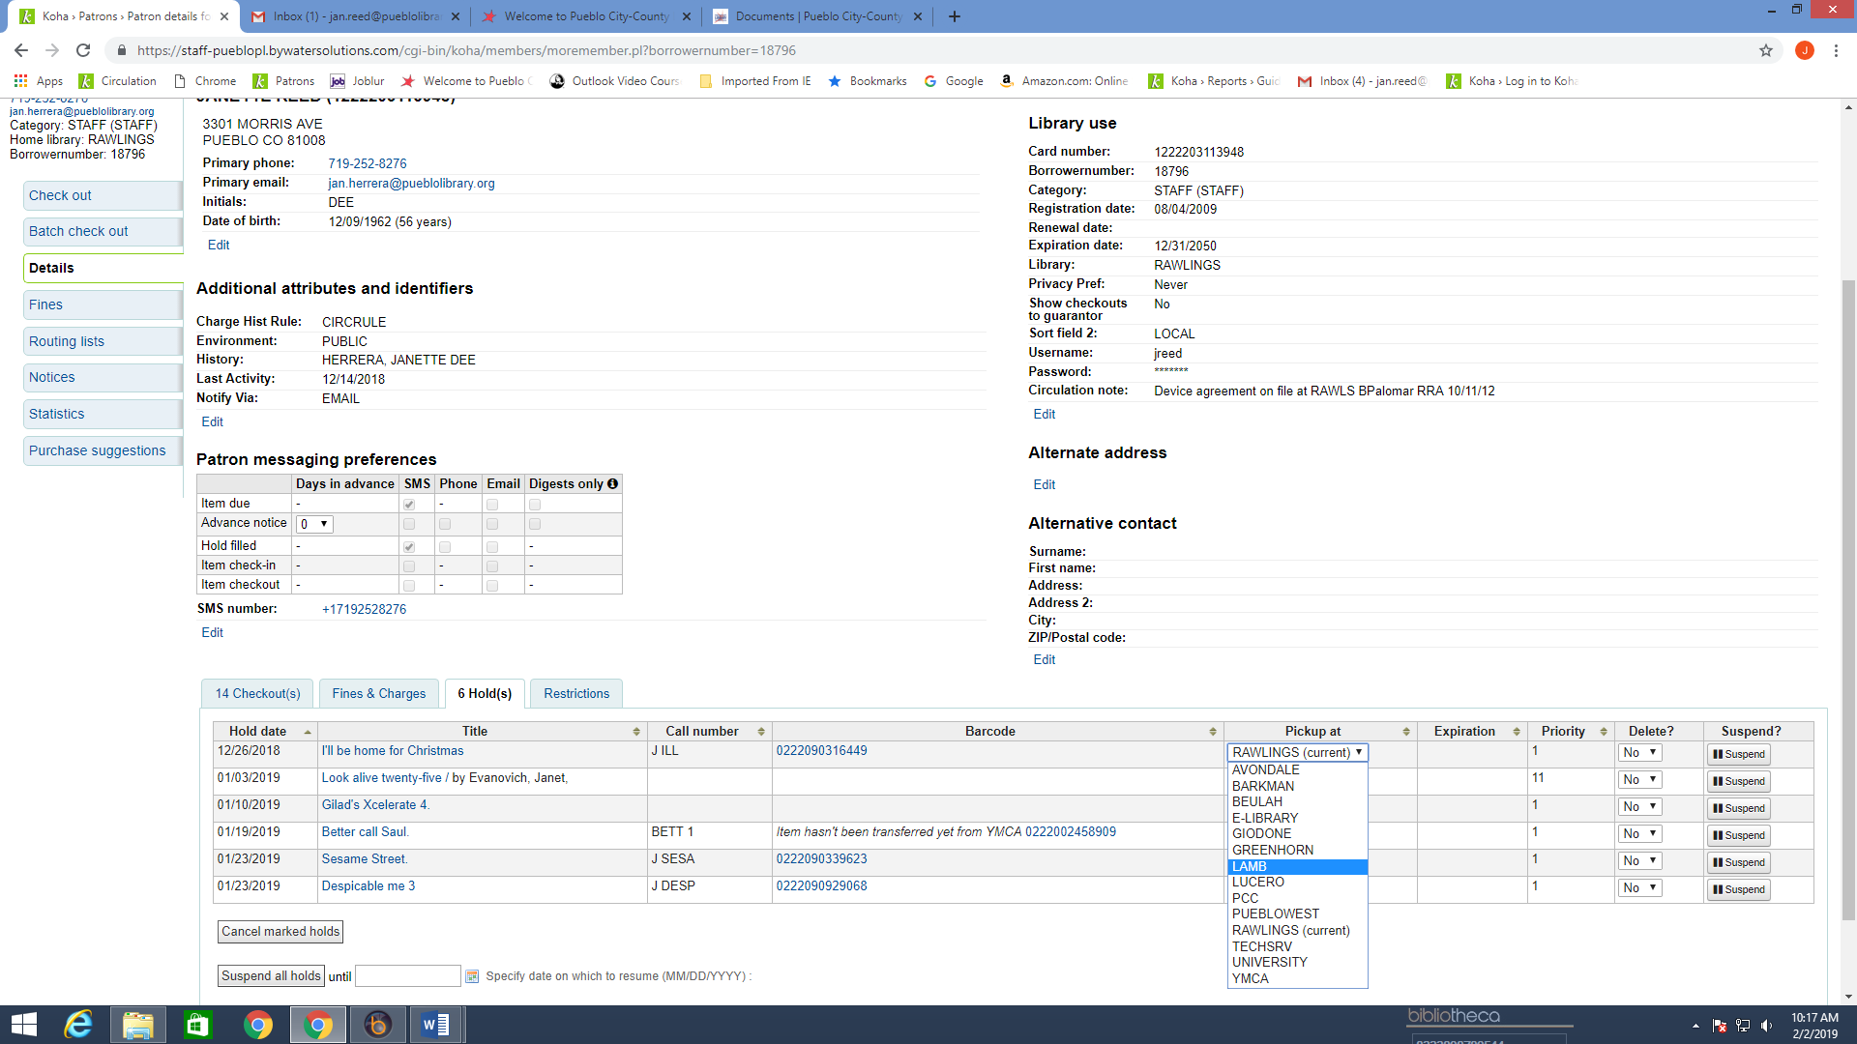

1. Once you click on the new location it will update the hold location.

