**Changing an Item ID and re-tagging**

1. Get the barcode of the item that you want to change - If the item does not have a barcode, you can get it from logging into the 13 digit tagging system and do a quick read.

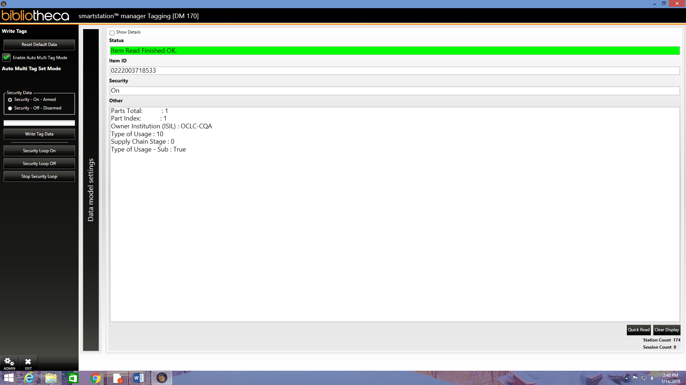

1. Go to Koha and search the catalog for the item using the barcode.

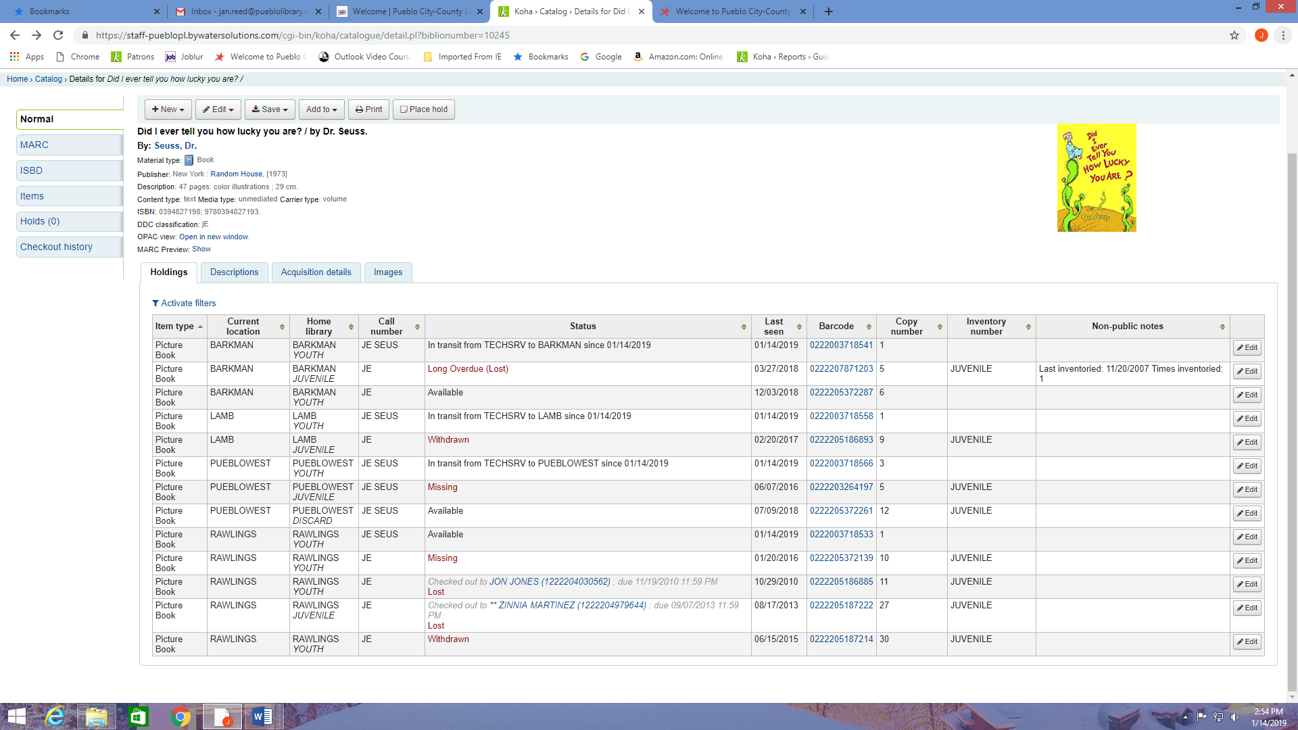

1. Once you locate the item using the barcode, click the button “edit” to the right of the item.
2. Input or scan the new barcode under the “barcode” box in the edit menu.

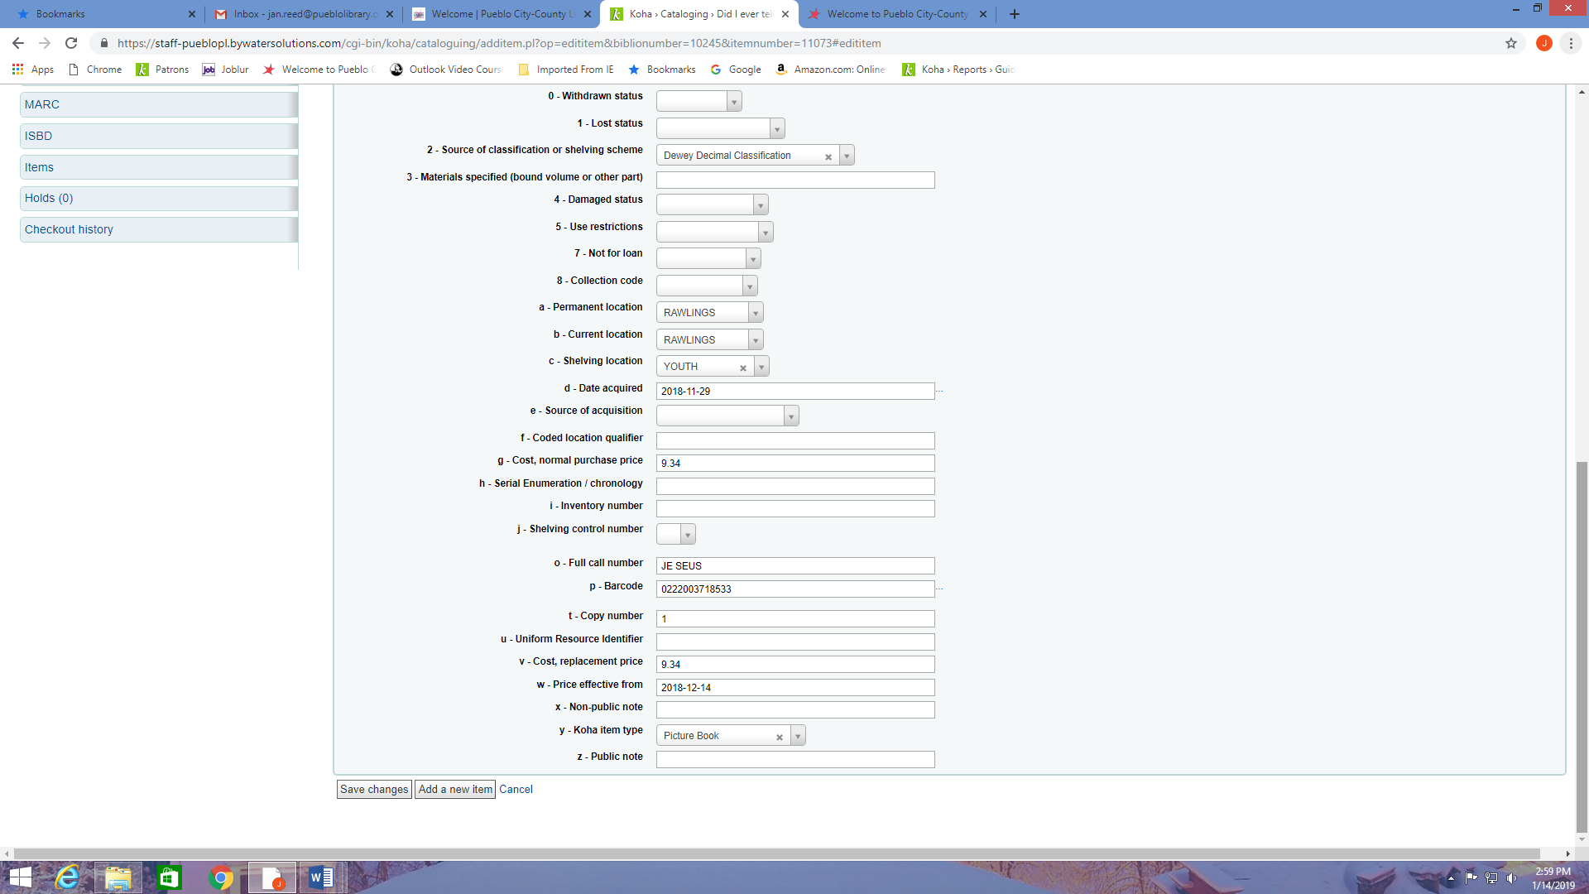

1. Hit “save” button at the bottom of the page.
2. Go back to the 13 digit tagger to match the new barcode with the item.

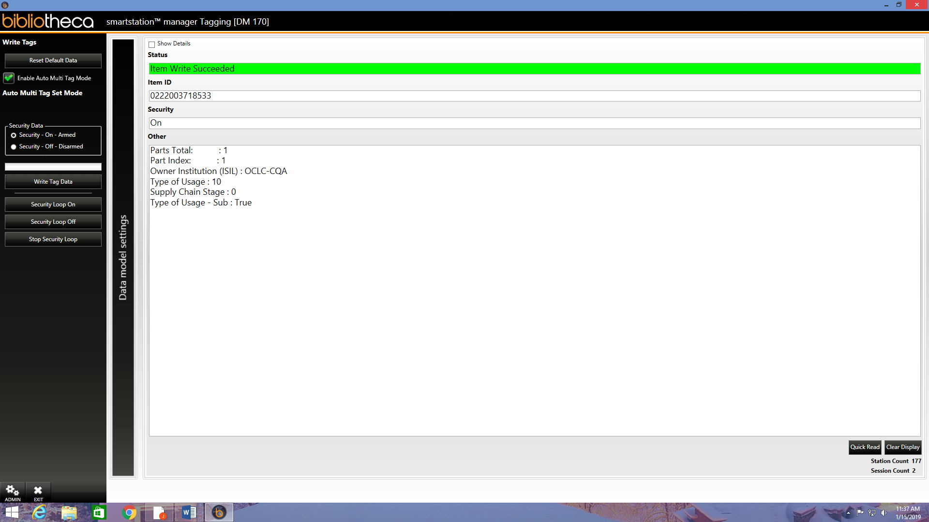

1. Scan item in Koha under “check-in” tab to make sure it took the new barcode