1. **ASSIGNING THE WAB**
2. **From Web Pay, go to Talent > Management Tasks**

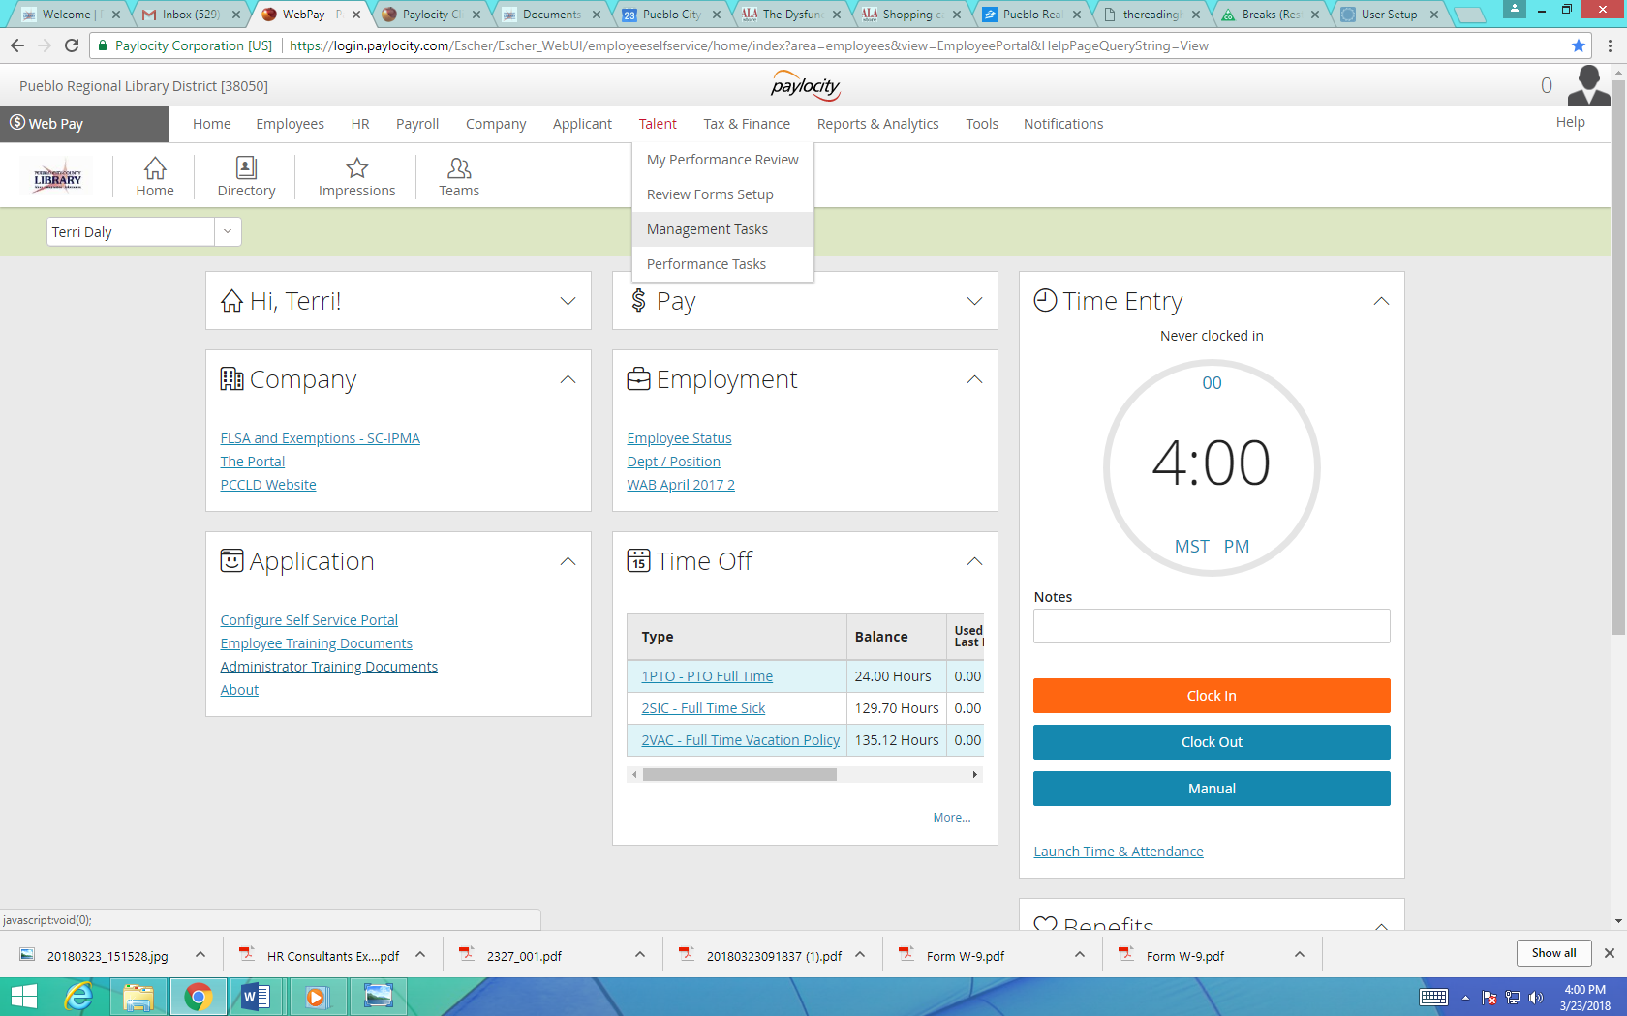

1. **Select the Review Status tab, then Assign Review.**

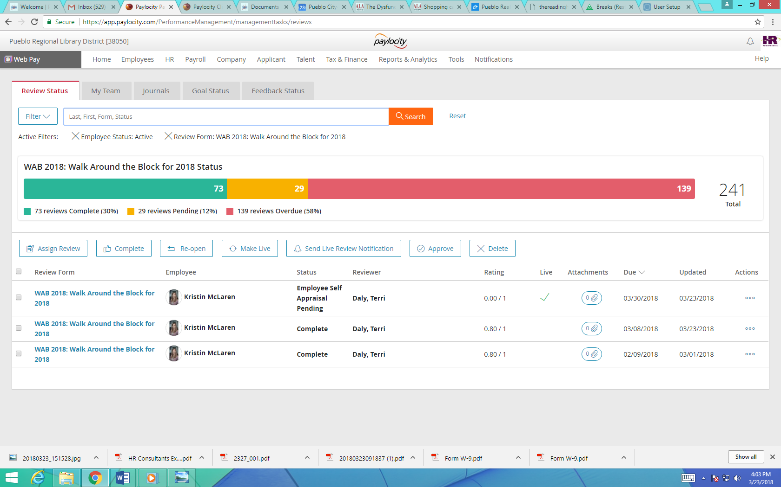

1. **Select WAB 2018: Walk Around the Block for 2018**

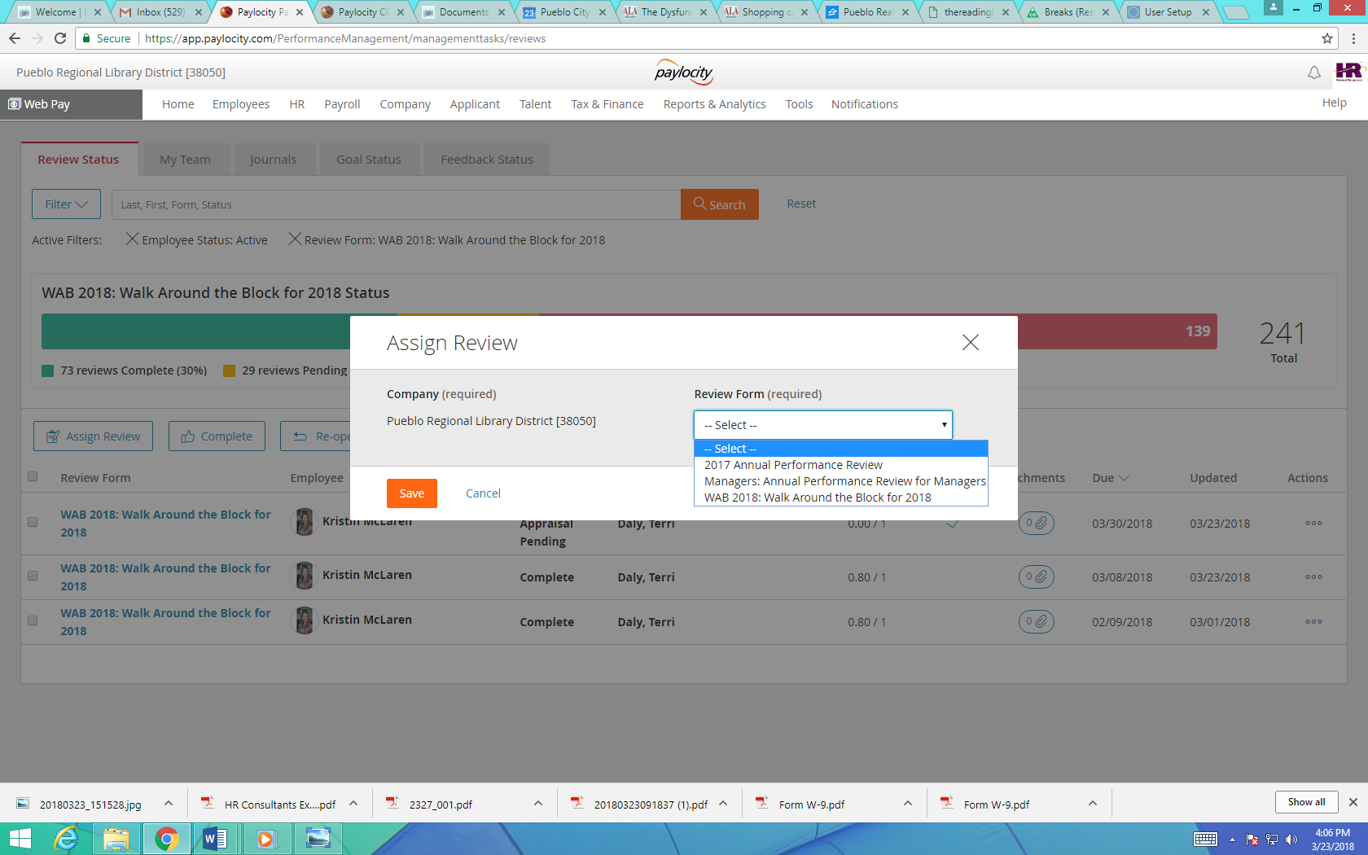

1. **Enter in the Review Available Date (usually the date you are initiating), the Review Due Date (the date you wish the WAB to be due) and Assign to Employees field (which employees you would like to select.)**

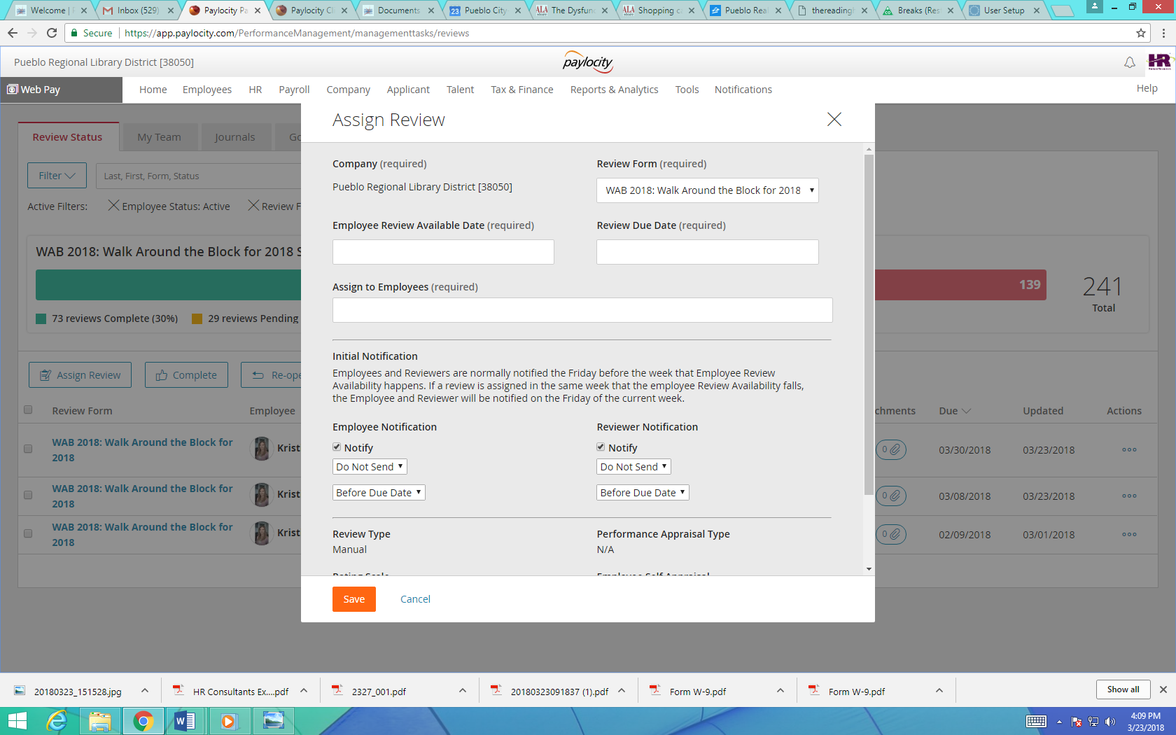

1. **MAKE LIVE BUTTON**



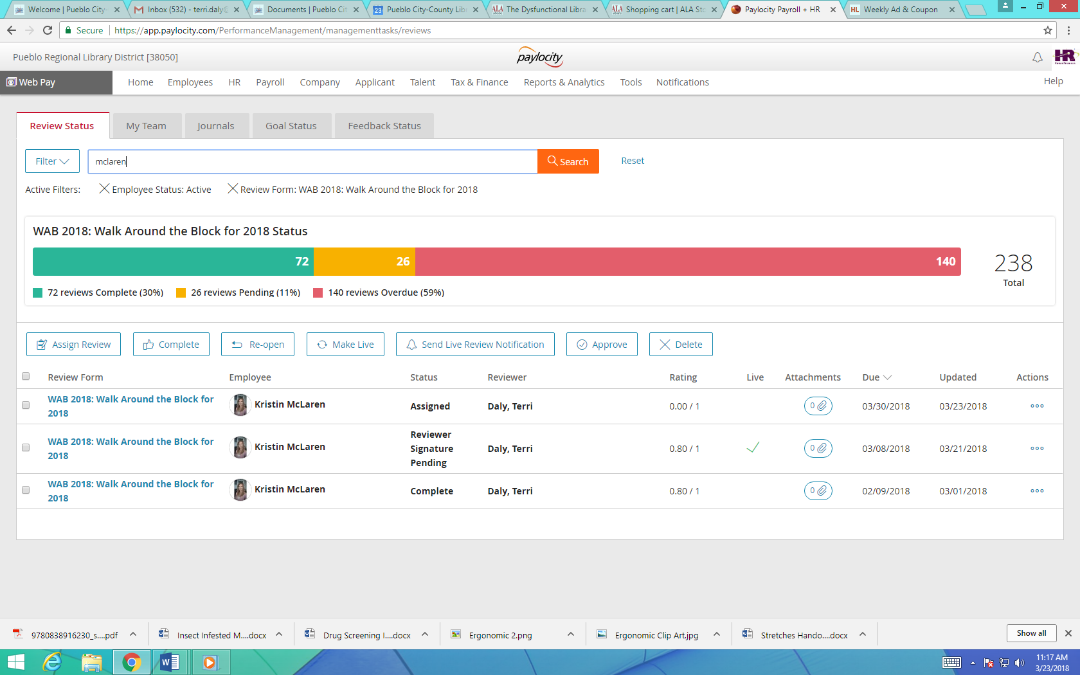

**Select the employee (or employees) you assigned the WAB**

**Select the Make Live button**

**After selecting the Make Live icon, you will see a checkmark in the Live column.**

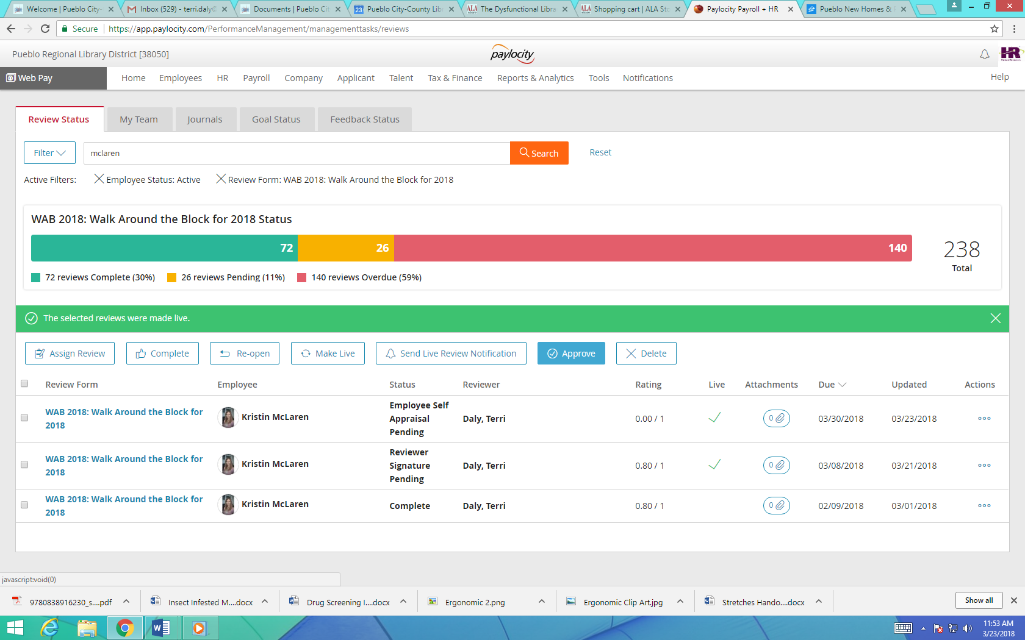

1. **TRACKING THE WALK AROUND THE BLOCK**

**While in the Review Status tab, you will note that you can see the status of each WAB for each employee**

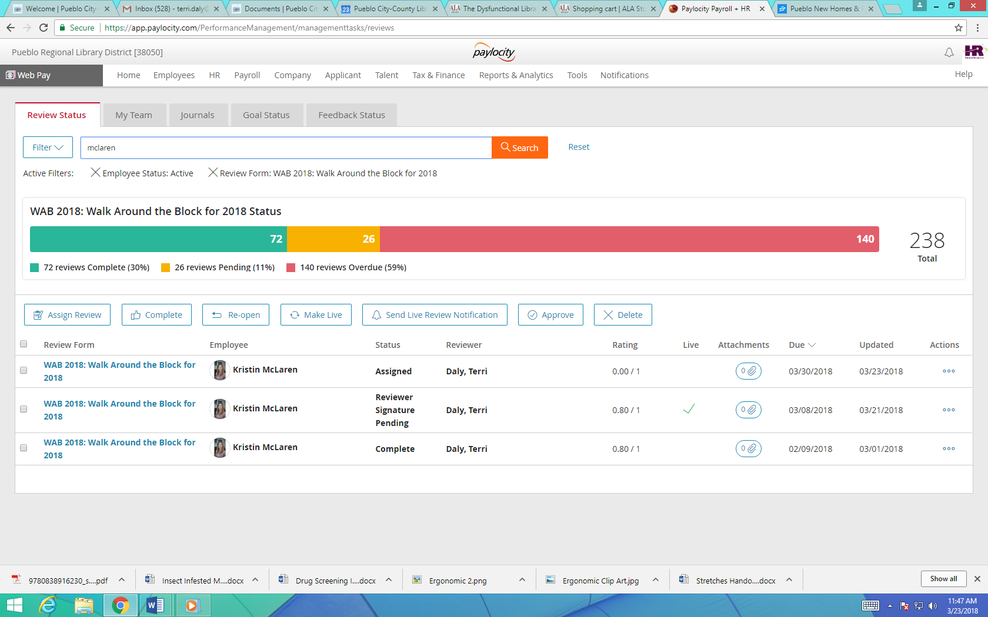

**Assess what stage each review is in by checking the Status column**

1. **Assigned:** The review has been assigned to the employee
2. **Employee Self Appraisal Pending:** The review is in the employee’s queue, because the employee has not completed it in some way. The employee must ensure that they have done all of the items below in order for their supervisor to see their review.

* Employee should select a rating as “none” for each of the categories.
* Employee should enter comments in each of the categories.
* Employee should select SUBMIT on the Summary page.

1. **Employee Self Appraisal Complete:** The employee has completed their part of the appraisal and the manager now has access to be able to complete the manager portion.
2. **Employee Signature Pending:** The manager (reviewer) has completed their portion and it is now in the Employee’s queue for final comments and signature.
3. **Reviewer Signature Pending:** The employee has signed the review and submitted it back to the manager for the manager (reviewer’s) signature. The system does not prompt the manager to go back and sign the review, but the manager can check the review status and see which reviews still need to be signed.
4. **Complete:** All parts of the review are completed.