Installing the Widevine Media Optimizer plugin in Chrome (Windows 8) via Web
- Your first step will be to open the control panel and Click on Uninstall a Program. You need to make sure that Adobe Flash Player Plugin is installed. I have also found that a fresh install of Google Chrome helps verify they do not have any “X” factors affecting your install so uninstall Google Chrome when you are in this area.

- Next go to www.google.com and click “install Google Chrome”
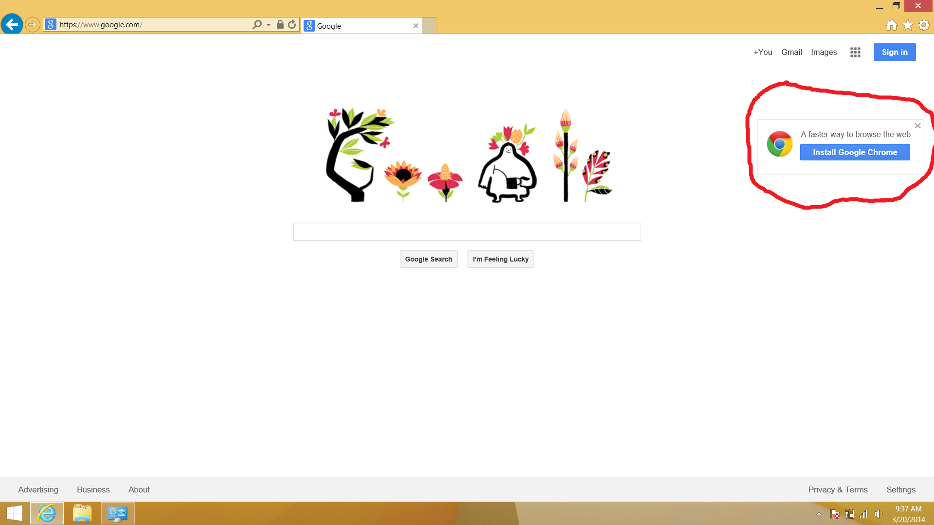

- Now that Google Chrome is installed, go to www.widevine.com/download/videooptimizer/index.html - move down to where you see Chrome: Click Here>>. After it is downloaded you will see the .exe in the bottom left of your browser, click to launch the installer.
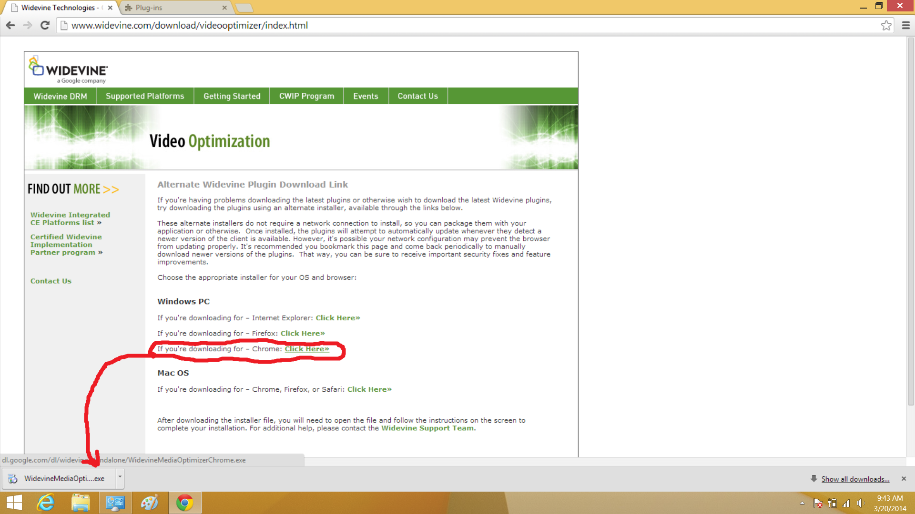

- It is going to give you an error message “Installation failed. Please try again.” This is normal, hit “close” and restart the browser (Close then reopen)
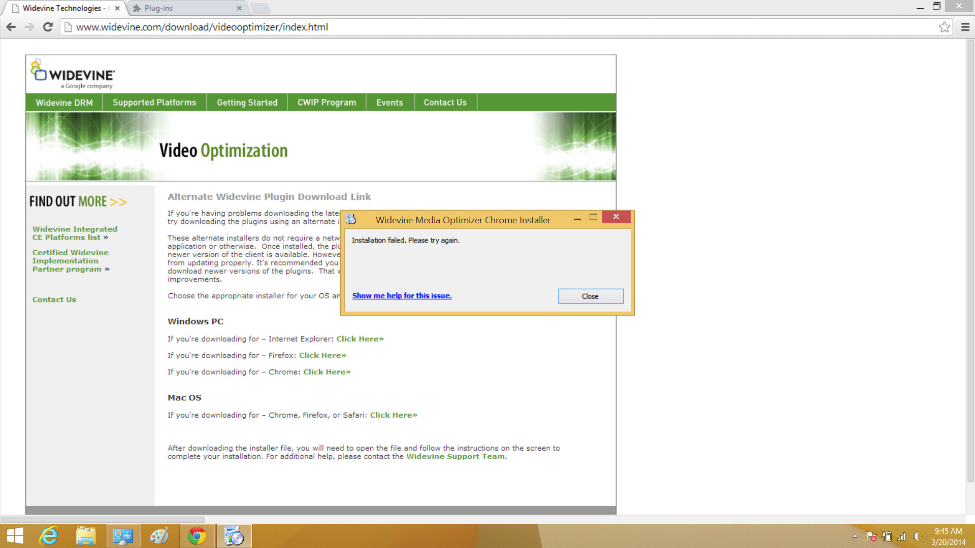

- Now go back to your Chrome browser and go to “chrome://plugins”. You will now see a Plug-in called “Widevine Media Optimizer” Click to Always allow. (If Adobe Flash Player does not have this selected, select Always allow with this as well)
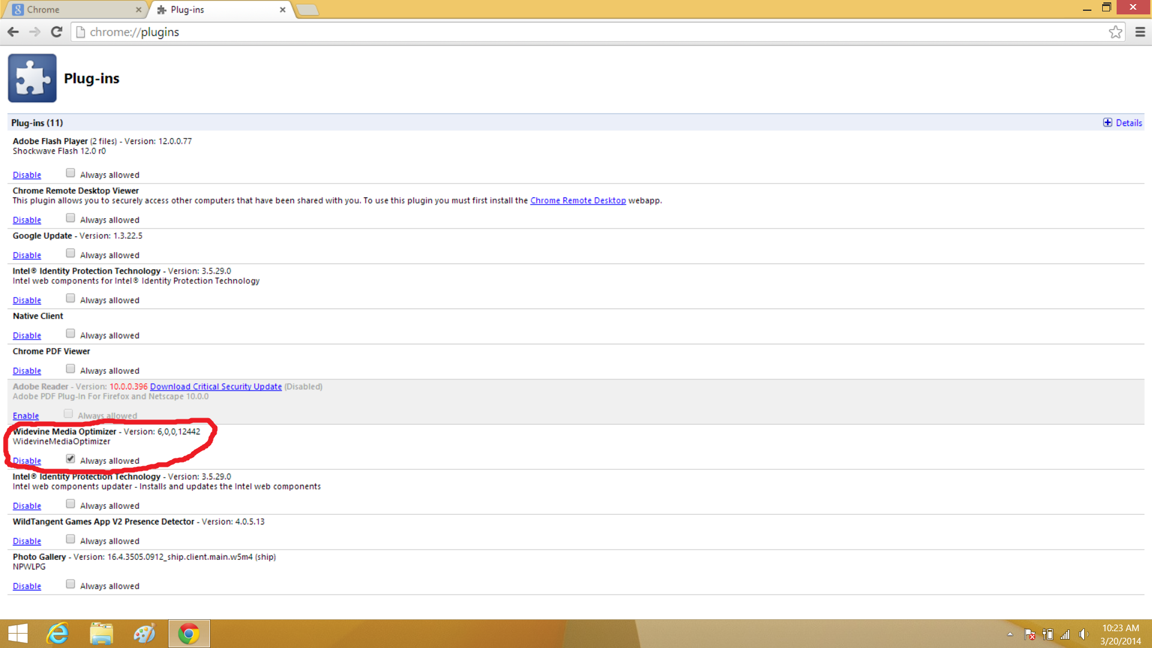

- 6. Now that you have your plug-in installed it is time to test this. Go back to hoopla and hit play on a piece of video content. It should play without issue now.

