Installing the Widevine Media Optimizer plugin in Internet Explorer 8 (Windows XP) via hoopla
- Open Internet Explorer 8
- Go to http://www.hoopladigital.com/ and click the “Sign In” button in the top right-hand corner 
- Sign in with the email address and password used when registering 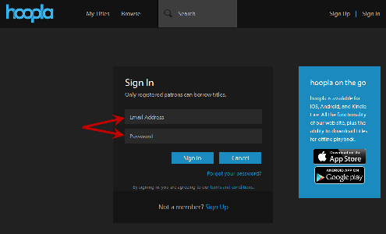
- Click on “Browse” 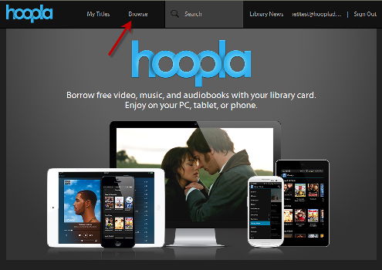
- Select the Movies tab (if not already selected), and click on a movie you’d like 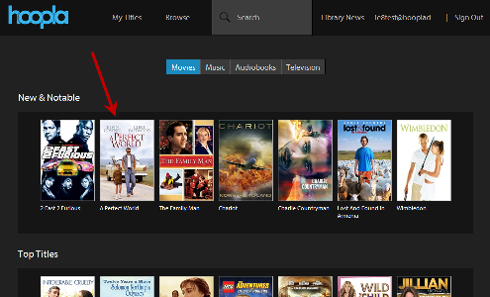
- Once on the title details page, click the “Borrow” button 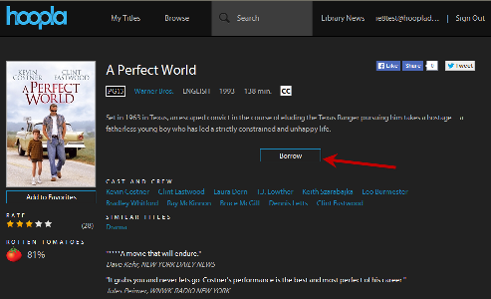
- After borrowing the movie, click the “Play” button 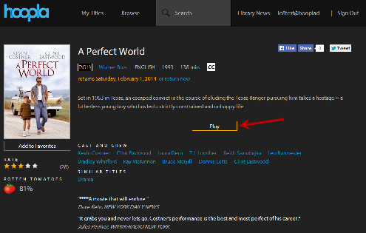
- You should be prompted to install the Widevine Media Optimizer plugin at this time
- Click “Install Plugin”, and it will open a new window 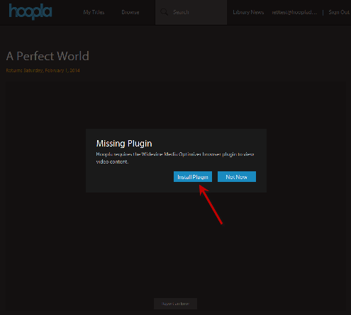
- Click the “Install Now!” button 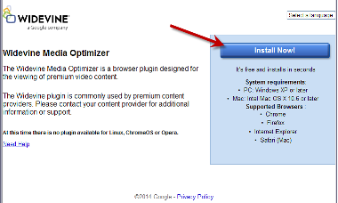
- The current window will change, with a “Thank you for downloading the Widevine Video Optimizer” message 
- A new message box will pop up letting you know that Widevine is downloading 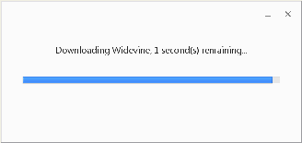
- After the download finishes, it will automatically install
- Click “Close” on the message box 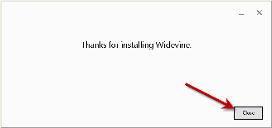
- Close the browser window with the “Thank you” Widevine message (from step 11)
- Refresh the hoopla browser tab by either clicking the refresh button, or pressing the F5 key on your keyboard
- Playback should automatically start
- Enjoy hoopla!

