Installing the Widevine Media Optimizer plugin in Safari (Mac) via hoopla
- Open Safari
- Go to http://www.hoopladigital.com/ and click the “Sign In” button in the top right-hand corner 
- Sign in with the email address and password used when registering 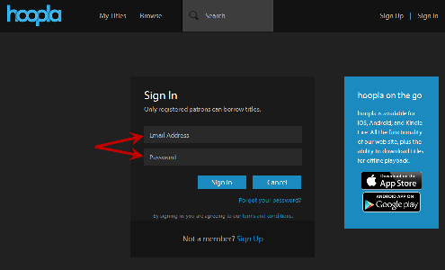
- Click on “Browse” 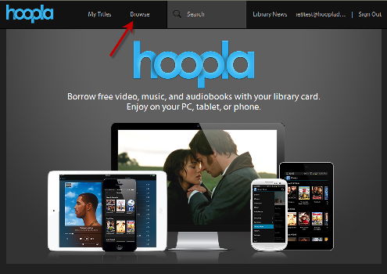
- Select the Movies tab (if not already selected), and click on a movie you’d like 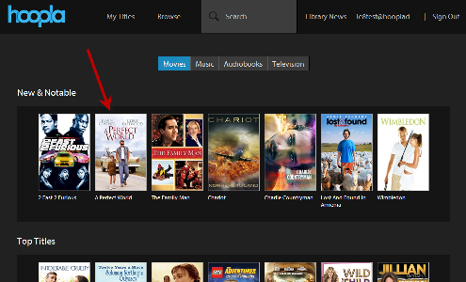
- Once on the title details page, click the “Borrow” button 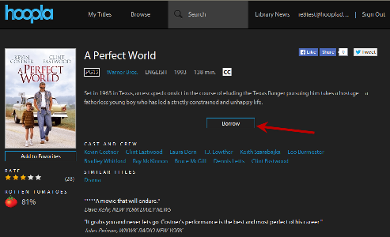
- After borrowing the movie, click the “Play” button 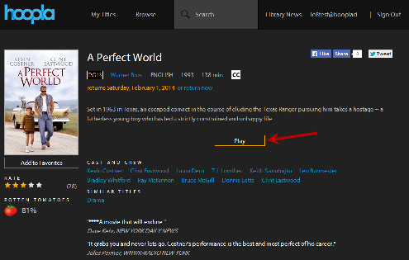
- You should be prompted to install the Widevine Media Optimizer plugin at this time
- Click “Install Plugin”, and it will open a new tab 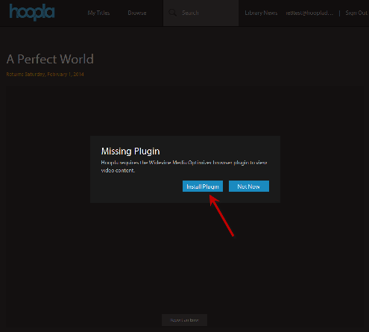
- Click the “Install Now!” button 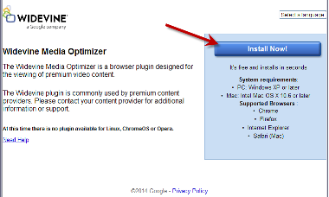

- Open the list of your downloads on the bottom right side of the screen and click “WidevineMediaOptimizer.dmg”
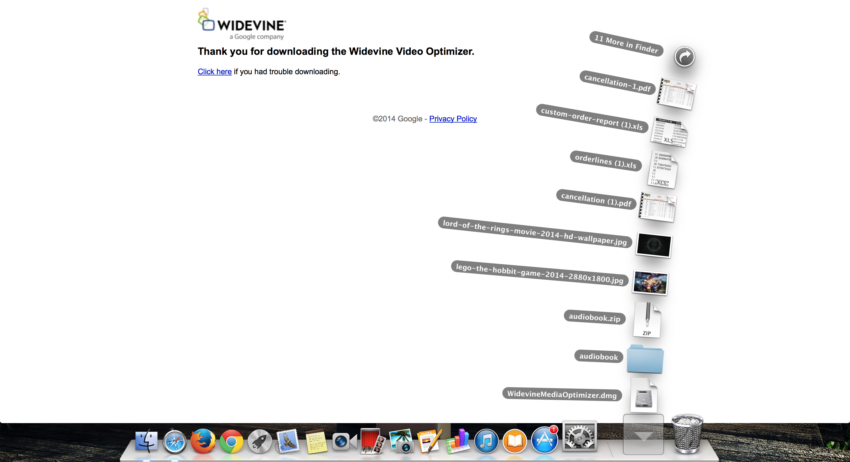
- Once the folder opens close out of Safari and click “Widevine Media Optimizer.app” to start installing Widevine. 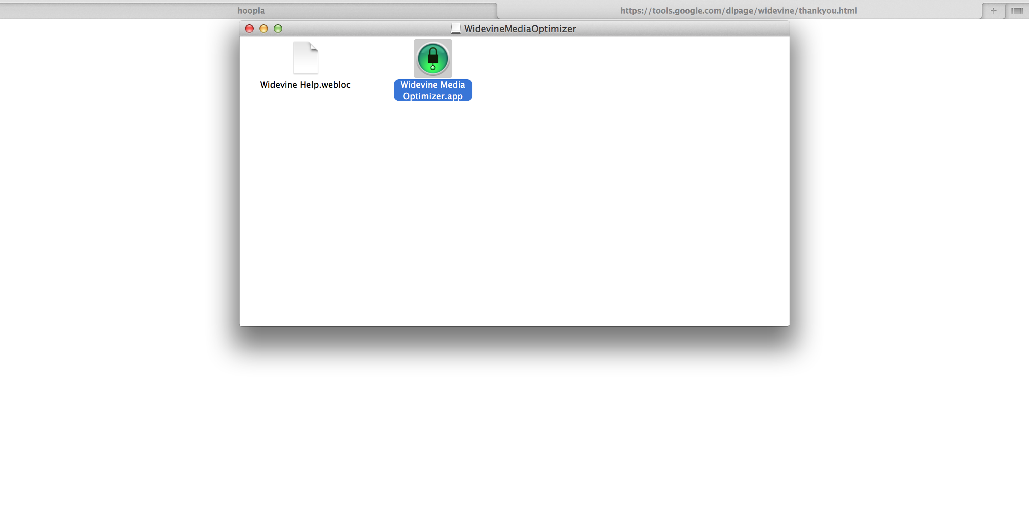
- Widevine will go through the installation process, click finish when it is done. 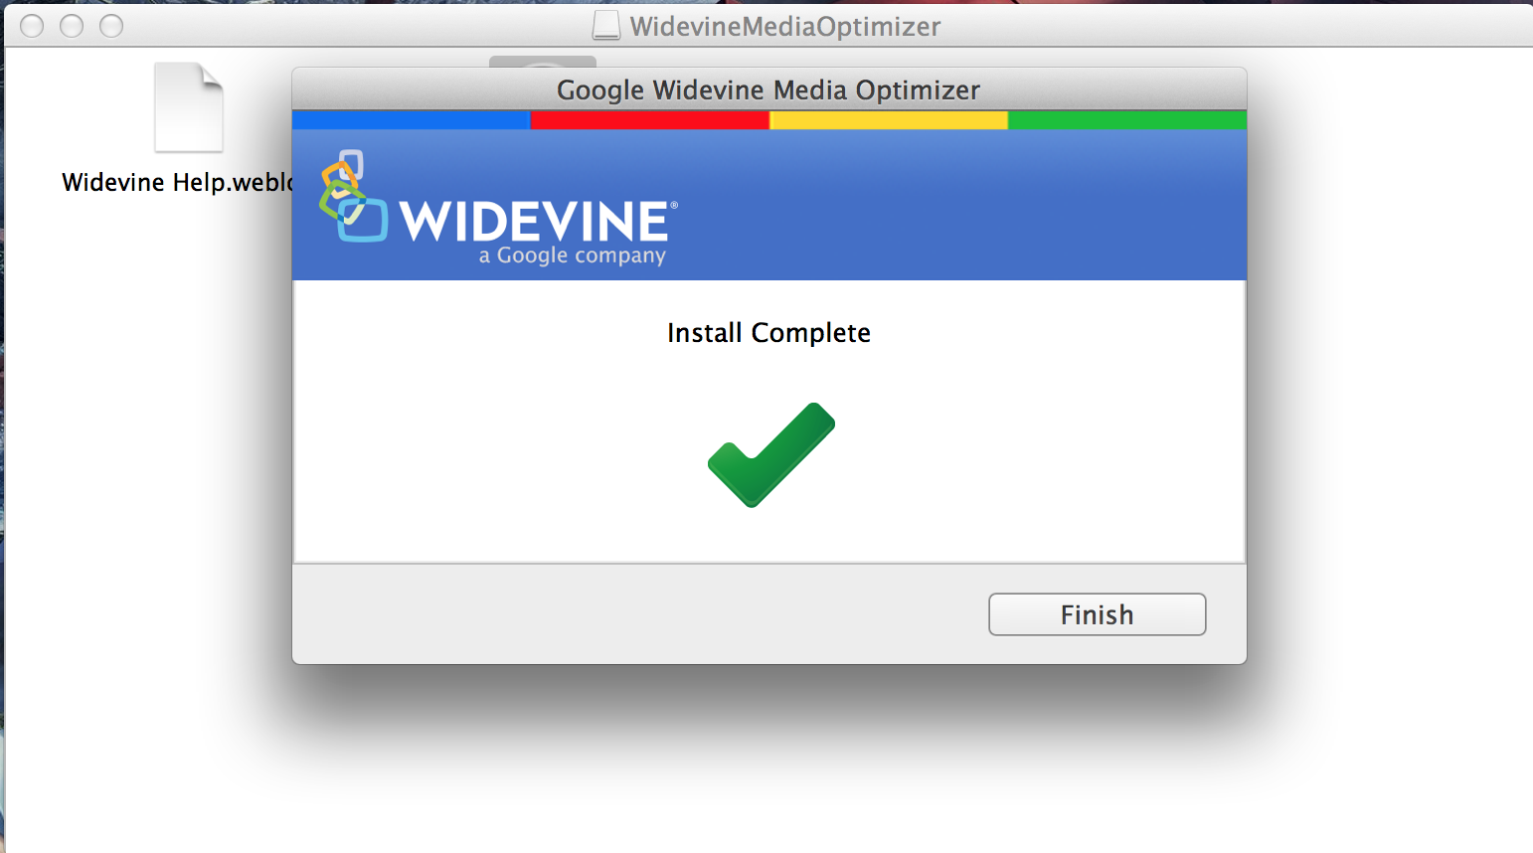
- Open Safari again and try to play your video. Click the “Trust” button to allow the Widevine plugin, and your video should work. 