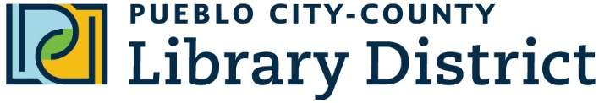

100 E. Abriendo Ave.

Pueblo, CO 81004-4232  
(719) 562-5600

www.pueblolibrary.org

Date

Address

Letter body

**­­­LIBRARIES**

Barkman Library

Greenhorn Valley Library

Lamb Library

Library @ the Y

Patrick A. Lucero Library

Pueblo West Library

Rawlings Library

Tom L & Anna Marie

Giodone Library

**COMMUNITY SATELLITES**

Avondale Elementary School

Beulah School of Natural Sciences

CSU Pueblo Library

Pueblo Community College Library