WIDEVINE INSTALATION CHROME (WIN 7)
- Open Chrome
- Goto www.hoopladigital.com
- Click Sign In in top right corner
- Enter your e-mail and password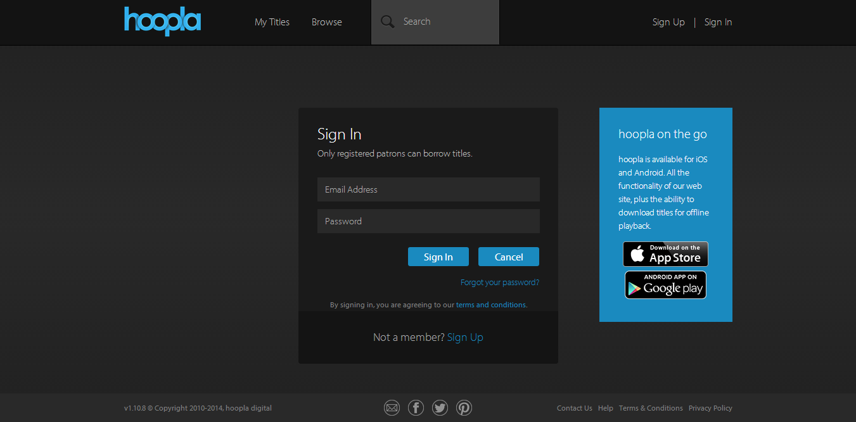
- Once signed in, click on “Browse” to find a title to watch.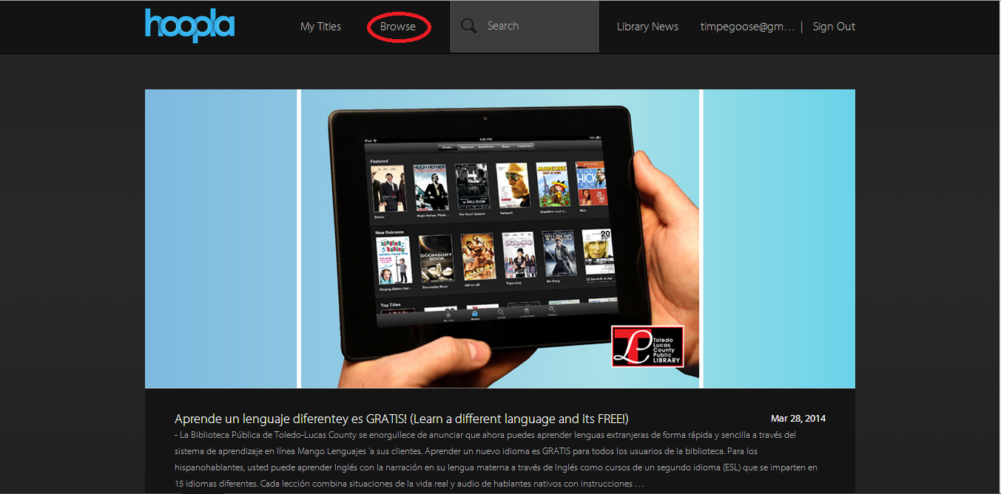
- Find a title you are interested in, and click to open up more details about the title.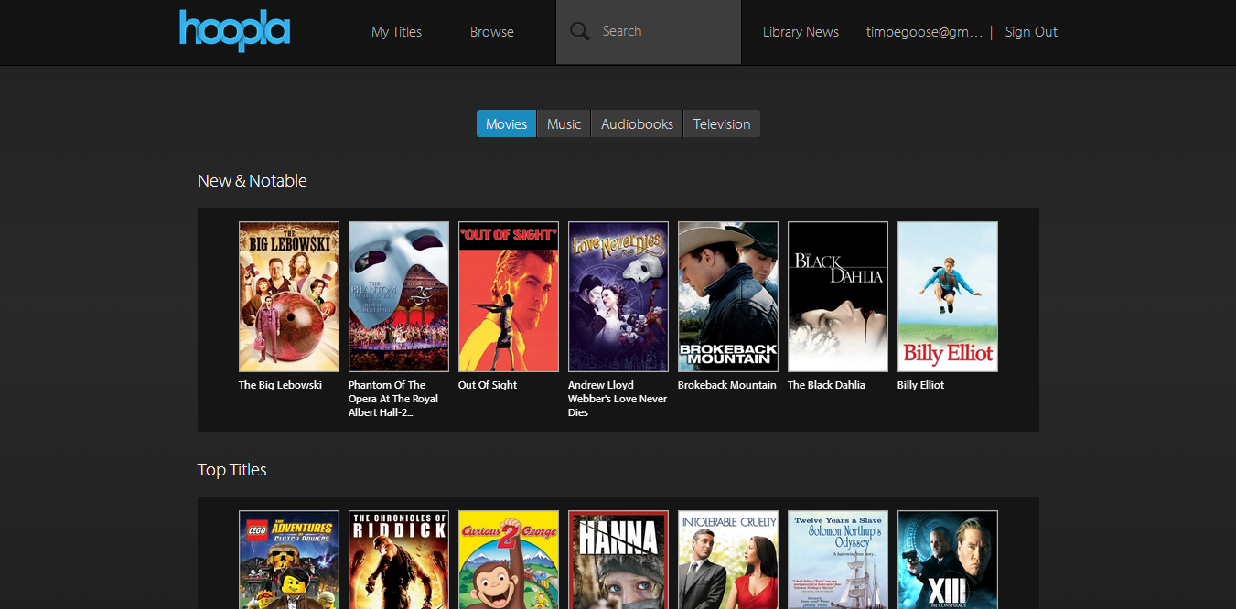
- Click “Borrow” to add the movie to “My Titles”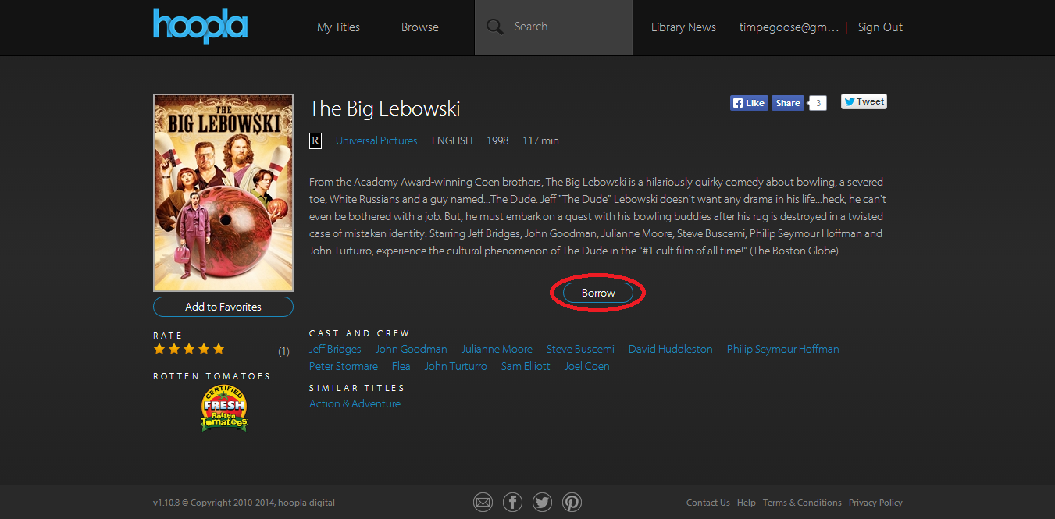
- The “Borrow” button should now say “Play”. Click “Play” to open the video player. 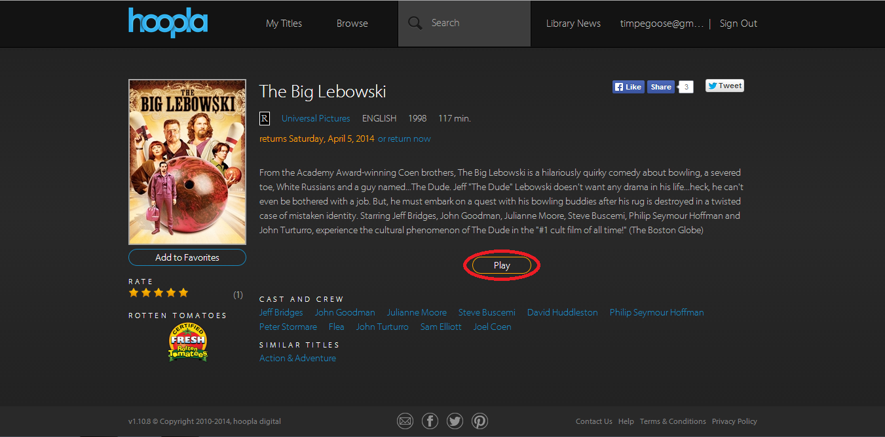
- A message should show up prompting you to install the missing plugin. Click “Install Plugin”.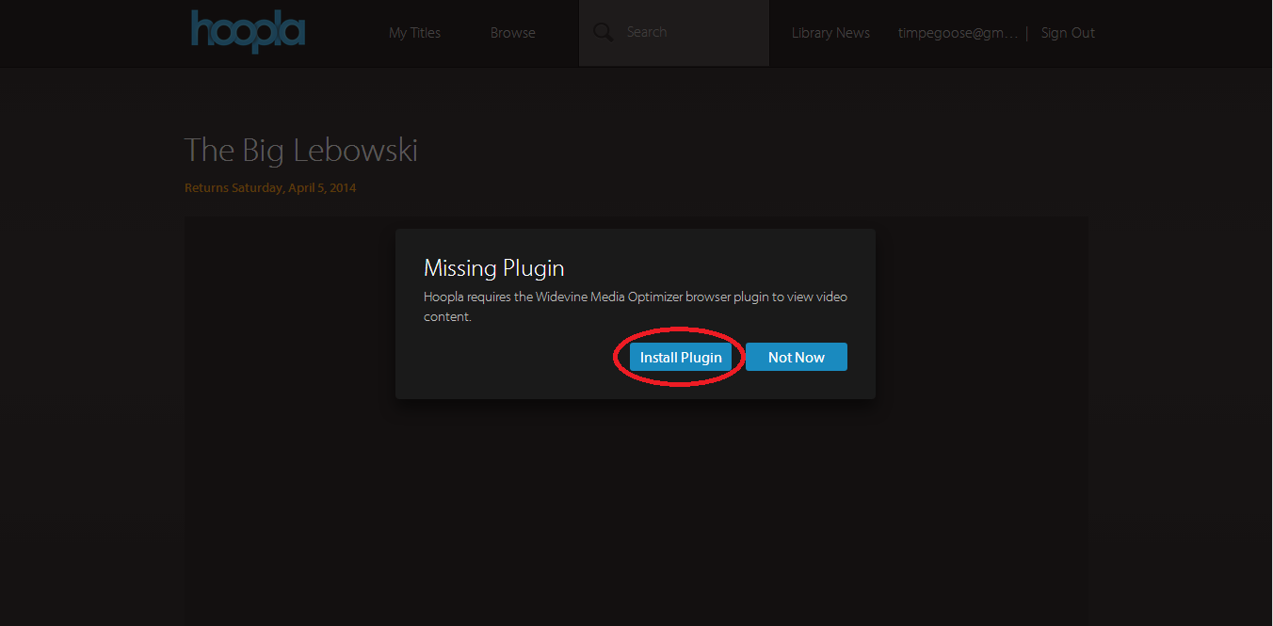
- This will take you to the Widevine website where you can install the plugin. Click “Install Now!” to begin the download.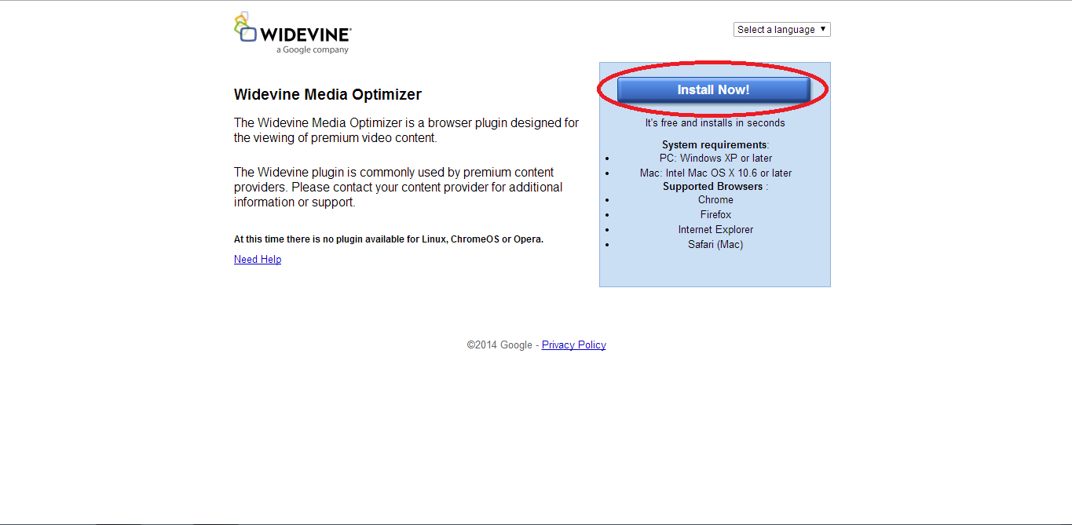
- Once the file is downloaded, click on the WidevineMediaOptimizer.exe button on the bottom of the page. 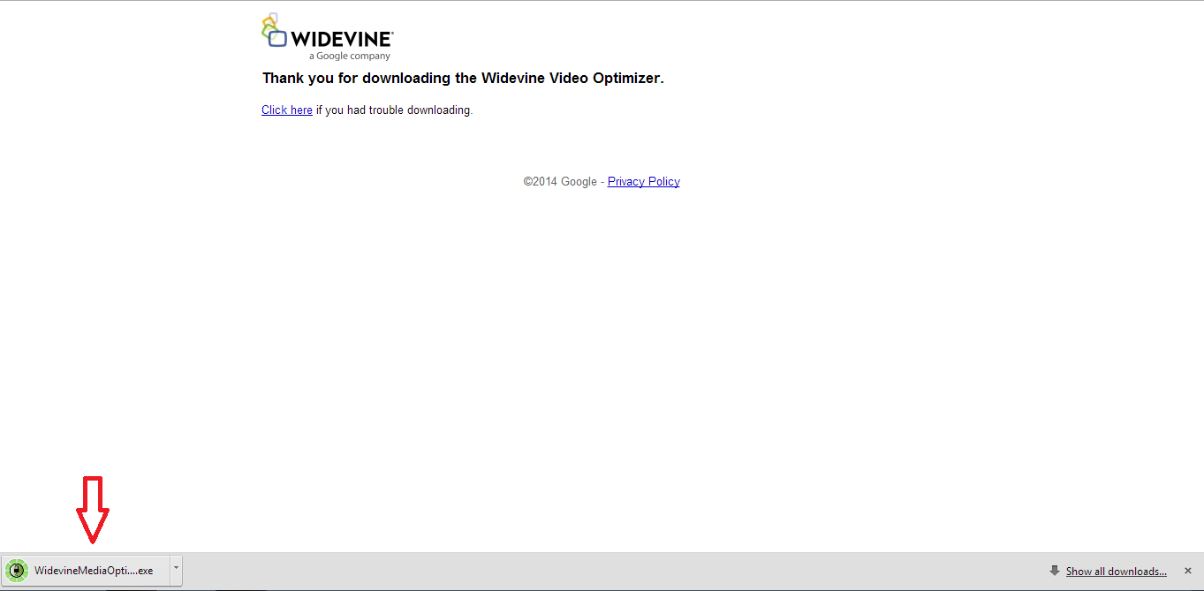
- Click “Run” to begin the installation. 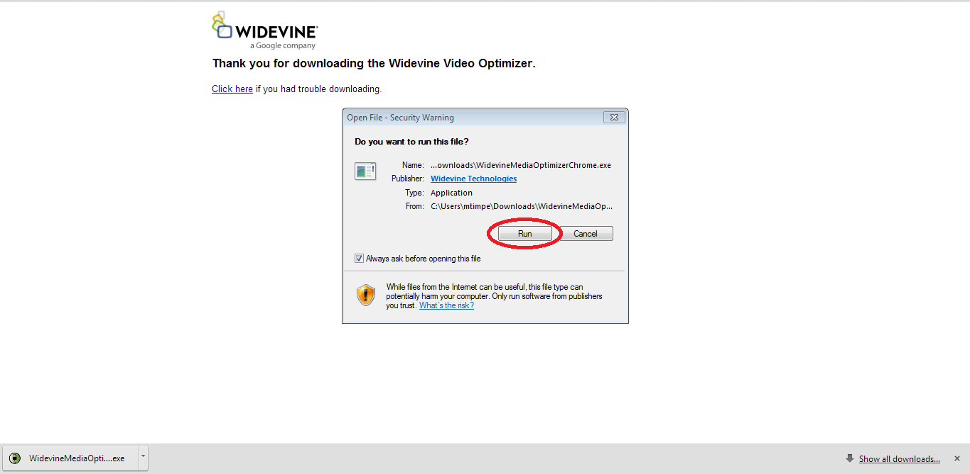
- Once the installation is finished, close out of your browser and restart it. Go into My Titles and select Borrowed. Then select your movie to start playback. 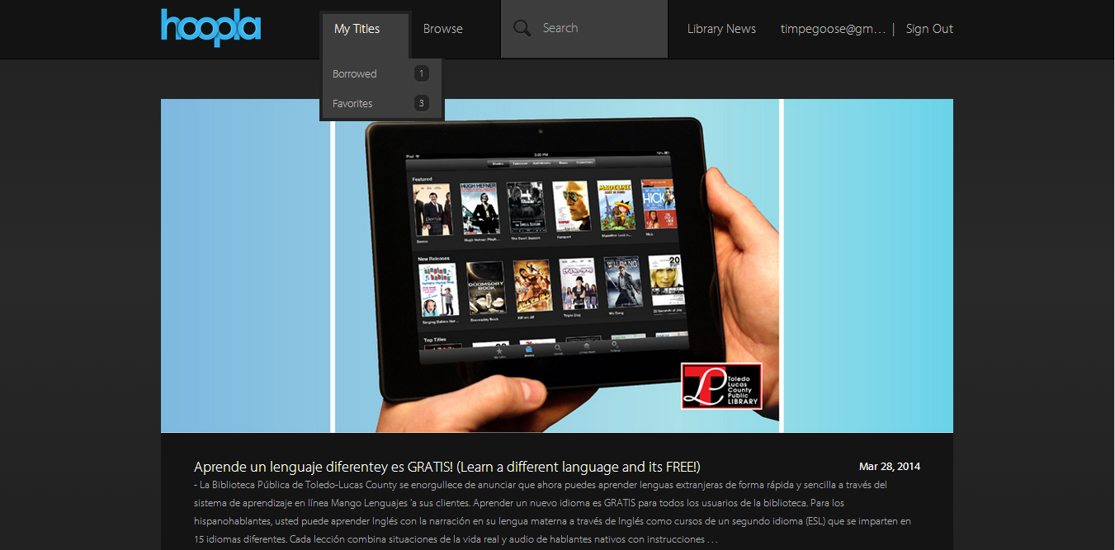
- Once you are on the player screen, click “Always run on this site” to ensure the player works everytime you play a video. 