**Use the following process to submit time card corrections from the Employee Dashboard. \**Note: Corrections are only possible for the current open pay period. Corrections for closed pay periods cannot be submitted.***

1. [**Navigate to Time & Labor**](https://paylocity.egain.cloud/system/templates/selfservice/pctycss/help/customer/locale/en-US/portal/308600000001010/content/PCTY-65253/Navigate-to-Time-Labor)

* For users with access rights extending beyond the **User Access Only**Feature Access Template, select **Time & Labor > My Time > Dashboard**.

1. Submit a time card correction in the **Activity**Section:

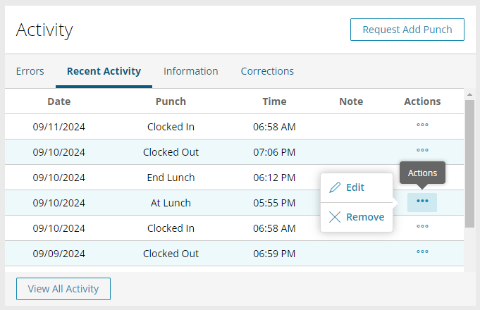

**To add a new punch**

1. Select **Request Add Punch.**
2. Adjust the fields as necessary. Fields include:
   * **Date**
   * **Time**
   * **Punch Type**
   * **Reason for Correction**
   * **Cost Center**
   * **Punch Note (Optional)**
3. Select **Submit Request**to submit the correction for approval.
   * Select **Cancel**to back out.

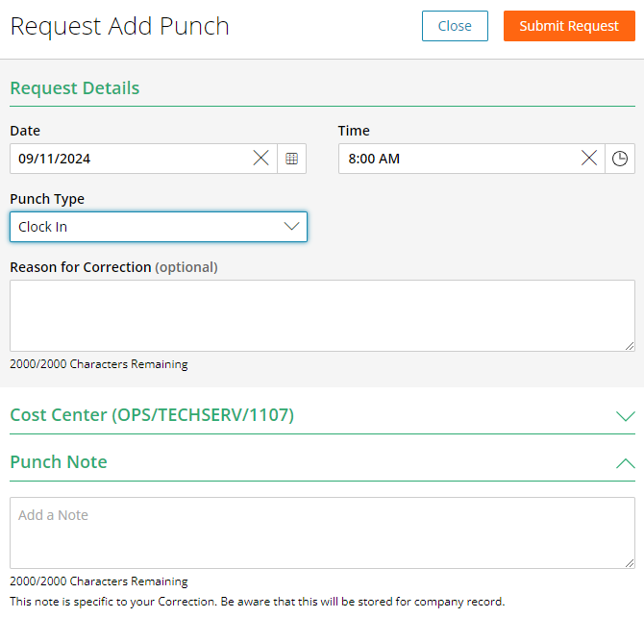

**To edit an existing punch**

1. Select the **Recent Activity** Tab.
2. For the desired punch, select the "..." under **Actions.**
   * If the punch does not appear, select**View All Activity**to see punches that have dropped from the **Recent Activity**View.
3. Select **Edit**from the pop-out.
4. Adjust the fields as necessary. Fields include:
   * **Date**
   * **Time**
   * **Punch Type**
   * **Reason for Correction**
   * **Cost Center**
   * **Punch Note (Optional)**
5. Select **Submit Request**to submit the correction for approval.
   * Select **Cancel**to back out.

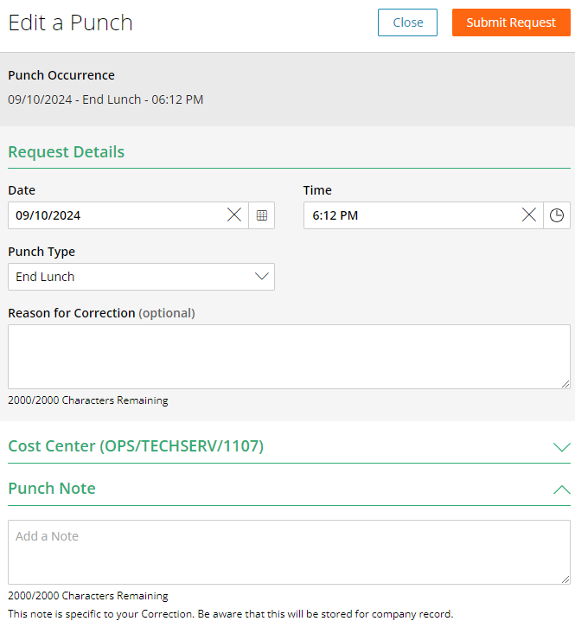

**To Remove an existing punch**

1. Select the **Recent Activity** Tab.
2. For the desired punch, select the "..." under **Actions.**
   * If the punch does not appear, select**View All Activity**to see punches that have dropped from the **Recent Activity**View.
3. Select **Remove**from the pop-out.
4. If applicable, enter a **Reason for Correction.**
5. Select **Submit Request**to submit the correction for approval.
   * Select **Cancel**to back out.

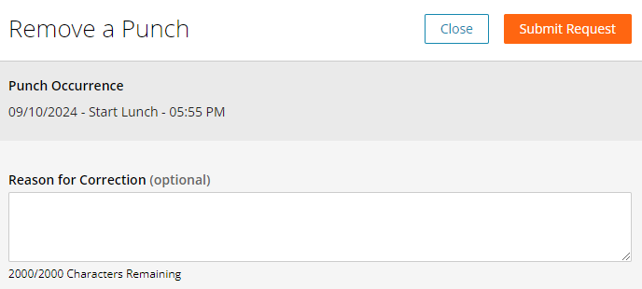

**To view the status of the correction**

1. Select the **Correction**Tab.
2. This section displays a list of Time Card Corrections for the open Pay Period, including:
   * **Request Type**- Type of correction, such as Add Punch.
   * **Request Date**- The date the user submitted the correction. Select the **Date**link to open a drawer to view the request details. Select **Cancel Request** to cancel the corrections request.
   * **Punch Date**- Date of the punch related to the correction.
   * **Status** - Current status of the correction request, such as Approved.
3. Select the **View All Requests**Button to open a drawer that displays all Time Card Correction Requests Submitted.

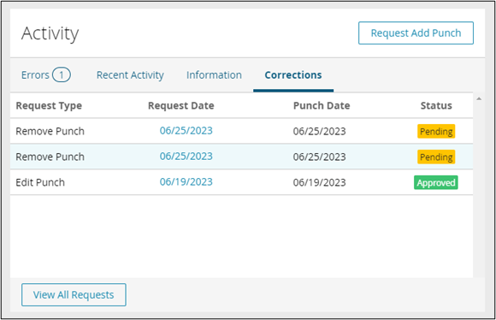

1. Select the **Request Date** for a correction to view the correction details.
   * Press **Cancel Request** to rescind the request.
   * Press **Close** to back out.

