**How to Remove Goals from Prior Years**

1. Navigate to Performance >Goals > My Goals
2. Click on the number under “My Goals”
3. There might be an Active Filter that shows something like Goal Start Date After: (then today’s date). Click the “x” next to this so that you can see all of your Active goals.

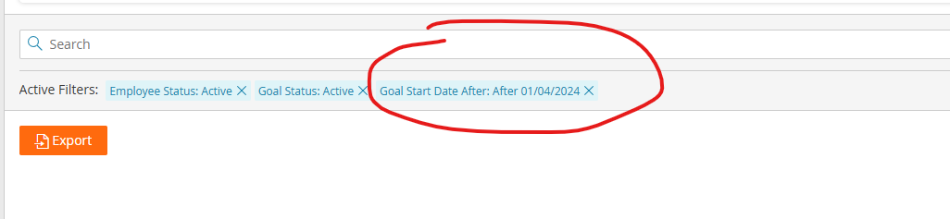

Here, you see a list of all your ***active*** individual goals.

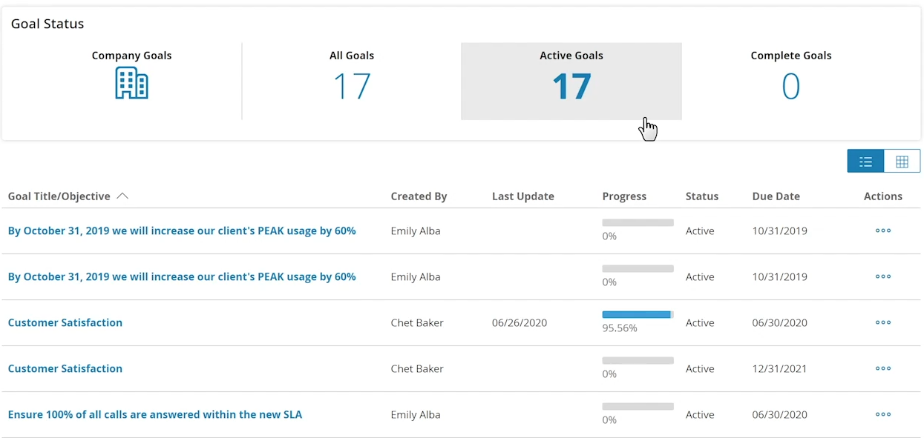

You can sort by “Due Date” by clicking on Due Date at the top of the column.

1. For past goals, click on the three dots under “Actions” next to the goal.
2. When you get into the goal, select the “Actions” button at the top and select “Edit.”

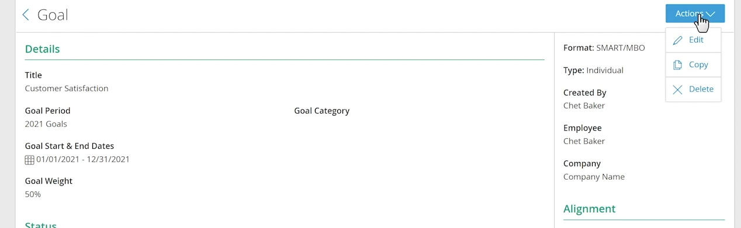

1. Next, under “Status”, select “Complete – Attained” if the goal was met, or “Complete – Missed” if the goal was not met.

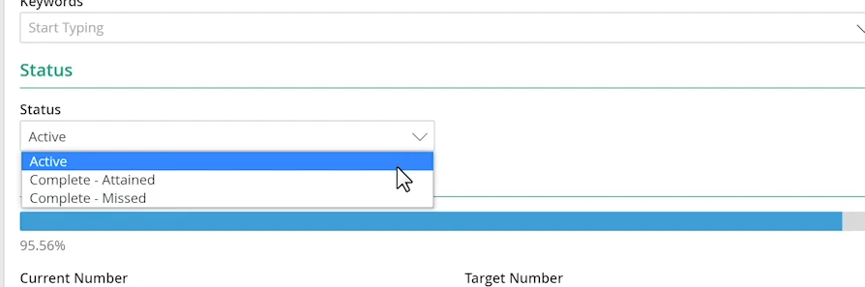

1. Then, select “Save.”

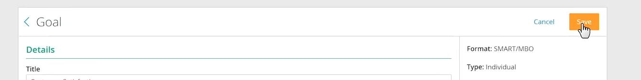

**Your past goal has now been archived!**